Fingerprint Access Control Card Reader User’s Manual

V1.0.1

Table of Contents

1 Overview 1
2 Device Structure 2
3 Device Installation 4
4 System Framework 6
4.1 Wiring 6
4.2 System Framework 6

Important Safeguards and Warnings
Please read the following safeguards and warnings carefully before using the product in order to avoid damages and losses.
Note:
- Do not expose the device to lampblack, steam or dust. Otherwise it may cause fire or electric shock.
- Do not install the device at position exposed to sunlight or in high temperature. Temperature rise in device may cause fire.
- Do not expose the device to humid environment. Otherwise it may cause fire.
- The device must be installed on solid and flat surface in order to guarantee safety under load and earthquake. Otherwise, it may cause device to fall off or turnover.
- Do not place the device on carpet or quilt.
- Do not block air vent of the device or ventilation around the device. Otherwise, temperature in device will rise and may cause fire.
- Do not place any object on the device.
- Do not disassemble the device without professional instruction.

Warning:
- Please use battery properly to avoid fire, explosion and other dangers.
- Please replace used battery with battery of the same type.
- Do not use power line other than the one specified. Please use it properly. Otherwise, it may cause fire or electric shock.

Special Announcement
- This manual is for reference only.
- All the designs and software here are subject to change without prior written notice.
-  All trademarks and registered trademarks are the properties of their respective owners.
- If there is any uncertainty or controversy, please refer to the final explanation of us.
-  Please visit our website for more information.

1 Overview
Fingerprint Access Control Card Reader is a biometric recognition device and also a complement to video monitoring and visual talk. Its appearance is neat and fashionable, and its function is enhanced. It is designed for commercial building, corporation property and intelligent community.

It has:
- Blue light
- Mifare card or EM card. Reading distance is 6cm~10cm. Response time is <0.1s.
- Fingerprint verification response time≤0.5s, fingerprint response time ≤1.5s.
- Max fingerprint storage is 4500.
- Wiegand protocol and RS485 output. RS495 baud rate is 9600bps.
- Can read 32 bit Mifare SN. Use high safety 64 bit key for mutual verification, via security algorithm. It has advanced key management system, lowering risk due to stolen data and copied intelligent card.
- ID recognition mode of card, card + fingerprint, fingerprint, card or fingerprint.
- Vandal-proof alarm, built-in watch dog program.
- All connection ports has over current and voltage protection.
- Online upgrade.
- Direct installation and open hole installation.
- Protection level: IP65, working temperature: ：-30℃～60℃, working temperature: ≤95%.
- Working voltage: 9VDC～15VDC, working current: 150mA.
- Dimension: 125mm*56mm*47mm，0.15kg.

2 Device Structure
Fingerprint Access Control Card Reader’s dimension is shown in Figure 2- and Figure 2- .

Figure 2-

Figure 2-

3 Device Installation
Fingerprint Access Control Card Reader’s installation illustration and steps are:
- Remove front cover, fix the device on wall via screw 1. See Figure 3- .

Figure 3-

- Put back front cover. Fix cover on the device via screw 2. See Figure 3- .
Figure 3-

4 System Framework

4.1 Wiring
Fingerprint Access Control Card Reader has 8-pin wiring, see Chart 4- .

No. | Color | Port | Note | Protocol
1 | Red | 12V | DC 12V power | -
2 | Black | GND | GND | -
3 | Blue | ALARM_OUT | Weigand vandal-proof alarm output | Weigand protocol
4 | White | D1 | Weigand signal line 1 | Weigand protocol
5 | Green | D0 | Weigand signal line 0 | Weigand protocol
6 | Brown | LED/BELL_CTRL | Weigand swiping card indicator signal line | Weigand protocol
7 | Yellow | RS485- | - | RS485 protocol
8 | Purple | RS485+ | - | RS485 protocol
Chart 4-

4.2 System Framework
Fingerprint Access Control Card Reader and access controller is connected as in Figure 4- .
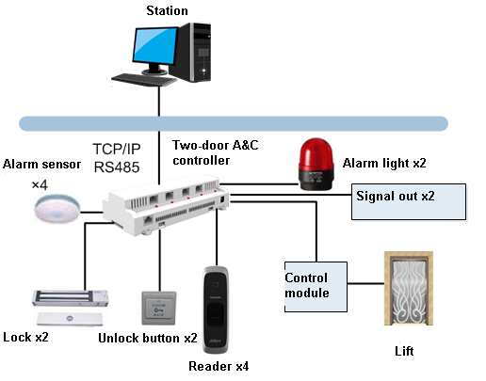
Figure 4-

Note:
- This manual is for reference only. Slight difference may be found in user interface.
- All the designs and software here are subject to change without prior written notice.
- All trademarks and registered trademarks are the properties of their respective owners.
- If there is any uncertainty or controversy, please refer to the final explanation of us.
- Please visit our website or contact your local service engineer for more information.

