Dahua HD Box Network Camera Quick Start Guide

Version 1.0.0
Zhejiang Dahua Vision Technology Co., LTD
Welcome
Thank you for purchasing our Network camera!
This user’s manual is designed to be a reference tool for your system.
Please read the following safeguard and warnings carefully before you use this series product!
Please keep this user’s manual well for future reference!

Important Safeguards and Warnings
1．Electrical safety
- All installation and operation here should conform to your local electrical safety codes.
- Please check if the power supply is correct before operating the device.
- The power shall conform to the requirement in the SELV (Safety Extra Low Voltage) and the Limited power source is rated DC 12V or AC 24V in the IEC60950-1. (Power supply requirement is subject to the device label).
- Please install easy-to-use device for power off before installing wiring, which is for emergent power off when necessary.
- Please prevent the line cord from being trampled or pressed, especially the plug, power socket and the junction from the device.
- Note: Do not connect these two power supplying sources to the device at the same time; it may result in device damage!
- We assume no liability or responsibility for all the fires or electrical shock caused by improper handling or installation.
- We are not liable for any problems caused by unauthorized modification or attempted repair.

2．Environment
- Please don’t aim the device at strong light (such as lighting, sunlight and so on) to focus; otherwise it may cause overexposure (It is not the device malfunction), which will affect the longevity of CCD or CMOS.
- Please transport, use and store the device within the range of allowed humidity and temperature.
- Please don’t keep the device in a place which is wet, dusty, extremely hot, and extremely cold and with strong electromagnetic radiation or unstable lighting.
- Please do not allow water and other liquid falling into the camera in case that the internal components are damaged.
- Please do not allow rain or damp to the indoor device in case fire or lightning may occur.
- Please keep the sound ventilation in case of heat accumulation.
- Please pack the device with standard factory packaging or material with same quality when transporting the device.
- Heavy stress, violent vibration or water splash are not allowed during transportation, storage and installation.

3. Operation and Daily Maintenance

- Please do not touch the heat dissipation component of the device directly in order to avoid scald.
- Please do not dismantle the device; there is no component which can be fixed by users themselves in the machine. It may cause water leakage or bad image for the device due to unprofessional dismantling. Please contact after-sale service to replace desiccant if it becomes green.
- It is recommended to use the device with thunder proof device in order to improve thunder proof effect.
- The grounding holes of the product are recommended to be grounded to further enhance the reliability of the camera.
- Do not touch the CCD (CMOS) optic component directly. You can use the blower to clean the dust or dirt on the lens surface. Please use a dry cloth wetted by alcohol to wipe away the dust gently if it is necessary to clean.
- Always use the dry soft cloth to clean the device. If there is too much dust, please use the water to dilute the mild detergent first and then use it to clean the device. Finally use the dry cloth to clean the device. Don’t use volatile solvent like alcohol, benzene, thinner and etc or strong detergent with abrasiveness, otherwise it will damage the surface coating or reduce the working performance of the device.
- Dome cover is an optical device, please don’t touch or wipe cover surface directly during installation and use, please refer to the following methods to deal with once dirt is found:
- Stained with dirt
- Use oil-free soft brush or hair dries to remove it gently.
- Stained with grease or fingerprint
- Use soft cloth to wipe the water drop or oil gently to make it dry, then use oil-free cotton cloth or paper soaked with alcohol or detergent to wipe from the lens center to outward. It is ok to change the cloth and wipe several times if it is not clean enough.

Warning
- Please modify the default password after login in order to avoid being stolen.
- Please use the standard accessories provided by manufacturer and make sure the device is installed and fixed by professional engineers.
- Please prevent the device surface from the radiation of laser beam when using laser beam device.
- Please do not provide two or more power supply modes for the device, otherwise it may cause damage to the device.

Statement
- Please refer to the actual product for more details; the manual is just for reference.
- The manual will be regularly upgraded according to the product update; the upgraded content will be added in the manual without prior announcement.
- Please contact the supplier or customer service if there is any problem occurred when using the device.
- Please contact the customer service for the latest procedure and supplementary documentation.
- There may be deviation between the actual value of some data and the value provided in the manual due to the reasons such as the real environment is not stable and so on. Please refer to the company’s final explanation if there is any doubt or dispute.
- The company is not liable for any loss caused by the operation which is not followed by the manual.

FCC Information
- FCC conditions：
This device complies with part 15 of the FCC Rules. Operation is subject to the following two conditions:
- This device may not cause harmful interference;
- This device must accept any interference received, including interference that may cause undesired operation.
- FCC compliance：
This equipment has been tested and found to comply with the limits for a digital device, pursuant to part 15 of the FCC Rules. These limits are designed to provide reasonable protection against harmful interference. This equipment generates uses and can radiate radio frequency energy and, if not installed and used in accordance with the instruction manual, may cause harmful interference to radio communication. However, there is no guarantee that interference will not occur in a particular installation. If this equipment does cause harmful interference to radio or television reception, which can be determined by turning the equipment off and on, the user is encouraged to try to correct the interference by one or more of the following measures:
- Reorient or relocate the receiving antenna.
- Increase the separation between the equipment and receiver.
- Connect the equipment into an outlet on a circuit different from that to which the receiver is connected.
- Consult the dealer or an experienced radio/TV technician for help.

Note:
Please refer to the disk for more details, check and download corresponding user’s manual and tool.
Before installation, please open the package and check all the components are included.
Contact your local retailer ASAP if something is broken in your package.

Accessory Name | Amount
Network Camera Unit | 1
C/CS Lens Adapter Ring | 1
Quick Start Guide | 1
CD | 1

Table of Contents
1 Device Structure 1
1.1 Rear Panel 1
1.2 Dimension 3
1.3 Bidirectional talk 3
1.4 Alarm Setup 4
1.4.1 Alarm Input and Output Connection 5
1.4.2 IR Light Connection 5
2 Device Installation 7
2.1 Lens Installation 7
2.1.1 Auto Iris Lens Installation 7
2.1.2 Manual Iris Lens Installation 7
2.2 SD Card Installation 8
2.3 I/O Port Application 8
3 Network Configuration 9
3.1 Modify IP Address 9
3.2 Login WEB Interface 10

Device Structure

Rear Panel
Note:
The figures are for reference only, which are used to know the functions of the rear panel.
Different devices may have different structures of rear panel, please refer to the actual product for more details. See Figure 1-1 and Figure 1-2.
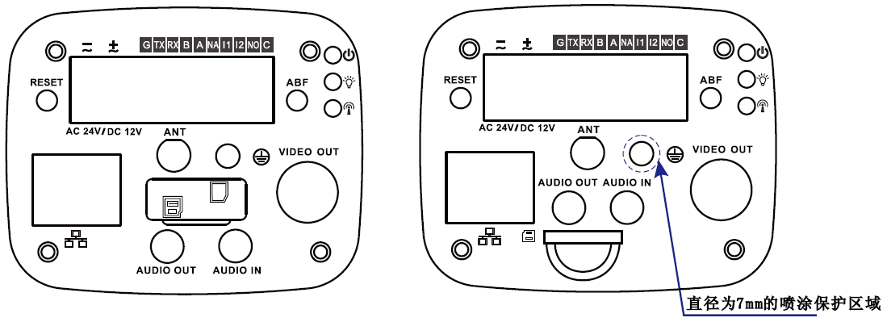

Figure 1-1
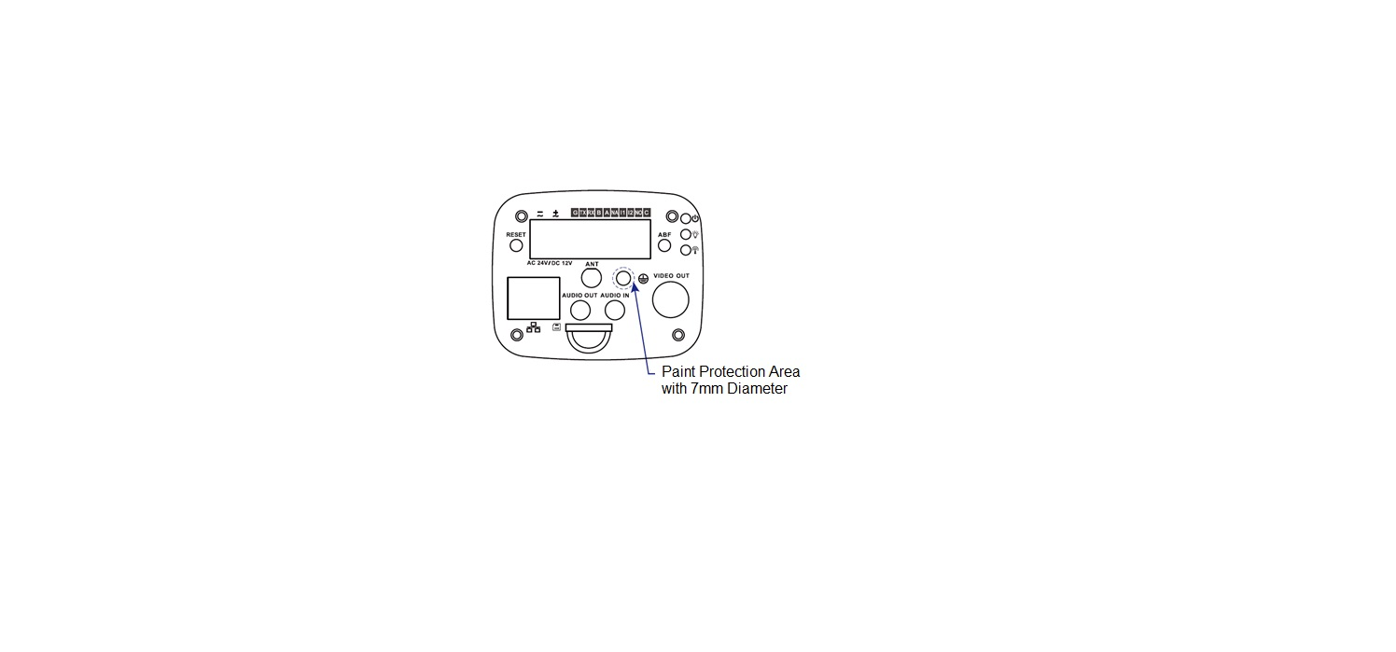
Figure 1-2
Please refer to the following sheet for detail information.
Port Name |  | Port Function
VIDEO OUT | Video output port | Output analog video signal. It can connect to TV monitor to check analog video.
AC 24V/ DC 12V | Power port | Able to input 12V DC or AC 24V power supply, and support power supply at the same time (4G devices are excluded, in accordance with label)
Indicator Light | Red light | - System boots up-red light is normally on  - System upgrades-red light flashes  - System resets-green light is off, red light is normally on.
Indicator Light | Green light | - Normal working status-green light is normally on.  - Display record status: recording-green light flashes.
Indicator Light | Yellow light | - Detect the wireless device-yellow light is normally on.
IN1 | Alarm input port 1 | Receive the on-off signal from the external alarm source.
NO | Alarm output port | Alarm output port. It is to output alarm signal to the alarm device.  - NO: Normally open alarm output end.  - C: Alarm output common end.
C | Alarm output port
IN2 | Alarm input port 2 | It is to receive the on-off signal from the external alarm source.
A | RS485 port | RS485_A port, control external PTZ etc.
B | RS485 port | RS485_B port, control external PTZ etc.
RX | RS232 port | Receiving end of RS232 serial port.
TX | RS232 port | Sending end of RS232 serial port.
G | GND | Ground end of RS232 serial port.
NA | IR light port | External IR light signal control port.
RESET | RESET button | Restore device factory default setup.  When system is running normally, press the RESET button for at least 5 seconds, system can restore factory default setup.
ABF | Auto back focus adjustment | Auto back focus adjustment, by adjusting Sensor board position to achieve precise back focus adjustment.
AUDIO OUT | Audio output port | 3.5mm JACK port, output audio signal to the passive device such as earphone and etc.
AUDIO IN | Audio input port | 3.5mm JACK, input audio signal from devices such as pick-up.
LAN/OPT | Network port /MB optical fiber port | LAN: Connect to standard Ethernet cable and provide PoE power supply function.  OPT: Transmit MB Ethernet data.
SD | SD card port | Connect it to SD card.
 | GND | Please make sure the device is securely earthed to prevent the thunderstorm strike when using the device.

Dimension
The figures are for reference only, which are used to know the device dimension, please refer to the actual device for more details. The unit is mm. See Figure 1-3 and Figure 1-4.
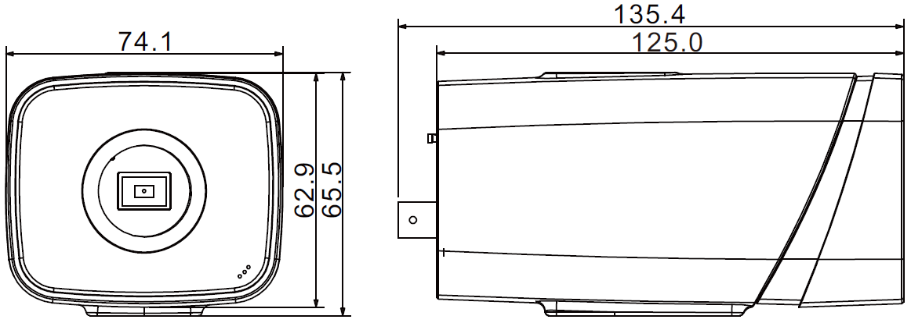
Figure 1-3
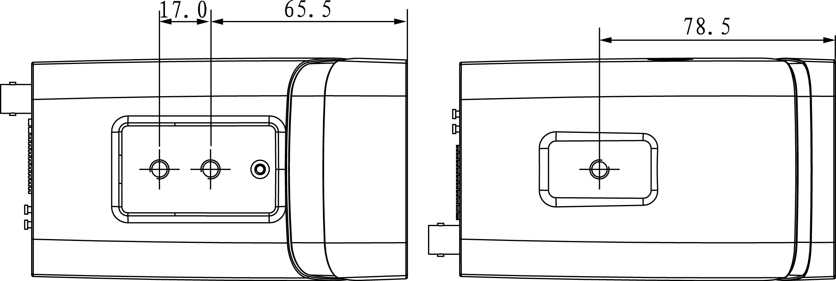
Figure 1-4

Bidirectional talk
Note:
- Some products do not support bidirectional talk, which cannot be applied to this chapter.
- It is not allowed to use on-site listening when the device is applying bidirectional talk.
Step 1
Connect the speaker or the MIC to the audio input port of the device and PC; connect the earphone to the audio output port of the device and PC respectively.
Step 2
Log in the device WEB interface, click “Talk” button to enable bidirectional talk. You can see the button becomes orange after you enabled the audio talk function. Click “Talk” button again to stop the bidirectional talk function.
Step 3
Input audio to speaker or MIC on the device end and PC respectively, and receive the audio via earphone on the device end and PC.

Alarm Setup
Note:
Some devices don’t support alarm function, which can’t be applied to this chapter.
The alarm interface is shown as in Figure 1-5.
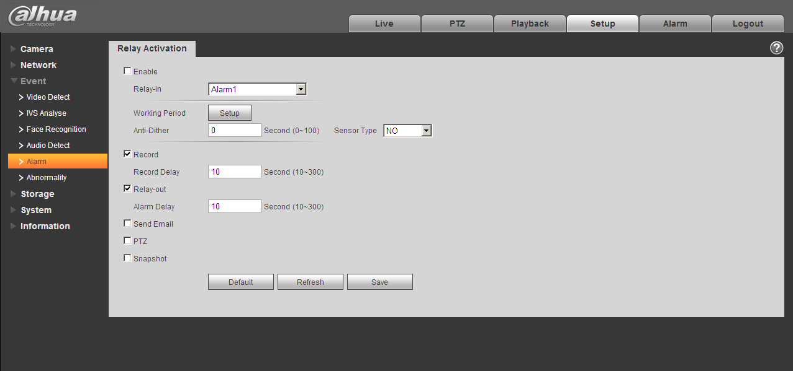
Figure 1-5

The alarm input, output connection description:
Step 1
Connect the alarm input device to the IN alarm input port on the rear panel I/O port.
Step 2
Connect the alarm output device to the NO alarm output port and C alarm output public
port on the rear panel I/O port. The alarm output port supports NO (normal open) alarm device only.
Step 3
Open the Web; go to the Figure 1-6. Here you can set the alarm input setup and alarm output
setup. Here the alarm input is the alarm input on the rear panel I/O port (as IN port). Then you
can select the corresponding type (NO/NC) according to the high/low level type when an alarm
occurs.
Step 4
Set the WEB alarm output. The alarm output 01 is the alarm output port of the device rear panel
I/O port (as the NO port).

Alarm Input and Output Connection
Please refer to the following figure for alarm input information. See Figure 1-6.
Alarm input: When the input signal is idle or grounded, the device can collect the different statuses of the alarm input port. When the input signal is connected to the 3.3V or it is idle, the device collects the logic “1”. When the input signal is grounded, the device collects the logic “0”.
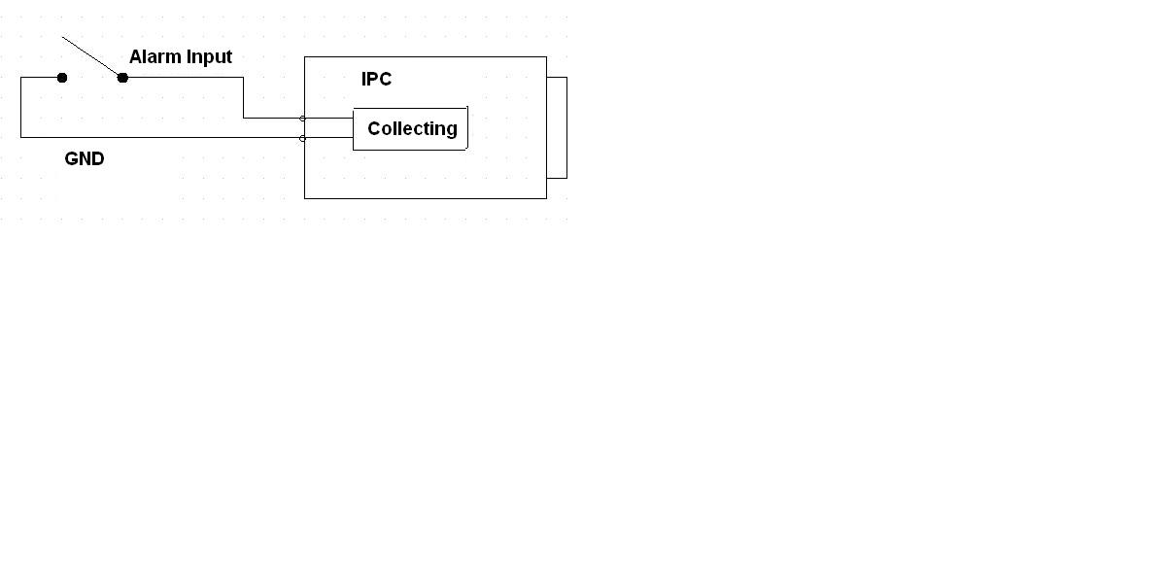
Figure 1-6
Please refer to the following figure for alarm output information. See Figure 1-7.
Port NO and Port C composes an on-off button to provide the alarm output.
If the type is NO, this button is normal open. The button becomes on when there is an alarm output.
If the type is NC, this button is normal off. The button becomes off when there is an alarm output.
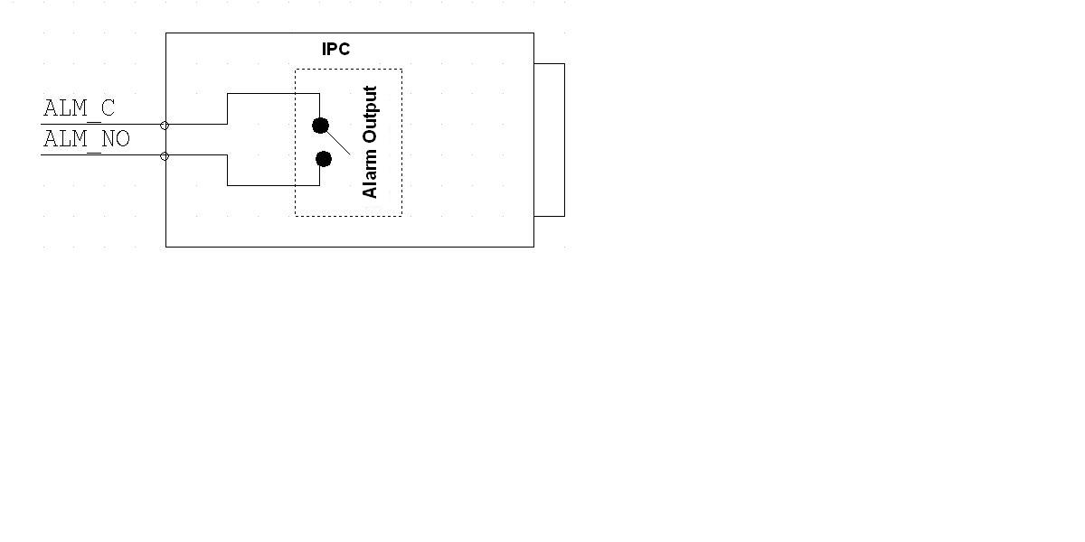
Figure 1-7

IR Light Connection
Note:
It needs to meet the following requirements before using IR light sync function:
- Device shall have external port for IR function.
- Log in Web, select Setup -> Camera -> Day&Night, and select “sensor input”. If it is not available, then you don’t need to configure it.
Please refer to the following figure for external IR light information. See Figure 1-8.
IR synchronization input signal. When the external IR light is on, the signal cable on the light board outputs 3.3V/1mA. It outputs 0V when the IR light is off.
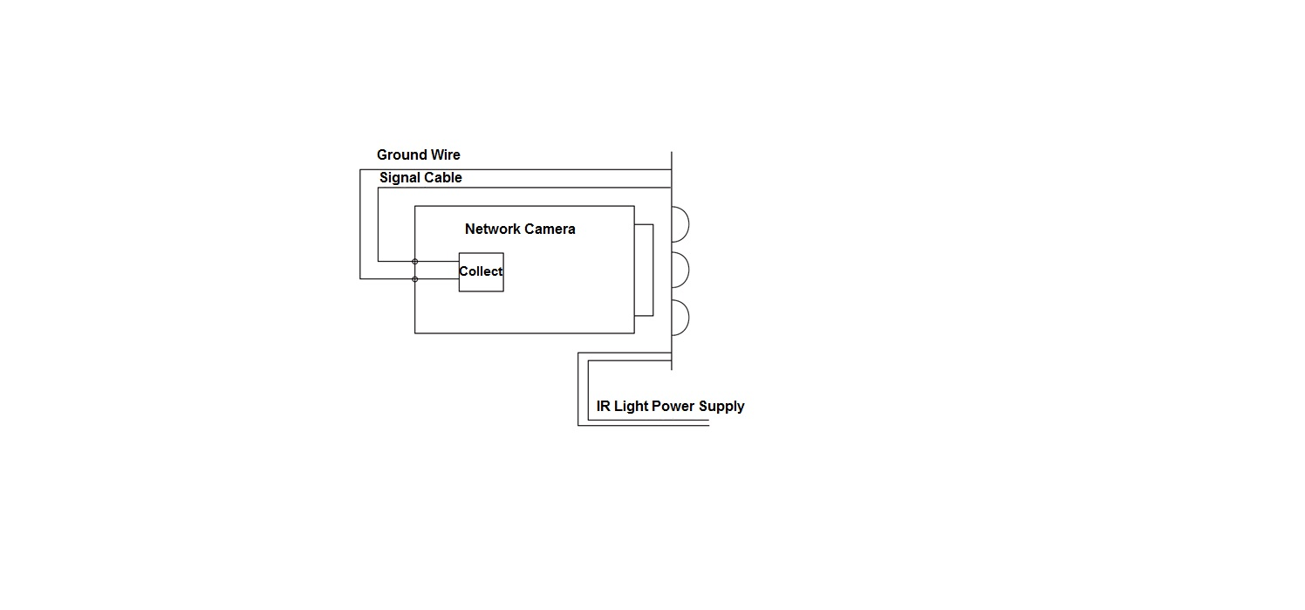
Figure 1-8

Device Installation

Lens Installation
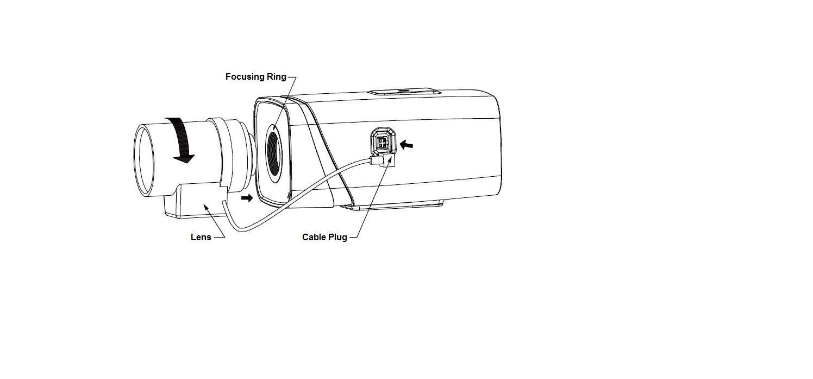
Figure 2-1

Auto Iris Lens Installation
Step 1
Remove the CCD protection cover on the device, aim the lens at the lens installation position, and turn the lens clockwise until it is installed firmly.
Step 2
Insert the lens cable plug into the connector of auto iris lens on the camera side panel.
Step 3
Make the image clear via adjusting focal length.

Manual Iris Lens Installation
Please follow the steps listed below for auto aperture lens installation.
Step 1
Remove the CCD protection cover of the device,
Step 2
Install the C/CS adapter ring on the camera; turn clockwise to the end to cling to the focusing ring on the camera closely. (Only C lens needs to install adapter ring)
Step 3
Aim the C port lens at the lens installation position of the C/CS adapter ring (aim the CS port lens at the lens installation position of the camera focusing ring); turn the lens clockwise until it is firmly installed.
Step 4
Use slotted screwdriver to unfasten the screw near the focusing ring and then turn counter clockwise to move the focusing ring out for several millimeters. Now you can focus manually and check the video is clear or not. If you can’t see the clear video, you can adjust back focus.
Step 5
After you completed the focus setup, use the slotted screwdriver to fix the screw firmly. Fasten the focusing ring. Now the installation completed.

SD Card Installation
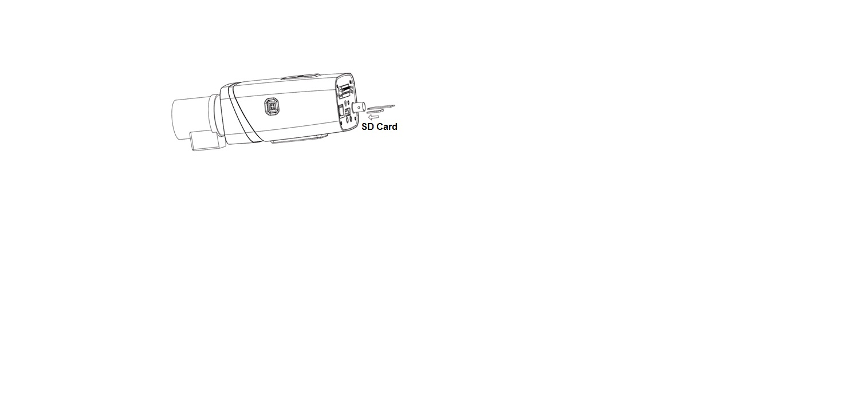
Figure 2-2
Step 1
Take down the SD card protection cover from the device.
Step 2
Install the SD card into the device according to the installation direction shown in Figure 2-2.
Step 3
Cover the SD card protection cover.
Step 4
Fix the SD card protection cover on the device.

I/O Port Application
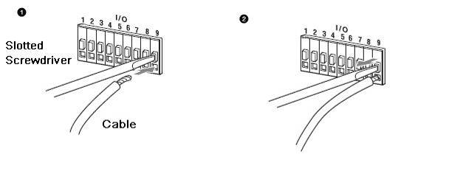
Figure 2-3

Install Cable:
Step 1
Use the small slotted screwdriver to press the corresponding button of cable groove.
Step 2
Insert the cable into the groove.
Step 3
Release the screwdriver which presses the groove button and complete cable installation.

Network Configuration
The IP address of all the cameras is the same when leaving factory (default IP192.168.1.108), in order to make the camera get access to the network smoothly, please plan the useable IP segment reasonably according to the actual network environment.

Modify IP Address
IP address can be acquired and modified through quick configuration tool for the cameras which are accessed via wired network, it needs to connect wired network to configure wireless parameters before using wireless network cameras. In this chapter, it will introduce the approach of modifying IP address via “Quick Configuration Tool”; also you can modify the IP address in the network parameters of the WEB interface, please refer to the document in the disk << WEB Operation Manual>> for more details.
Note:
Currently the quick configuration tool only supports the cameras which apply to the same network segment with computer IP address.
Step 1 Double click the “ConfigTools.exe” and open the quick configuration tool.
Step 2 Double click the device to be configured, the system will pop out the “Login” dialog box. Enter the IP address, user name, password and port number of the camera, and click “Confirm”.
Note:
The default user name and password are admin and admin respectively, the default of port is
37777. See Figure 3-1 for more details.
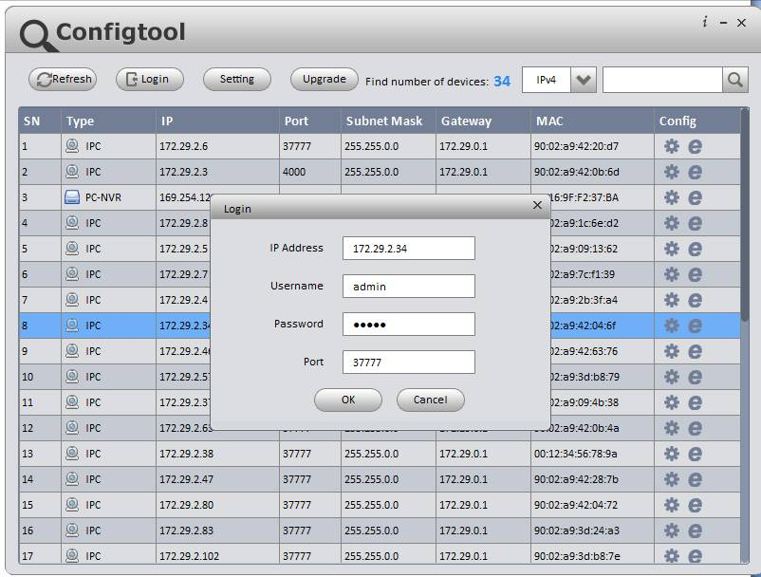
Figure 3-1
Step 3 Modify the camera IP address on the “Net” interface, click “Save” to finish modification.
See Figure 3-2 for more details.
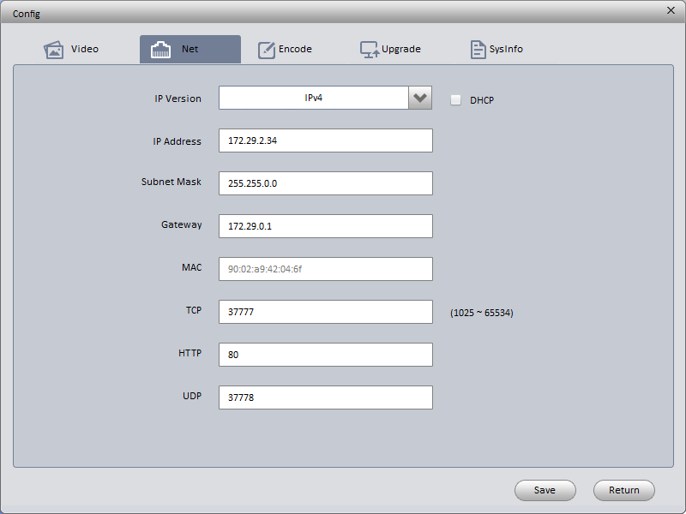
Figure 3-2

Login WEB Interface
Note:
Different devices may have different WEB interfaces, the figures below are just for reference, please refer to the document <<WEB Operation Manual>> in the disk and the actual interface for more details
Step 1 Open IE and input the modified camera IP address in the address bar.
Step 2 The login interface is shown below, please input your user name and password (Default user name is admin and password is admin respectively), click “login”.
See Figure 3-3 for more details.
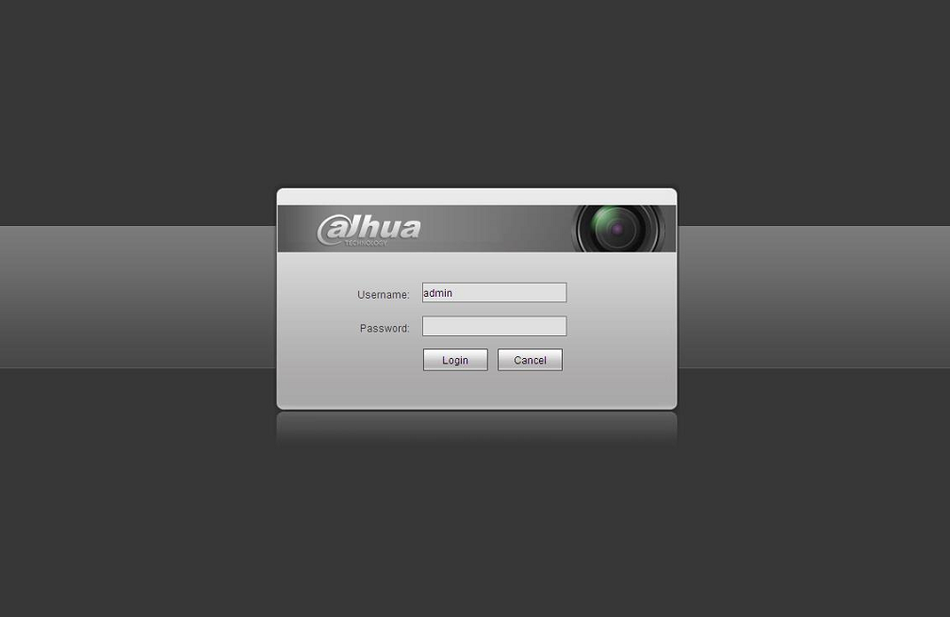
Figure 3-3
Step 3 Install controls according to the system prompt; see Figure 3-4 for the WEB main interface. Please modify the administrator password as soon as possible after you successfully logged in.
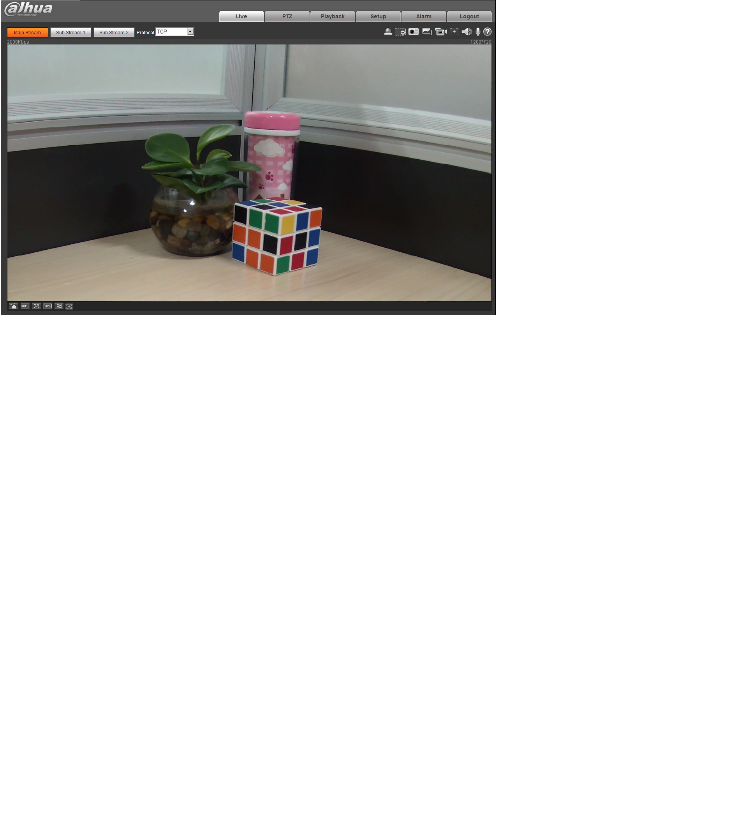
Figure 3-4

Note:
- This quick start guide is for reference only.
- Slight difference may be found in user interface.
- All the designs and software here are subject to change without prior written notice.
- If there is any uncertainty or controversy, please refer to the final explanation of us.
- Please visit our website or contact your local service engineer for more information.



Zhejiang Dahua Vision Technology Co., Ltd
Address：No.1199 Bin’an Road, Binjiang District, Hangzhou, PRC.
Postcode: 310053
Tel: +86-571-87688883
Fax: +86-571-87688815
Email:overseas@dahuatech.com
Website: www.dahuasecurity.com

