**Dahua K Series 4G LTE Cube Network Camera**

**Quick Start Guide**

**V 1.0.0**

**Dahua Technology Co., LTD**

**Welcome**

Thank you for purchasing our Network camera!

This user’s manual is designed to be a reference tool for your system.

Please read the following safeguard and warnings carefully before you use this series product!

Please keep this user’s manual well for future reference!

**Important Safeguards and Warnings**

**1．Electrical safety**

* All installation and operation here should conform to your local electrical safety codes.
* Please check if the power supply is correct before operating the device.
* The power shall conform to the requirement in the SELV (Safety Extra Low Voltage) and the Limited power source is rated DC 12V or AC 24V in the IEC60950-1. (Power supply requirement is subject to the device label).
* Please install easy-to-use device for power off before installing wiring, which is for emergent power off when necessary.
* Please prevent the line cord from being trampled or pressed, especially the plug, power socket and the junction from the device.
* **Note: Do not connect these two power supplying sources to the device at the same time; it may result in device damage!**
* We assume no liability or responsibility for all the fires or electrical shock caused by improper handling or installation.
* We are not liable for any problems caused by unauthorized modification or attempted repair.

**2．Environment**

* Please don’t aim the device at strong light (such as lighting, sunlight and so on) to focus; otherwise it may cause overexposure (It is not the device malfunction), which will affect the longevity of CCD or CMOS.
* Please transport, use and store the device within the range of allowed humidity and temperature.
* Please don’t keep the device in a place which is wet, dusty, extremely hot, and extremely cold and with strong electromagnetic radiation or unstable lighting.
* Please do not allow water and other liquid falling into the camera in case that the internal components are damaged.
* Please do not allow rain or damp to the indoor device in case fire or lightning may occur.
* Please keep the sound ventilation in case of heat accumulation.
* Please pack the device with standard factory packaging or material with same quality when transporting the device.
* Heavy stress, violent vibration or water splash are not allowed during transportation, storage and installation.

**3. Operation and Daily Maintenance**

* Please do not touch the heat dissipation component of the device directly in order to avoid scald.
* Please do not dismantle the device; there is no component which can be fixed by users themselves in the machine. It may cause water leakage or bad image for the device due to unprofessional dismantling. Please contact after-sale service to replace desiccant if it becomes green.
* It is recommended to use the device with thunder proof device in order to improve thunder proof effect.
* The grounding holes of the product are recommended to be grounded to further enhance the reliability of the camera.
* Do not touch the CCD (CMOS) optic component directly. You can use the blower to clean the dust or dirt on the lens surface. Please use a dry cloth wetted by alcohol to wipe away the dust gently if it is necessary to clean.
* Always use the dry soft cloth to clean the device. If there is too much dust, please use the water to dilute the mild detergent first and then use it to clean the device. Finally use the dry cloth to clean the device. Don’t use volatile solvent like alcohol, benzene, thinner and etc or strong detergent with abrasiveness, otherwise it will damage the surface coating or reduce the working performance of the device.
* Dome cover is an optical device, please don’t touch or wipe cover surface directly during installation and use, please refer to the following methods to deal with once dirt is found:
* Stained with dirt
* Use oil-free soft brush or hair dries to remove it gently.
* Stained with grease or fingerprint
* Use soft cloth to wipe the water drop or oil gently to make it dry, then use oil-free cotton cloth or paper soaked with alcohol or detergent to wipe from the lens center to outward. It is ok to change the cloth and wipe several times if it is not clean enough.

**Warning**

* Please modify the default password after login in order to avoid being stolen.
* Please use the standard accessories provided by manufacturer and make sure the device is installed and fixed by professional engineers.
* Please prevent the device surface from the radiation of laser beam when using laser beam device.
* Please do not provide two or more power supply modes for the device, otherwise it may cause damage to the device.

**Statement**

* Please refer to the actual product for more details; the manual is just for reference.
* The manual will be regularly upgraded according to the product update; the upgraded content will be added in the manual without prior announcement.
* Please contact the supplier or customer service if there is any problem occurred when using the device.
* Please contact the customer service for the latest procedure and supplementary documentation.
* There may be deviation between the actual value of some data and the value provided in the manual due to the reasons such as the real environment is not stable and so on. Please refer to the company’s final explanation if there is any doubt or dispute.
* The company is not liable for any loss caused by the operation which is not followed by the manual.

**Note:**

Please refer to the disk for more details, check and download corresponding user’s manual and tool.

Before installation, please open the package and check all the components are included.

Contact your local retailer ASAP if something is broken in your package.

|  |  |
| --- | --- |
| Accessory Name | Amount |
| Network Camera Unit | 1 |
| Quick Start Guide | 1 |
| Screw Package | 1 |
| Power Adapter | 1 |

**Table of Contents**

1 Product Structure 1

1.1 Device Components 1

1.2 Bidirectional talk 2

1.2.1 Device-end to PC-end 2

1.2.2 PC-end to the Device-end 2

1.3 Alarm 3

2 Device Installation 5

3 Network Configuration 6

3.1 Modify IP Address 6

3.2 Login WEB Interface 7

# Product Structure

## Device Components

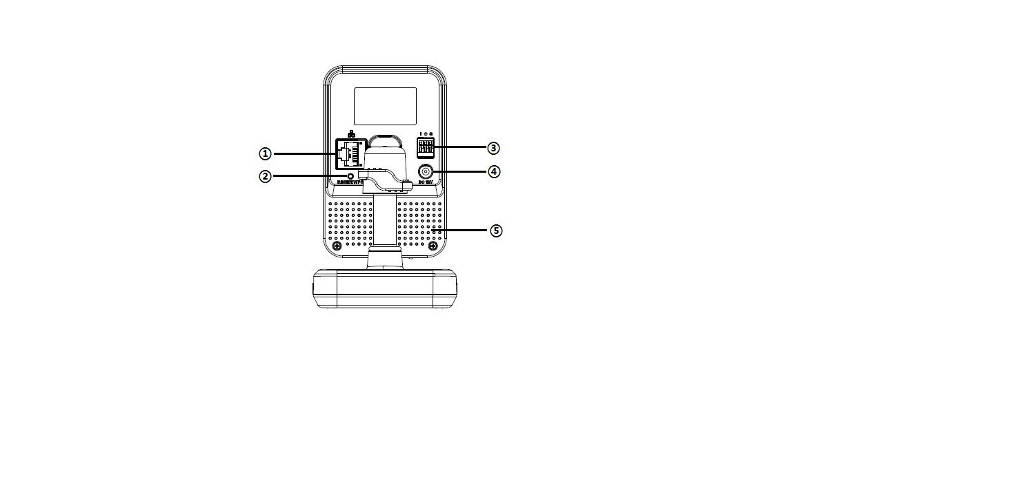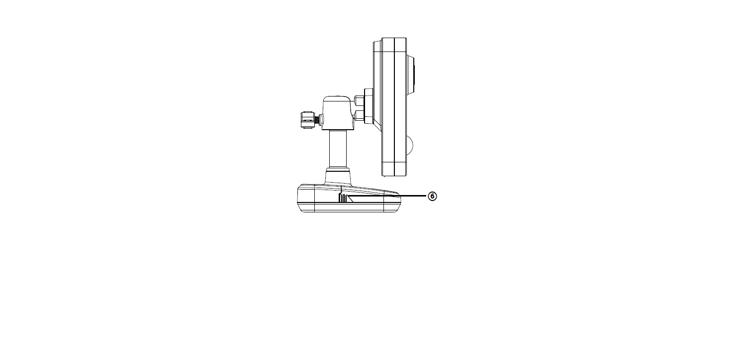

Figure 1-1 Figure 1-2

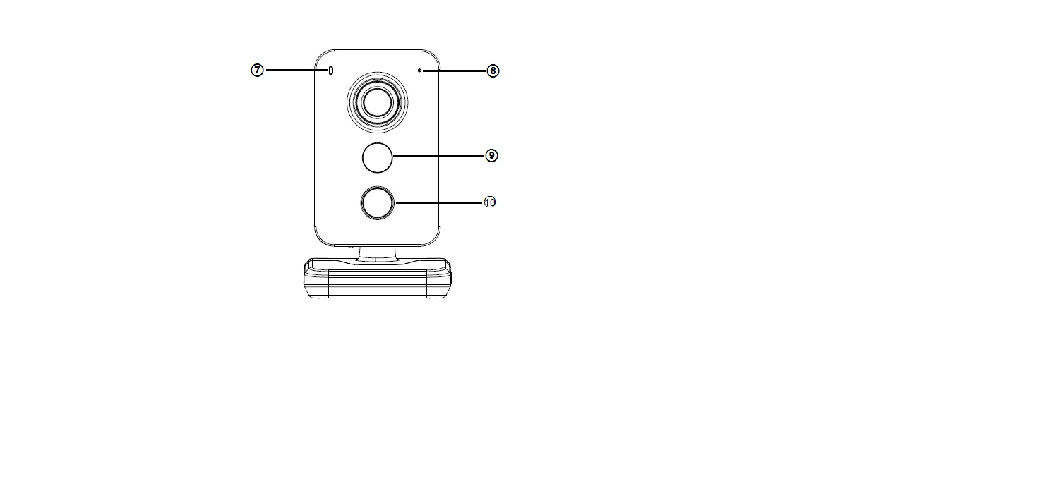

Figure 1-3

Please refer to the following sheet for more details about each port.

| **SN** | **Name** |
| --- | --- |
| 1 | Network port |
| 2 | Reset button |
| 3 | Alarm input/output |
| 4 | Power port |
| 5 | Built-in speaker |
| 6 | 4G LTE card slot |
| 7 | Indicator light |
| 8 | Built-in MIC |
| 9 | IR LED |
| 10 | PIR |

Sheet 1-1

**Note:**

For reset, long press for 8 seconds and then the light is off; please refer to the following sheet for more details about status of indicator light.

|  |  |
| --- | --- |
| **Indicator light status** | **Device status** |
| Red light normally on | Booting , device malfunction, fail to boot up |
| Green light flashes | Booting completed, waiting for 4G network connection |
| Green light normally on | Device operates normally. (The standard of normal operation: 4G network connection is successful) |
| Red and green lights flash alternately | Device upgrade, including SD card boot upgrade, cloud upgrade etc. |
| Red light flashes | SD card malfunction or external hardware alarm. |

Sheet 1-2

Press reset button after the device boots up, and the light is off after reset takes effect; it will return to the status of red light normally on after reboot. 0

## Bidirectional talk

### Device-end to PC-end

**Device Connection**

Please connect the earphone to the audio output port in the PC. Login the Web and then click the Audio button to enable the bidirectional talk function. You can see the button becomes yellow after you enabled the audio talk function. Click Audio button again to stop the bidirectional talk function.

**Listening Operation**

Speak or play music at the device-end, you can use the earphone or the sound box of the PC-end to listen the audio information from the device-end.

### PC-end to the Device-end

**Device Connection**

Connect the speaker or the MIC to the audio input port in the PC. Login the Web and then click the Audio button to enable the bidirectional talk function. You can see the button becomes yellow after you enabled the audio talk function. Click Audio button again to stop the bidirectional talk function.

**Listening Operation**

Speak or play music at the PC-end, you can use the built-in speaker of the device-end to listen.

**Note**

Please go to the Master Volume interface of the PC to set first if you want to use the dual-way bidirectional talk. Please select Front Mic mode in the record control interface. (You can select microphone enhanced in advanced interface if the audio is too low.)

## Alarm

The alarm interface is shown as in 4. Please follow the steps listed below for local alarm input and output connection.

1) Connect the alarm input device to the alarm input port of the I/O cable.

2) Connect the alarm output device to the alarm output port of I/O cable. Alarm output port is open collector output which requires pull-up resistor of 10k to 3.3V eternally.

3) Open the Web; go to the 4. Set alarm input and output correspondingly. Alarm input on WEB corresponds to I/O cable on device. When there is alarm, alarm input device will generate signal of high and low level. Set corresponding NO and NC inputs.

4) Set the WEB alarm output. The alarm output s for the alarm output port of the device. It is the alarm output port of the I/O cable.

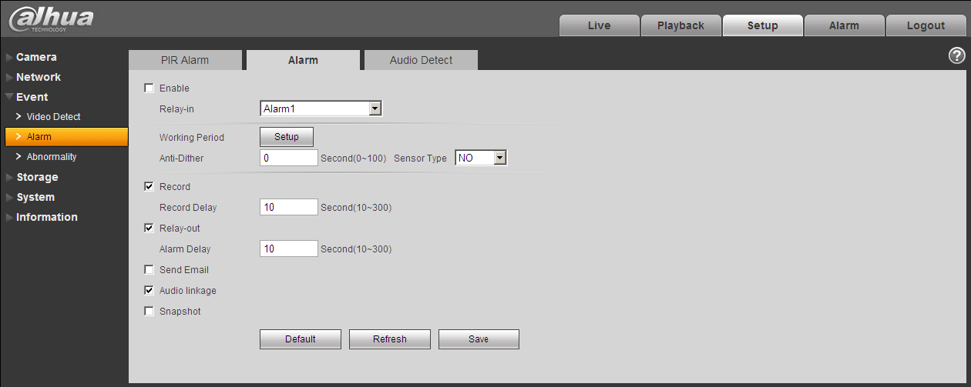

Figure 1‑4 Alarm

Please refer to the following figure for alarm input information. See 5.

Alarm input: When the input signal is idle or grounded, the device can collect the different statuses of the alarm input port. When the input signal is connected to the 5V or is idle, the device collects the logic “1”. When the input signal is grounded, the device collects the logic “0”.

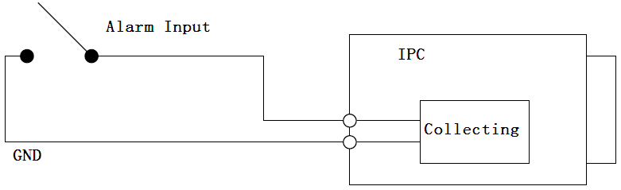

Figure 1‑5 Alarm input

Please refer to the following figures for alarm output information. See 6 and Figure 1-7.

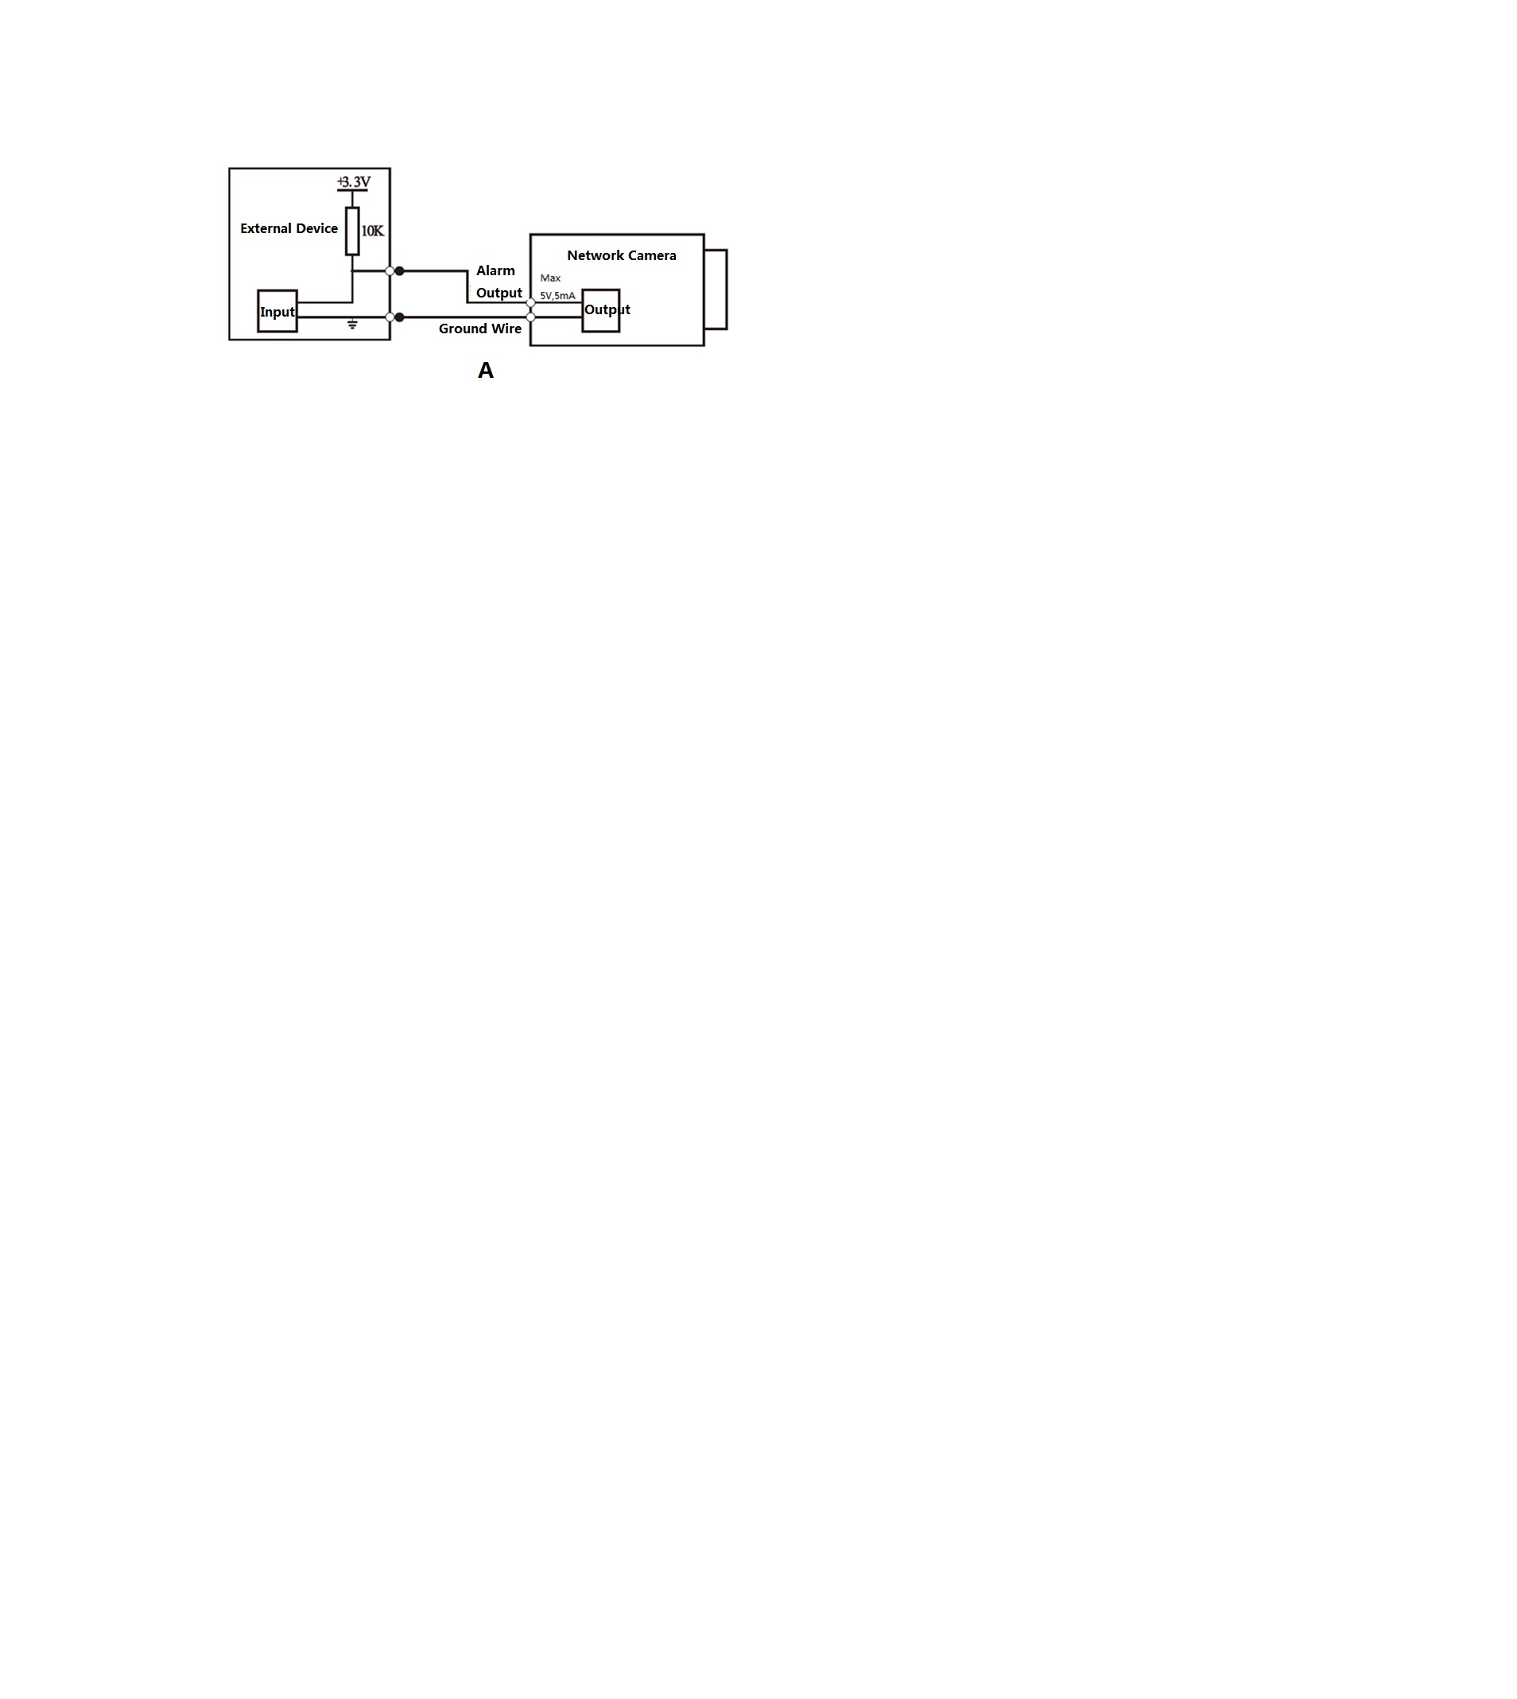

Figure 1‑6

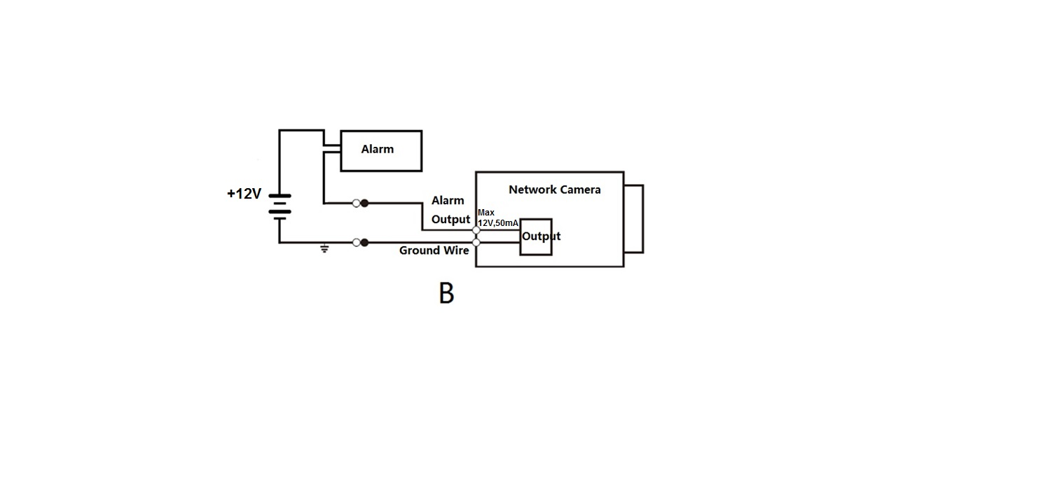

Figure 1-7

Mode A:

Level application. Alarm output high and low level, alarm output is OC; it needs to increase pull-up resistance externally to work normally. Max external pull-up level is 5V, max port current is 5mA. After external pull-up resistance is increased, the default of output signal is high level (external pull-up voltage), and it switches to low level when there is alarm output (when the working current is 5mA, output voltage is less than 0.8V).

Mode B:

Switch application. Alarm output is used to drive external circuit, max current is 50mA, max voltage is 12V (it can be applied together with alarm siren, acousto-optic alarm siren HC103) it is advised to add a relay if it is beyond the value.

# Device Installation

**Important**

**Please make sure the installation surface can min support the 3X weight of the camera and the bracket.**

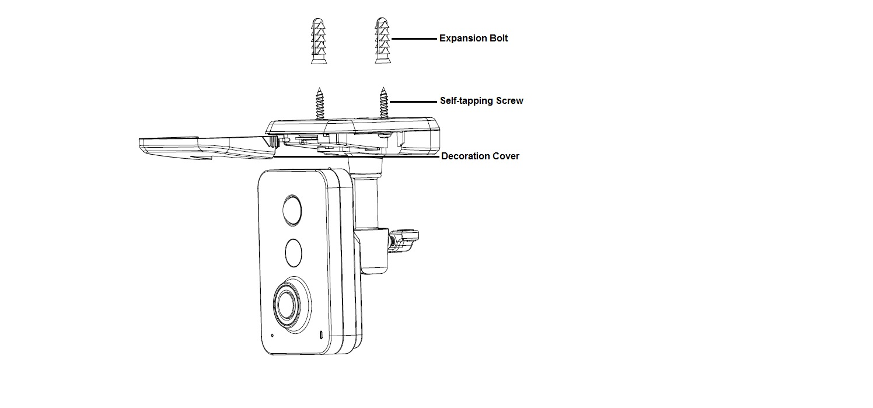

Figure 2-1

**Step 1**

Remove the decoration cover and dig two holes on the wall according to the holes on the pedestal.

**Step 2**

Insert the expansion bolts into the holes you just dug.

**Step 3**

Put the self-tapping screws into the expansion bolts and fix them firmly.

**Step 4**

Insert the 4G LTE card into the slot and put the decoration cover back in place.

**Step 5**

Loosen the adjusting knob for a little bit, adjust the camera to a proper monitoring position according to your practical requirements.

**Step 6**

Secure the knob of the bracket to fix the camera.

# Network Configuration

The IP address of all the cameras is the same when leaving factory (default IP192.168.1.108), in order to make the camera get access to the network smoothly, please plan the useable IP segment reasonably according to the actual network environment.

## Modify IP Address

IP address can be acquired and modified through quick configuration tool for the cameras which are accessed via wired network, it needs to connect wired network to configure wireless parameters before using wireless network cameras. In this chapter, it will introduce the approach of modifying IP address via “Quick Configuration Tool”; also you can modify the IP address in the network parameters of the WEB interface, please refer to the document in the disk << WEB Operation Manual>> for more details.

Note:

Currently the quick configuration tool only supports the cameras which apply to the same network segment with computer IP address.

Step 1 Double click the “ConfigTools.exe” and open the quick configuration tool.

Step 2 Double click the device to be configured, the system will pop out the “Login” dialog box. Enter the IP address, user name, password and port number of the camera, and click “Confirm”.

Note:

The default user name and password are admin and admin respectively, the default of port is

37777. See Figure 3-1 for more details.

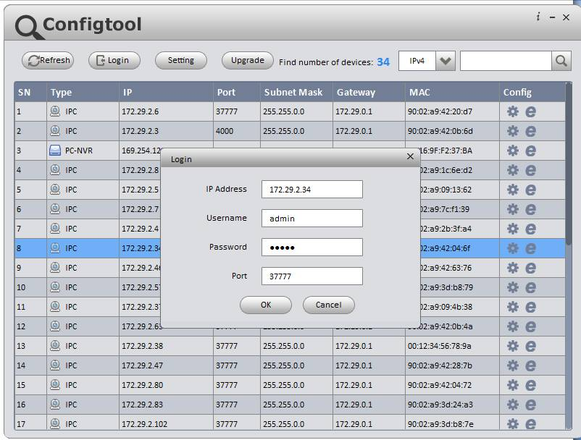

Figure 3-1

Step 3 Modify the camera IP address on the “Net” interface, click “Save” to finish modification.

See Figure 3-2 for more details.

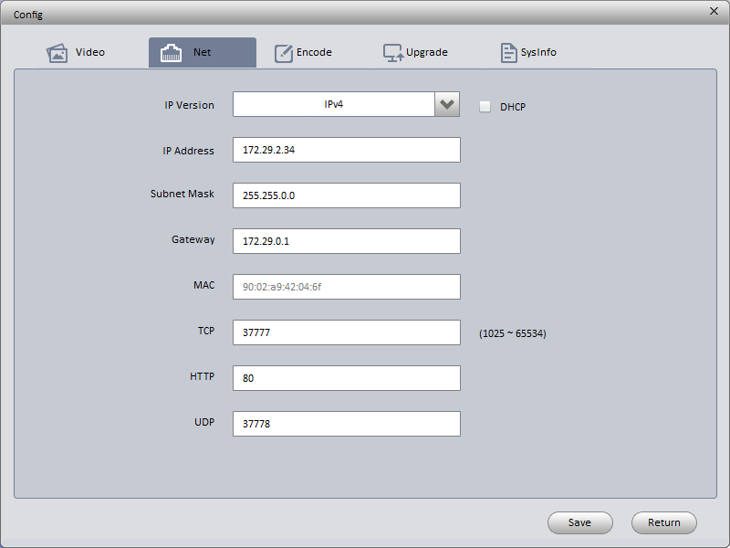

Figure 3-2

## Login WEB Interface

Note:

Different devices may have different WEB interfaces, the figures below are just for reference, please refer to the document <<WEB Operation Manual>> in the disk and the actual interface for more details

Step 1 Open IE and input the modified camera IP address in the address bar.

Step 2 The login interface is shown below, please input your user name and password (Default user name is admin and password is admin respectively), click “login”.

See Figure 3-3 for more details.

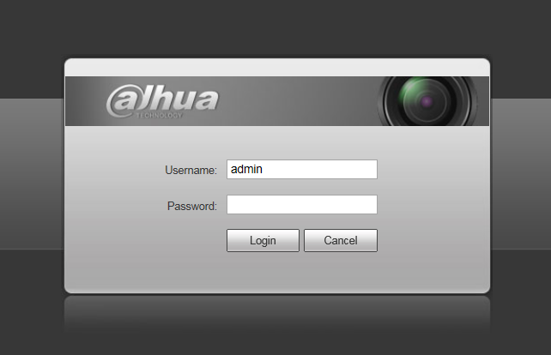

Figure 3-3

Step 3 Install controls according to the system prompt; see Figure 3-4 for the WEB main interface. Please modify the administrator password as soon as possible after you successfully logged in.

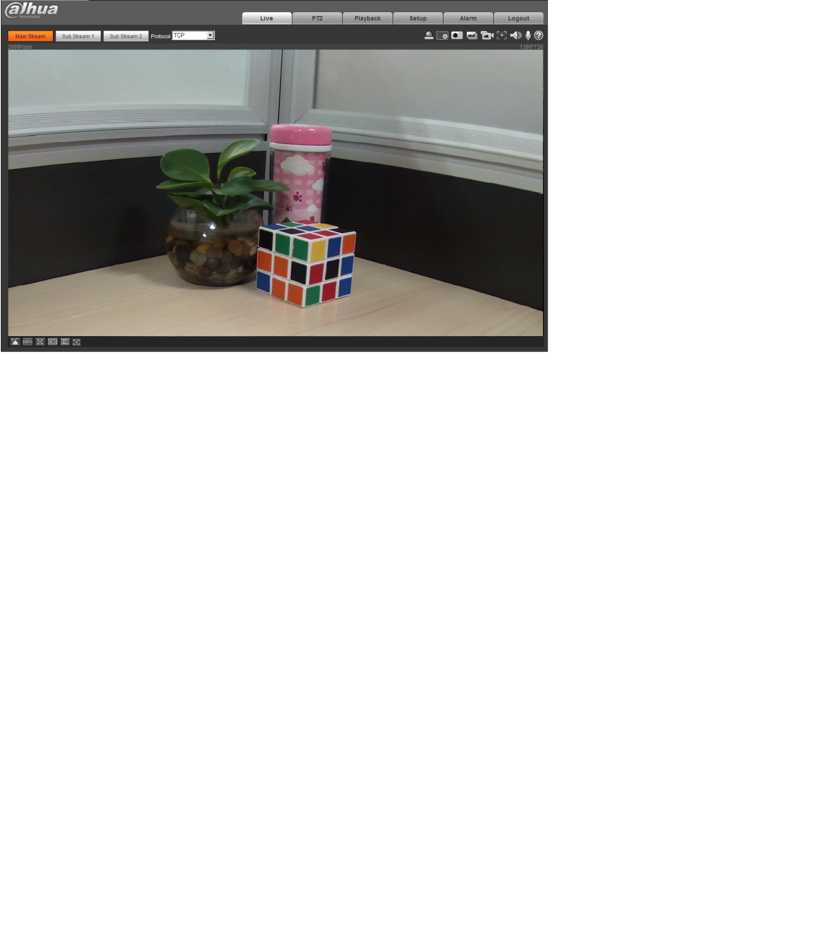

Figure 3-4

**Note:**

* **This quick start guide is for reference only. Slight difference may be found in user interface.**
* **All the designs and software here are subject to change without prior written notice.**
* **If there is any uncertainty or controversy, please refer to the final explanation of us.**
* **Please visit our website or contact your local service engineer for more information.**



**Dahua Technology Co., Ltd**

Address：No.1199 Bin’an Road, Binjiang District, Hangzhou, PRC.

Postcode: 310053

Tel: +86-571-87688883

Fax: +86-571-87688815

Email:overseas@dahuatech.com

Website: www.dahuasecurity.com