Dahua IR Wi-Fi Bullet Camera Quick Start Guide

V 1.0.1
Zhejiang Dahua Vision Technology CO., LTD

Packing List
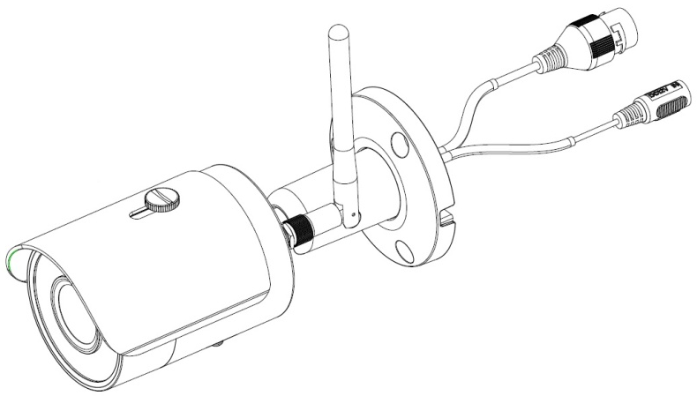
Device × 1

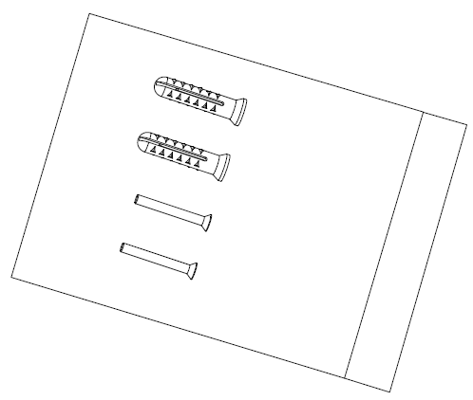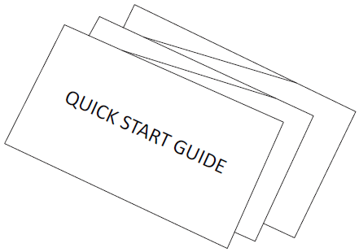
Screw Package ×1 QSG ×1

Product Appearance

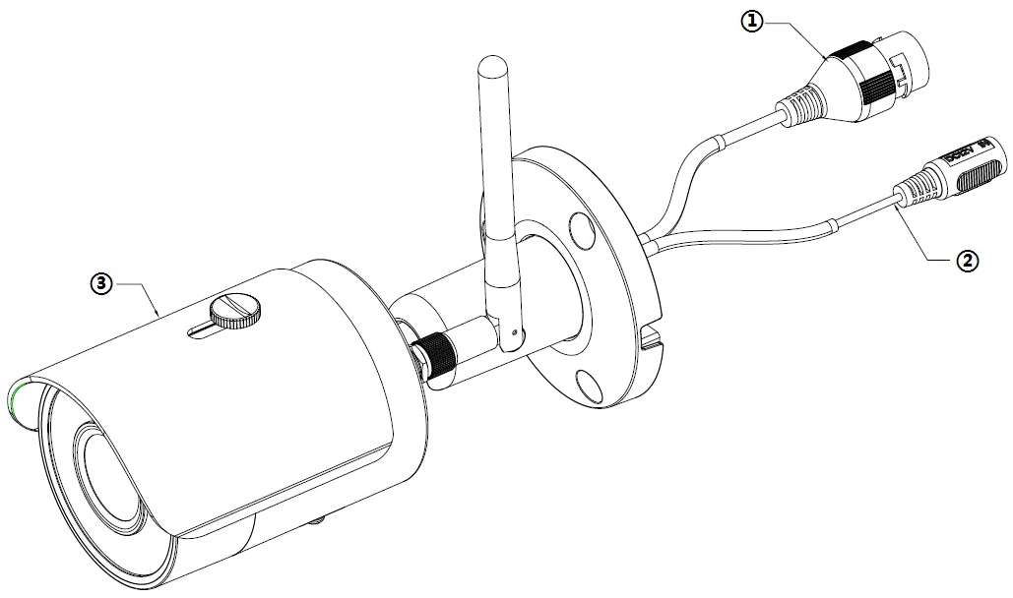
Figure 2-1

Please refer to the following sheet for more details about the device.
SN | Name
 | Network port
 | Power port
 | Unit device
Sheet 2-1

Figure 2-2
Please refer to the following sheet for more details about each component.

SN | Name
 | Reset/ WPS (Wi-Fi Protected Setup) button
 | Indicator light 1
 | Lower cover
 | Micro SD card slot
 | Indicator light 2
 | Waterproof ring
 | Wifi antenna
 | Locking screw

Sheet 2-2
Note:
For reset, long press for 8 seconds and then the light off; For WPS (Wi-Fi Protected Setup), one quick press.
Please refer to the following sheet for more details about status of indicator light.

Indicator light status | Device status
Red light normally on | Booting
Green light slow flashing | Booting completed, await wifi config, enter smart config status;
Green light quick flashing | Wifi smart config in progress, including WPS (Wi-Fi Protected Setup), management frame and etc.
Green light normally on | Wifi connection succeeded, operate normally.
Red and green lights flash alternately | Device upgrade
Red light slow flashing | Network connection failure or disconnection after network connection success.
Red light quick flashing | Device malfunction, fail to boot up; alarm or SD card malfunction
Sheet 2-3

Operate by Easy4ip APP
Step 1
Power on the device with power adapter.

Step 2
Connect your smart phone to your WiFi network. Scan the “Easy4ip APP” QR on the packing box, download and install the Easy4ip APP.

Step 3
Open Easy4ip APP (take IOS as an example), tap login to login the APP (Please register for first use).

Step 4
Tap “+” to add devices.
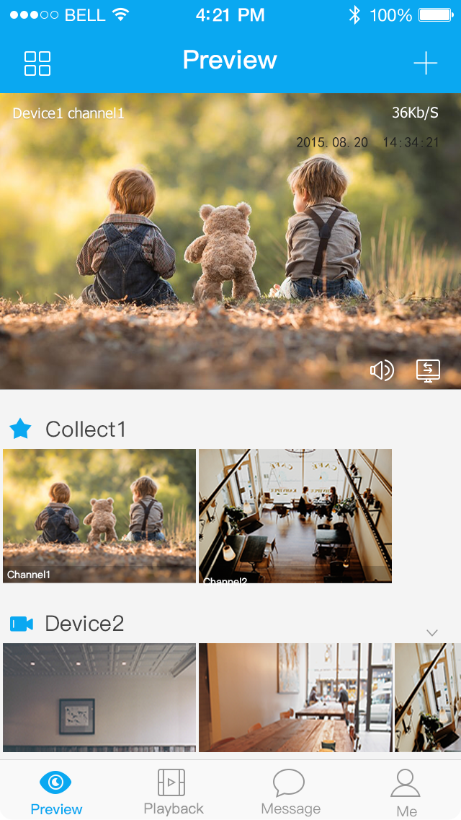
Figure 3-1
Step 5
Please select “Wired” when the network cable is connected, select “Wireless” for wireless connection. Here is an example of wireless connection.
Figure 3-2

Step 6
Name the camera and scan the QR code on camera.
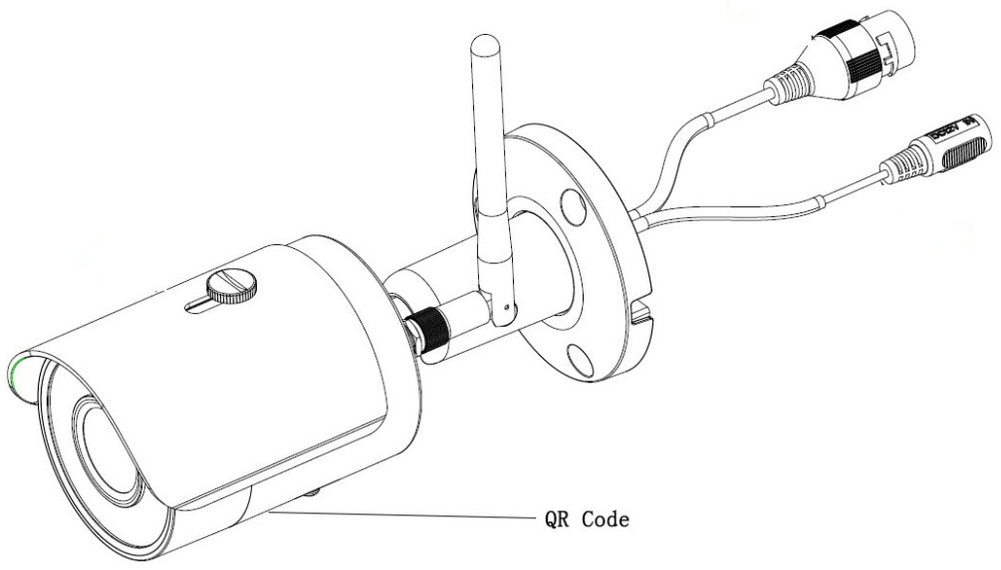

Figure 3-3
Figure 3-4
Step 7
Input the Wi-Fi password.
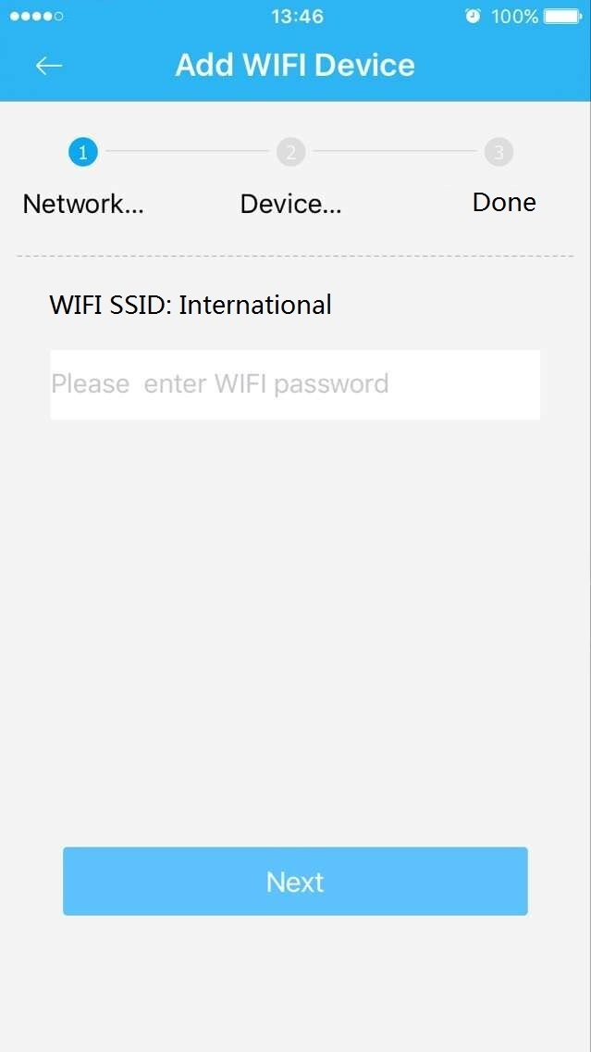
Figure 3-5
Step 8
Waiting for 60s to finish the Wi-Fi connection.
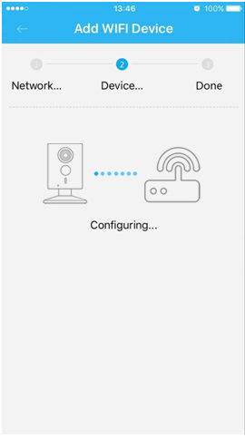
Figure 3-6

Note: If you want to change the Wi-Fi signal, please reset the camera to factory default and repeat step 5-8;

Device Installation
Important
Before the installation, please make sure the installation environment can at least support 3x weight of the camera.
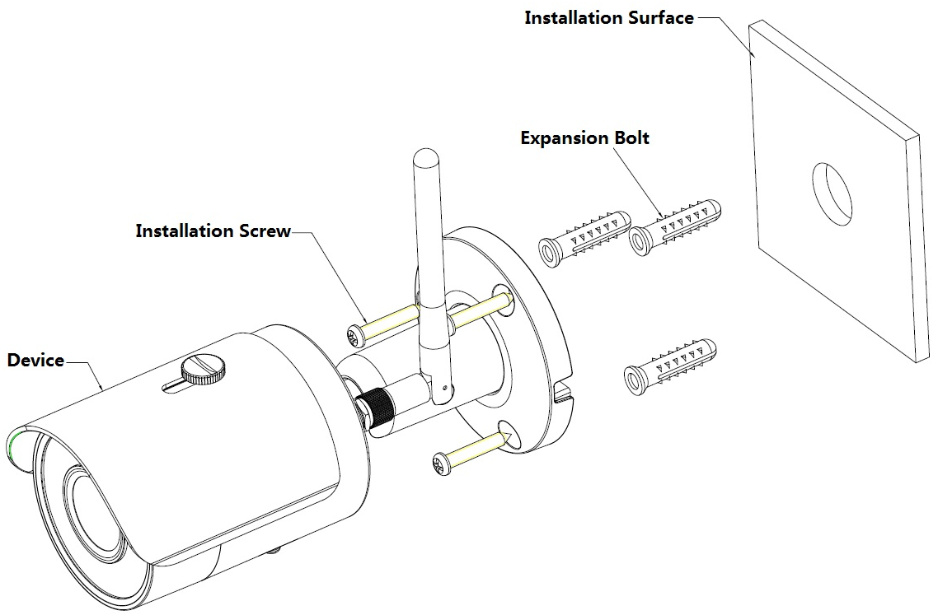
Figure 4-1
Please see Figure 4-1 and Figure 4-2.
Step 1
Dig holes on the installation surface (wall or ceiling).
Step 2
Open accessories bag, take out expansion bolt and insert it into the hole you just dug.
Step 3
Open accessories bag, take out installation screws. Tighten the screws to fix the device on the installation surface (wall or ceiling). You can move device sunshade back and forth. When you have fixed the device, you must tighten screws on sunshade.
Step 4
Plug external wiring of the device properly.
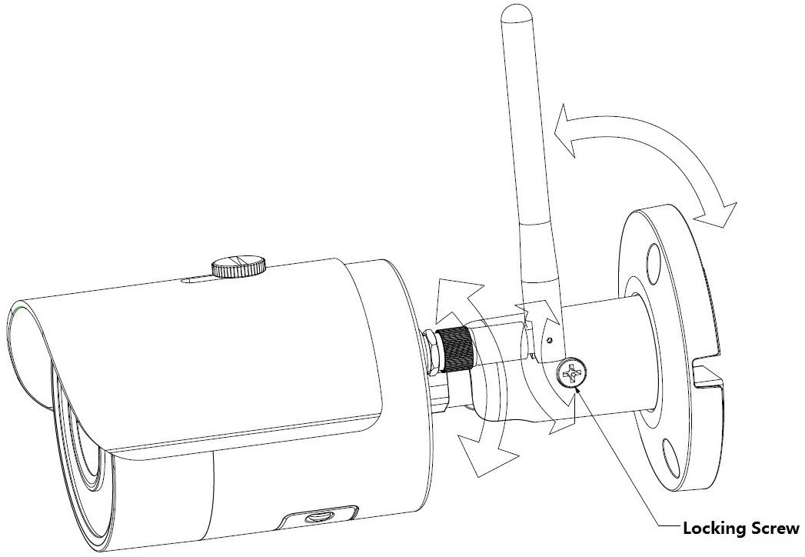
Figure 4-2
Step 5
Use cross screwdriver (in accessories bag) to loosen adjusting screw.
Step 6
Adjust the device in all possible directions, and set its monitoring direction according to the requirements.
Step 7
Use cross screwdriver to tighten the adjusting screws.

Note:
- This quick start guide is for reference only. Slight difference may be found in user interface.
- All the designs and software here are subject to change without prior written notice.
- All trademarks and registered trademarks mentioned are the properties of their respective
owners.
- If there is any uncertainty or controversy, please refer to the final explanation of us.
- Please visit our website or contact your local service engineer for more information.

Zhejiang Dahua Vision Technology Co., Ltd
Address：No.1199 Bin’an Road, Binjiang District, Hangzhou, PRC.
Postcode: 310053
Tel: +86-571-87688883
Fax: +86-571-87688815
Email:overseas@dahuatech.com
Website: www.dahuasecurity.com

