Dahua Vandal Proof Wi-Fi Dome Camera Quick Start Guide

V 1.0.1
Zhejiang Dahua Vision Technology CO., LTD

Packing List
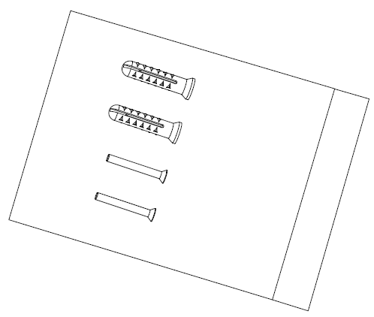
Device × 1 Screw Package ×1

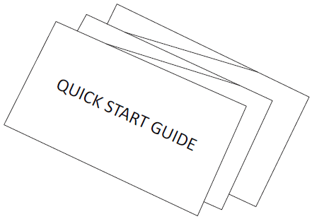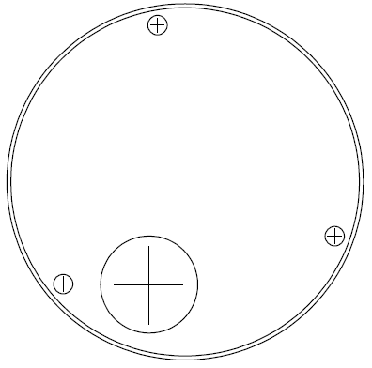
QSG ×1 Installation Position Map×1

Product Appearance

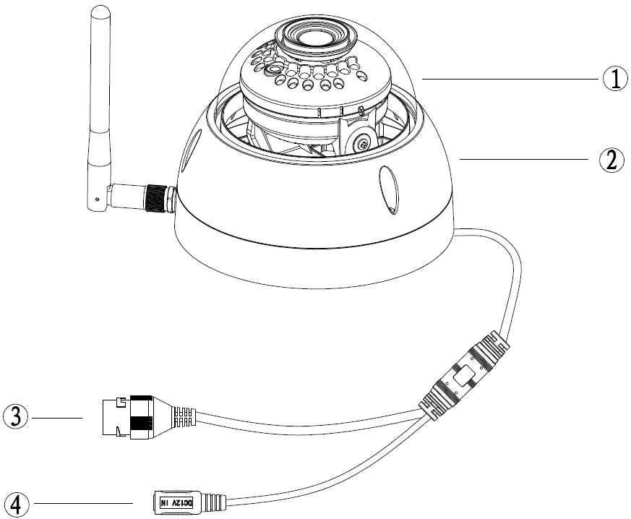
Figure 2-1

Please refer to the following sheet for more details about the device.
SN | Name
 | Dome cover
 | Dome enclosure
 | Network Port
④ | Power Port
Sheet 2-1
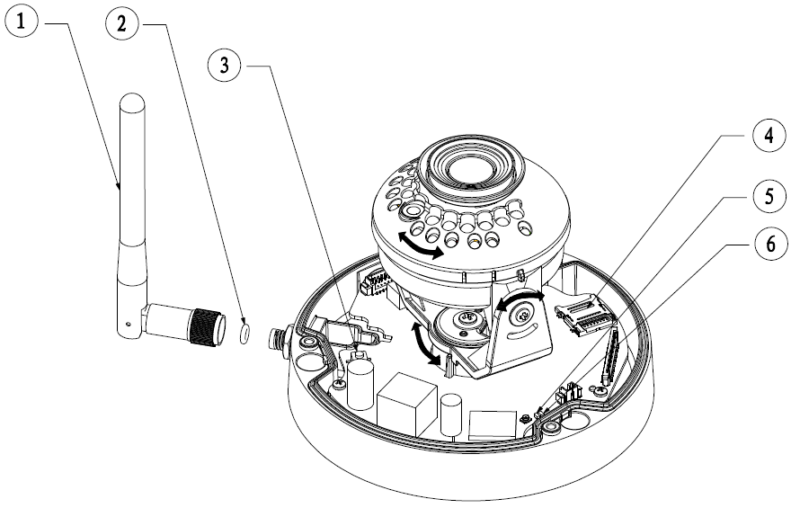
Figure 2-1
Please refer to the following sheet for more details about each component.
SN | Name
 | Wireless antenna
 | Waterproof ring
 | Reset/ WPS (Wi-Fi Protected Setup) button
 | Micro SD card slot
 | Indicator light 1
 | Indicator light 2

Sheet 2-2
Note:
For reset, long press for 8 seconds and then the light off; For WPS (Wi-Fi Protected Setup), one quick press.
Please refer to the following sheet for more details about status of indicator light.
Indicator light status | Device status
Red light normally on | Booting
Green light slow flashing | Booting completed, await wifi config, enter smart config status;
Green light quick flashing | Wifi smart config in progress, including WPS (Wi-Fi Protected Setup), management frame and etc.
Green light normally on | Wifi connection succeeded, operate normally.
Red and green lights flash alternately | Device upgrade
Red light slow flashing | Network connection failure or disconnection after network connection success.
Red light quick flashing | Device malfunction, fail to boot up; alarm or SD card malfunction
Sheet 2-3

Operate by Easy4ip APP
Step 1
Power on the device with power adapter.
Step 2
Connect your smart phone to your WiFi network. Scan the “Easy4ip APP” QR on the packing box, download and install the Easy4ip APP.
Step 3
Open Easy4ip APP (take IOS as an example), tap login to login the APP (Please register for first use).
Step 4
Tap “+” to add devices.
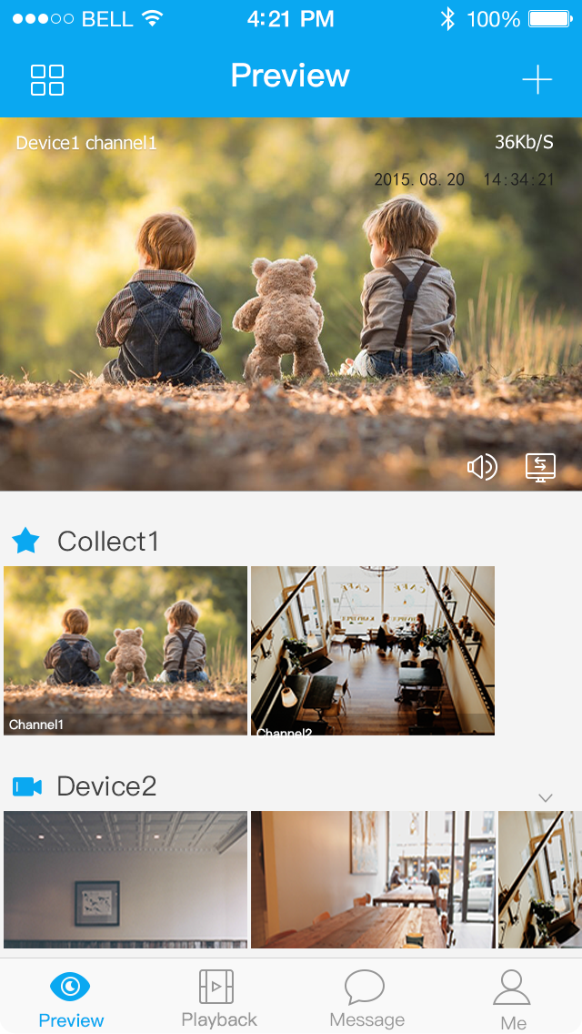
Figure 3-1
Step 5
Please select “Wired” when the network cable is connected, select “Wireless” for wireless connection. Here is an example of wireless connection.
Figure 3-2

Step 6
Name the camera and scan the QR code (on the bottom of the device chassis) on camera.
Figure 3-3
Step 7
Input the Wi-Fi password.
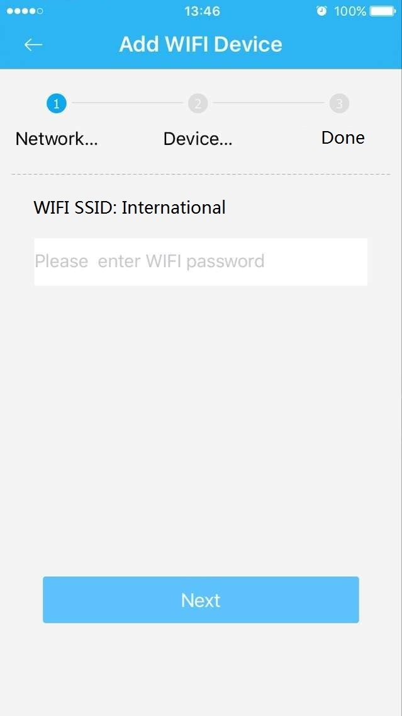
Figure 3-4
Step 8
Waiting for 60s to finish the Wi-Fi connection.
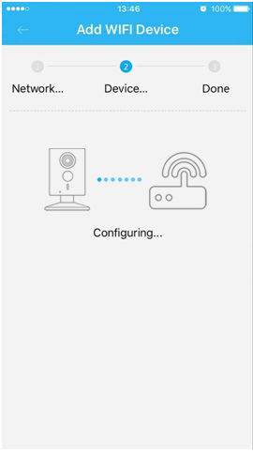
Figure 3-5

Note: If you want to change the Wi-Fi signal, please reset the camera to factory default and repeat step 5-8;

Device Installation
Important
Before the installation, please make sure the installation environment can at least support 3x weight of the camera.
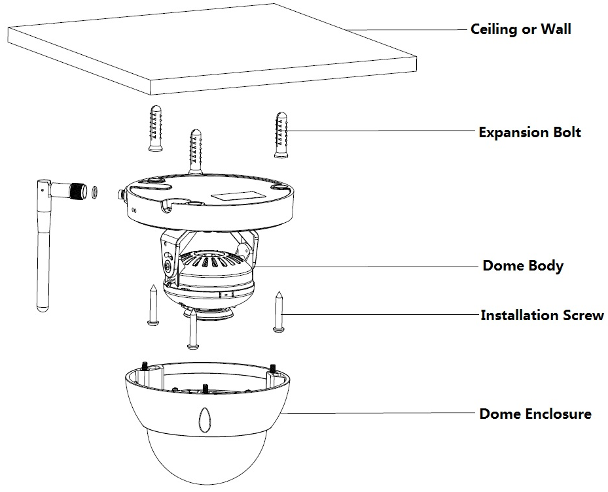
Figure 4-1
Step 1
Use inner hex wrench in the accessories bag to open dome enclosure by unfastening three inner hex screws on enclosure.
Step 2
Please take out the installation position map in the accessories bag, and then paste it on the ceiling or the wall according to your monitor area requirements.
Step 3
Find cross signs on the map, and dig three plastic expansion bolts holes on the installation surface and then insert three expansion bolts in the holes. Secure these three bolts firmly.
Note:
- If user pulls out cable from top of installation surface, you must dig an exit hole on installation surface according to the installation position map.
- If user pulls out cable from side of cable channel, it must go through the U-shape channel on dome pedestal, and take out cable from the side exit hole on pedestal.
Step 4
Adjust the device installation pedestal to the proper position and then pull cable through the exit hole on Installation surface. Make direction of TOP sign same as it on installation position map. Line up the three screw holes in the device pedestal to the three plastic expansion bolt holes in the installation position. Put the three self-tapping screws in the three plastic expansion bolts firmly. Fix dome body on installation surface.
Step 5
Hold both sides of the rotation bracket bottom with hands, rotate horizontally along the axis, and adjust lens horizontal direction to designated position. Hold the LED decoration cover with hand, rotate along the vertical direction, adjust the lens vertical direction to designated position; it is okay to loosen the fix screws on both sides of the bracket first if it is too tight to adjust (just make it loose, do not take it down), then adjust the lens, tighten the fix screws after adjustment. Hold the LED decoration cover with hands, rotate horizontally along the axis, and adjust the lens image to designated position. Range of lens: vertical (0°～+64°), horizontal (0°～+355°), image rotation direction (0°～+355°).

Note:
When it rotates to 64° vertically, please pay attention to the image rotation direction in order to avoid the outer cover blocking IR light and influencing IR effect.

Note:
- This quick start guide is for reference only. Slight difference may be found in user interface.
- All the designs and software here are subject to change without prior written notice.
- All trademarks and registered trademarks mentioned are the properties of their respective
owners.
- If there is any uncertainty or controversy, please refer to the final explanation of us.
- Please visit our website or contact your local service engineer for more information.

Zhejiang Dahua Vision Technology Co., Ltd
Address：No.1199 Bin’an Road, Binjiang District, Hangzhou, PRC.
Postcode: 310053
Tel: +86-571-87688883
Fax: +86-571-87688815
Email:overseas@dahuatech.com
Website: www.dahuasecurity.com

