Dahua 2-inch Network Speed Dome
Installation Manual

Version 1.0.1
Dahua Technology CO., LTD
Table of Contents
1 INTELLIGENT SPEED DOME INSTALLATION 1
1.1 Installation Environments 1
1.2 Check installation space and installation location intension 1
1.3 Please keep all package material well for future use 1
2 SETUP BEFORE INSTALLATION 2
2.1 Check Accessories 2
2.2 Open Device 2
2.3 Installation Position Map 2
2.4 SD Card Slot and Button 3
3 CAMERA INSTALLATION 4
3.1 Component Installation 4
3.2 Installation Steps 4
3.2.1 Installation Environments 5
3.2.2 Installation Steps 5
4 APPENDIX Ⅰ LIGHTENING PROTECTION AND SURGE PROTECTION 5
5 APPENDIX Ⅱ12V DC WIRE GAUGE AND TRANSMISSION DISTANCE RELATIONSHIP SHEET 7
6 APPENDIX Ⅲ WIRE GAUGE REFERENCE SHEET 8

Welcome
Thank you for purchasing our speed dome!
Please read the following safeguards and warnings carefully before you install or use the product!

Important Safeguards and Warnings
Safety Measures
1. Qualified Engineer Needed
- The installation engineer or maintenance engineer shall have corresponding CCTV system installation certificate or maintenance qualification certificate.
- The installation engineer or maintenance engineer shall have qualification certificate for work at height.
- The installation engineer or maintenance engineer shall have the basic knowledge and operation technique for low-voltage cable layout and low-voltage electronic cable connection.
- Please read the installation manual carefully and keep it well for future reference,
- We are not liable for any problems caused by unauthorized modifications or attempted repair.

2. Lifting Appliance Requirement
- Please select the proper speed dome installation mode and use the lifting appliances at the safety environment.
- The lifting appliances shall have the enough capacity to reach the installation height.
- The lifting appliances shall have safe performance.

The precaution measures include two types: Warning and Note.
- Warning: It is to alert you there is an optional risk of death or series injury!
- Note: It is to alert you there is an optional risk of damage or property loss!

Warning
- All installation and operation here should conform to your local electrical safety codes. We assume no liability or responsibility for all the fires or electrical shock caused by improper handling or installation.
- Be sure to use all the accessories (such as power adapter) recommended by manufacturer.
- Do not connect several speed domes to one power adapter. It may result in overheat or fire if it exceeds the rated load.
- Avoid aiming the lens at the strong radiation source directly (such as sun, laser, molten steel etc); in case it may cause unrecoverable damage to the thermal imaging detector. What’s worse, it may cause severe damage to the detector.
- Avoid oil stain and kinds of chemicals tarnishing and damaging the lens surface.
- Store the device in a cool and dry place where there is ventilation but no intense electromagnetic field.
- Violent vibration or crash is not allowed during transportation and application.
- Before you connect the cable, install or uninstall, or begin the daily maintenance work, please turn off the power and unplug the power cable.
- Please make sure the produce is secure firmly on the wall or the ceiling.
- Please turn off the power and unplug the power cable, If there is any smoke, disgusting smell, or noise. Please contact your local retailer or customer service centre for help.
- All the examination and repair work should be done by the qualified service engineers. We are not liable for any problems caused by unauthorized modifications or attempted repair.

Note
1. Safety Transportation
- Heavy stress, violent vibration or water splash are not allowed during transportation, storage and installation.
- This series product must use split type package during the transportation.
- We are not liable for any damage or problem resulting from the integrated package during the transportation.
2. When device is malfunction
Shut down the device and disconnect the power cable immediately if there is smoke, abnormal smell or abnormal function. Please contact your local retailer ASAP.

3. Do not try to dismantle or modify the device
- There is risk of personal injury or device damage resulting from opening the shell.
- Please contact your local retailer if there is internal setup or maintenance requirement.
- We are not liable for any problems caused by unauthorized modifications or attempted repair.

4. Do not allow other object falling into the device
- Please make sure there is no metal or inflammable, explosive substance in the speed dome.
- The above mentioned objects in the device may result in fire, short-circuit or damage.
- Please shut down the device and disconnect the power cable if there is water or liquid falling into the camera. Please contact your local retailer ASAP.
- Please pay attention to the camera. Avoid the sea water or rain to erode the camera.

5. Handle carefully
Do not allow this series product fall down to the ground.
Avoid heavy vibration.

6. Installation Environment Requirement
- This series speed dome should be installed in a cool, dry place away from direct sunlight, inflammable, explosive substances and etc.
- This series product shall be away from the strong electromagnetism radiant, please keep it away from wireless power, TV transmitter, transformer and etc.

7. Daily Maintenance
- Please use the soft cloth to clean dust on the shell, or you can use soft cloth with cleaning liquid to clean the shell and then use soft cloth to make it dry.
- Do not use gasoline, dope thinner or other chemical material to clean the shell. It may result in shell transfiguration or paint flake.
- Do not allow the plastic or rubber material to touch the shell for a long time. It may result in paint flake.

INTELLIGENT SPEED DOME INSTALLATION

Installation Environments
Basic Requirement
- All installation and operation here should conform to your local electrical safety codes.
- Before installation, please open the package and check all the components are included. Please make sure the speed dome installation environment and installation mode can meet your requirement. If there is special requirement, please contact your local retailer for more information.
- We assume no liability or responsibility for all the fires or electrical shock caused by improper handling or installation.

Check installation space and installation location intension
Please make sure the installation environment has enough space to install the speed dome and its corresponding bracket.
Please make sure the ceiling, wall and the bracket can support the speed dome and its corresponding installation component. It shall sustain the 8X weight of the speed dome.

Please keep all package material well for future use
Please keep speed dome package material well in case you need to send it back to your local retailer or manufacturer for maintenance work.
Non-original package material may result in device damage during the transportation.

SETUP BEFORE INSTALLATION

Check Accessories
Before the installation, please check the accessories one by one according to the packing list. Please make sure all the components listed are included. (Please check the container list for details.)

Open Device
Remove the package and then take out the device. See Figure 2-1.
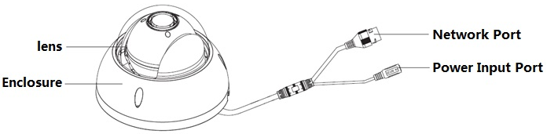
Figure 2-1

Installation Position Map
The installation position map is used for drilling positioning on the ceiling and outlet position. See Figure 2-2.
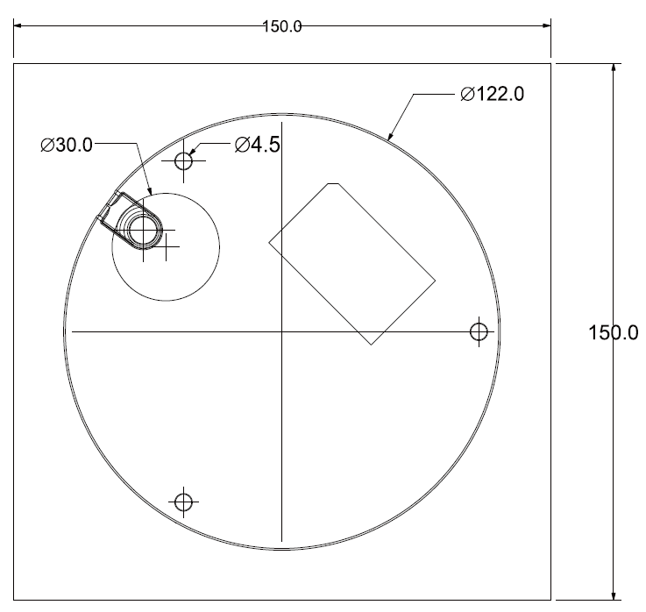
Figure 2-2

SD Card Slot and Reset Button
SD card slot and button is shown in Figure 2-3.
Please make sure the SD card is in the non read-write state when removing it. Otherwise, it may result in data loss and SD card damage. The button is used for default setting. Long press Reset button for more than 5 seconds, the system configuration information will be recovered to default setting.
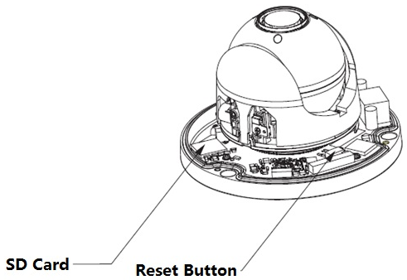
Figure 2-3

CAMERA INSTALLATION
2-inch network speed dome mainly adopts ceiling mount mode, which can be installed on the ceiling or wall.

Component Installation
The installation of pedestal seal ring is shown in Figure 3-1.
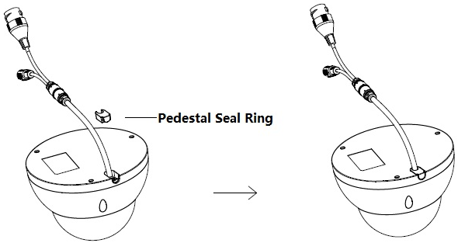
Figure 3-1
The ceiling mount speed dome is shown in Figure 3-2.
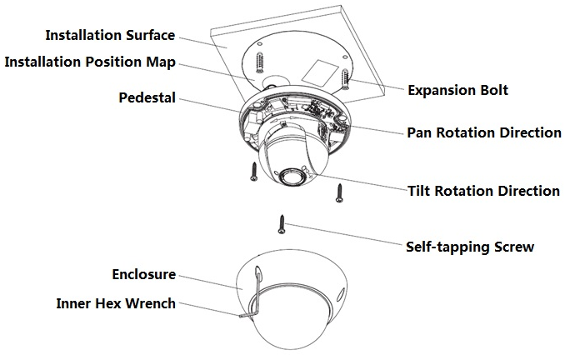
Figure 3-2

Installation Steps

Installation Environments
The ceiling mount speed dome can be installed in the hard construction ceiling in the indoor environment. Before the installation, please make sure:
- The ceiling is thick enough to install the expansion bolt.
- The ceiling can at least sustain the 8x weight of the speed dome.

Installation Steps
Note: There are two outlet modes for ceiling mount installation.
Don’t drill hole on the ceiling, and open wire outlet from the side of the speed dome.
Drill hole on the ceiling, and concealed wire outlet from the ceiling.

Step 1
Install the default pedestal seal ring on the pedestal according to the way shown in Figure 3-1.
Step 2
Confirm installation position and outlet mode first, dig holes on the ceiling according to the installation position map, and then put the three plastic expansion bolts into the holes you just dug.
Step 3
Unscrew three locking screws on the enclosure by using inner hex wrench, and remove the enclosure.
Step 4
Lay the outgoing line according to the outlet mode, and use three self-tapping screws to fix the pedestal on the installation surface, and insert the screws into the expansion bolts.
Step 5
Use three locking screws to fix the dome enclosure on the pedestal.
So far, the camera installation is completed, and you can adjust the lens angle, zoom, focus and etc on the WEB interface.

APPENDIX Ⅰ LIGHTENING PROTECTION AND SURGE PROTECTION
This series speed dome adopts TVS lighting protection technology. It can effectively prevent damages from various pulse signals below 2000W, such as sudden lighting and surge. While maintaining your local electrical safety code, you still need to take necessary precaution measures when installing the speed dome in the outdoor environment.

- The distance between the signal transmission cable and high-voltage device (or high-voltage cable) shall be at least 50 meters.
- Outdoor cable layout shall go under the penthouse if possible.
- For vast land, please use sealing steel tube under the land to implement cable layout and connects one point to the earth. Open floor cable layout is forbidden.
- In area of strong thunderstorm hit or near high sensitive voltage (such as near high-voltage transformer substation), you need to install additional high-power thunder protection device or lightning rod.
- The thunder protection and earth of the outdoor device and cable shall be considered in the building whole thunder protection and conform to your local national or industry standard.
- System shall adopt equal-potential wiring. The earth device shall meet anti-jamming and at the same time conforms to your local electrical safety code. The earth device shall not short circuit to N (neutral) line of high voltage power grid or mixed with other wires. When connect the system to the earth alone, the earth resistance shall not be more than 4Ω and earth cable cross-sectional area shall below 25 mm2.

APPENDIX Ⅱ12V DC WIRE GAUGE AND TRANSMISSION DISTANCE RELATIONSHIP SHEET
The recommended max transmission distance is under the following environments: The wire diameter is fixed and the DC 12V power voltage loss rate is below 10%. For the device of DC power supplying, the max allowed voltage loss rate is 10%. All the wires listed in the following sheet are copper wire. (Copper wire resistance)

mm  Feet（m）  w | 0.8000 | 1.000 | 1.250 | 2.000
5 | 122.13（37.23） | 190.83（58.16） | 298.17（90.88） | 763.31（232.66）
10 | 61.06（18.61） | 95.41（29.08） | 149.08（45.44） | 381.66（116.33）
15 | 40.71（12.41） | 63.61（19.39） | 99.39（30.29） | 254.44（77.55）
20 | 30.53（9.31） | 47.71（14.54） | 74.54（22.72） | 190.83（58.16）
25 | 24.43（7.45） | 38.17（11.63） | 59.63（18.18） | 152.66（46.53）
30 | 20.35（6.20） | 31.80（9.69） | 49.69（15.15） | 127.22（38.78）
35 | 17.45（5.32） | 27.26（8.31） | 42.60（12.98） | 109.04（33.24）
40 | 15.27（4.65） | 23.85（7.27） | 37.27（11.36） | 95.41（29.08）
45 | 13.57（4.14） | 21.20（6.46） | 33.13（10.10） | 84.81（28.85）
50 | 12.21（3.72） | 19.08（5.82） | 29.82（9.09） | 76.33（23.27）
55 | 11.10（3.38） | 17.35（5.29） | 27.11（8.26） | 69.39（21.15）
60 | 10.18（3.10） | 15.90（4.85） | 24.85（7.57） | 63.61（19.39）
65 | 9.39（2.86） | 14.68（4.47） | 22.94（6.99） | 58.72（17.90）
70 | 8.72（2.66） | 13.63（4.15） | 21.30（6.49） | 54.52（16.62）
75 | 8.14（2.48） | 12.72（3.88） | 19.88（6.06） | 50.89（15.51）
80 | 7.63（2.33） | 11.93（3.64） | 18.64（5.68） | 47.71（14.54）
85 | 7.18（2.19） | 11.23（3.42） | 17.54（5.35） | 44.90（13.69）
90 | 6.78（2.07） | 10.60（3.23） | 16.56（5.05） | 42.41（12.93）
95 | 6.43（1.96） | 10.04（3.06） | 15.69（4.78） | 40.17（12.25）
100 | 6.11（1.86） | 9.54（2.91） | 14.91（4.54） | 38.17（11.63）

APPENDIX Ⅲ WIRE GAUGE REFERENCE SHEET

Metric bare wire diameter  （mm） | AWG | SWG | Bare wire cross section  （mm²）
0.050 | 43 | 47 | 0.00196
0.060 | 42 | 46 | 0.00283
0.070 | 41 | 45 | 0.00385
0.080 | 40 | 44 | 0.00503
0.090 | 39 | 43 | 0.00636
0.100 | 38 | 42 | 0.00785
0.110 | 37 | 41 | 0.00950
0.130 | 36 | 39 | 0.01327
0.140 | 35 | / | 0.01539
0.160 | 34 | 37 | 0.02011
0.180 | 33 | / | 0.02545
0.200 | 32 | 35 | 0.03142
0.230 | 31 | / | 0.04115
0.250 | 30 | 33 | 0.04909
0.290 | 29 | 31 | 0.06605
0.330 | 28 | 30 | 0.08553
0.350 | 27 | 29 | 0.09621
0.400 | 26 | 28 | 0.1257
0.450 | 25 | / | 0.1602
0.560 | 24 | 24 | 0.2463
0.600 | 23 | 23 | 0.2827
0.710 | 22 | 22 | 0.3958
0.750 | 21 | / | 0.4417
0.800 | 20 | 21 | 0.5027
0.900 | 19 | 20 | 0.6362
1.000 | 18 | 19 | 0.7854
1.250 | 16 | 18 | 1.2266
1.500 | 15 | / | 1.7663
2.000 | 12 | 14 | 3.1420
2.500 | / | / | 4.9080
3.000 | / | / | 7.0683

Note
- This manual is for reference only. Slight difference may be found in the user interface.
- All the designs and software here are subject to change without prior written notice.
- All trademarks and registered trademarks are the properties of their respective owners.
- If there is any uncertainty or controversy, please refer to the final explanation of us.
- Please visit our website or contact your local service engineer for more information.



Dahua Technology Co., Ltd
Address：No.1199 Bin’an Road, Binjiang District, Hangzhou, PRC.
Postcode: 310053
Tel: +86-571-87688883
Fax: +86-571-87688815
Email:overseas@dahuatech.com
Website: www.dahuatech.com

