IR Intelligent Speed Dome Installation Manual

Version 1.0.2
Table of Contents
1 IR INTELLIGENT SPEED DOME INSTALLATION 1
1.1 Installation Preparation 1
1.2 Check Accessories 2
1.3 Open the Device 2
1.4 Dial Switch Setup 2
1.4.1 Dial Switch Address and Function 2
1.4.2 Dial Switch Setup 4
1.4.3 Address Setup 4
1.4.4 Baud Rate, Parity Setup, HD/SD Video Mode Setup 5
1.4.5 Terminal Matched Resistance Setup 6
1.5 Reset and SD Card Installation (network speed dome) 6
1.6 Speed Dome Installation 7
Note: 7
1.6.1 Quick Installation Connector 7
1.6.2 Cable Connection 8
1.6.3 Install the speed dome 9
2 BRACKET DIMENSIONS 11
2.1 Wall Mount Bracket 11
2.2 Hanging Mount Bracket (Multiple Lengths) 11
2.3 Corner Mount Bracket 12
2.4 Pole Mount Bracket 13
3 WALL MOUNT BRACKET INSTALLATION 15
3.1 Component Installation 15
3.2 Installation 15
3.2.1 Installation Requirements 15
3.2.2 Installation Steps 15
4 HANG MOUNT BRACKET INSTALLATION 18
4.1 Component Installation 18
4.2 Installation 18
4.2.1 Installation Requirements 18
4.2.2 Installation Steps 18
5 CORNER MOUNT BRACKET INSTALLATION 21
5.1 Component Installation 21
5.2 Installation 21
5.2.1 Installation Requirements 21
5.2.2 Installation Steps 21
6 POLE MOUNT BRACKET INSTALLATION 24
6.1 Installation 24
6.1.1 Installation Requirements 24
6.1.2 Installation Steps 24
7 APPENDIX Ⅰ LIGHTNING PROOF AND SURGE PROTECTION 27
8 APPENDIX Ⅱ ABOUT RS485 BUS 28
8.1 RS485 Bus Main Feature 28
8.2 RS485 Bus Transmission Distance 28
8.3 The Problem in Practical Use 28
8.4 RS485 Bus FAQ 29
9 APPENDIX Ⅲ THE RELATIONSHIP BETWEEN THE 24V AC CABLE DIAMETER AND THE TRANSMISSION DISTANCE 30
10 APPENDIX Ⅳ THE RELATIONSHIP BETWEEN THE 12V DC CABLE DIAMETER AND THE TRANSMISSION DISTANCE 32
11 APPENDIX IV WIRE GAUGE REFERENCE SHEET 34

Welcome
Thank you for purchasing our speed dome!
Please read the following safeguards and warnings carefully before you install or use the product!

Important Safeguards and Warnings
Safety Measures
1. Qualified Engineer Needed
- The installation engineer or maintenance engineer shall have corresponding CCTV system installation certificate or maintenance qualification certificate.
- The installation engineer or maintenance engineer shall have qualification certificate for work at height.
- The installation engineer or maintenance engineer shall have the basic knowledge and operation technique for low-voltage cable layout and low-voltage electronic cable connection.
- Please read the installation manual carefully and keep it well for future reference,
- We are not liable for any problems caused by unauthorized modifications or attempted repair.

2. Lifting Appliance Requirement
- Please select the proper speed dome installation mode and use the lifting appliances at the safety environment.
- The lifting appliances shall have the enough capacity to reach the installation height.
- The lifting appliances shall have safe performance.

The precaution measures include two types: Warning and Note.
- Warning: It is to alert you there is an optional risk of death or series injury!
- Note: It is to alert you there is an optional risk of damage or property loss!

Warning
- All installation and operation here should conform to your local electrical safety codes. We assume no liability or responsibility for all the fires or electrical shock caused by improper handling or installation.
- Be sure to use all the accessories (such as power adapter) recommended by manufacturer.
- Laser light is dangerous; please do not look at it straight.
- Do not connect several speed domes to one power adapter. It may result in overheat or fire if it exceeds the rated load.
- Before you connect the cable, install or uninstall, or begin the daily maintenance work, please turn off the power and unplug the power cable.
- Please make sure the produce is secure firmly on the wall or the ceiling.
- Please turn off the power and unplug the power cable, If there is any smoke, disgusting smell, or noise. Please contact your local retailer or customer service centre for help.
- All the examination and repair work should be done by the qualified service engineers. We are not liable for any problems caused by unauthorized modifications or attempted repair.

Note
1. Safety Transportation
- Heavy stress, violent vibration or water splash are not allowed during transportation, storage and installation.
- This series product must use split type package during the transportation.
- We are not liable for any damage or problem resulting from the integrated package during the transportation.
2. When device is malfunction
Shut down the device and disconnect the power cable immediately if there is smoke, abnormal smell or abnormal function. Please contact your local retailer ASAP.

3. Do not try to dismantle or modify the device
- There is risk of personal injury or device damage resulting from opening the shell.
- Please contact your local retailer if there is internal setup or maintenance requirement.
- We are not liable for any problems caused by unauthorized modifications or attempted repair.

4. Do not allow other object falling into the device
- Please make sure there is no metal or inflammable, explosive substance in the speed dome.
- The above mentioned objects in the device may result in fire, short-circuit or damage.
- Please shut down the device and disconnect the power cable if there is water or liquid falling into the camera. Please contact your local retailer ASAP.
- Please pay attention to the camera. Avoid the sea water or rain to erode the camera.

5. Handle carefully
Do not allow this series product fall down to the ground.
Avoid heavy vibration.

6. Installation Environment Requirement
- This series speed dome should be installed in a cool, dry place away from direct sunlight, inflammable, explosive substances and etc.
- This series product shall be away from the strong electromagnetism radiant, please keep it away from wireless power, TV transmitter, transformer and etc.

7. Daily Maintenance
- Please use the soft cloth to clean dust on the shell, or you can use soft cloth with cleaning liquid to clean the shell and then use soft cloth to make it dry.
- Do not use gasoline, dope thinner or other chemical material to clean the shell. It may result in shell transfiguration or paint flake.
- Do not allow the plastic or rubber material to touch the shell for a long time. It may result in paint flake.
- It is highly recommended to use the product with a lightning-proof device, which can realize better lightning-proof effect.

IR INTELLIGENT SPEED DOME INSTALLATION

Installation Preparation
Basic Requirement
- All installation and operation here should conform to your local electrical safety codes.
- Before installation, please open the package and check all the components are included. Please make sure the speed dome installation environment and installation mode can meet your requirement. If there is special requirement, please contact your local retailer for more information.
- We assume no liability or responsibility for all the fires or electrical shock caused by improper handling or installation.

Check installation space and installation location intension
Please make sure the installation environment has enough space to install the speed dome and its corresponding bracket.
Please make sure the ceiling, wall and the bracket can support the speed dome and its corresponding installation component. It shall sustain the 8X weight of the speed dome. Please notice that the installation height should be more than 6m if it is a laser speed dome.

About cable
Please select the cable according to your transmission distance.
The minimum video coaxial-cable requirement is:
- 75 ohm.
- Full cable with copper conductor
- 95% knitted copper shield
International Model | Max Distance  (Ft\M)
RG59/U | 750ft (229m)
RG6/U | 1,000ft (305m)
RG11/U | 1,500ft (457m)
- Please refer to appendix 2 for more information about RS485 communication cable.
Select proper power supply cable according to transmission distance
Refer to appendix 3 for 24VAC power supply device.
Refer to appendix 4 for 12VDC power supply device.

Please keep all package material well for future use
Please keep speed dome package material well in case you need to send it back to your local retailer or manufacturer for maintenance work.
Non-original package material may result in device damage during the transportation.

Check Accessories
Before the installation, please check the accessories one by one according to the packing list. Please make sure all the components listed are includes.

Open the Device
Please open the box and then take out the speed dome. See Figure 1-1.
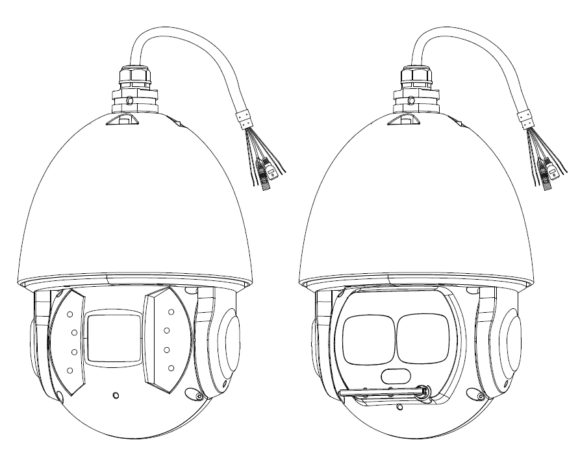
Figure 1-1
Note:
There are two types of IR intelligent speed dome which are shown in Figure 1-1, please refer to the actual object for details.
There is laser light and IR light on the laser speed dome, the laser light is used for light compensation while the IR light can be used to indicate whether the laser light is on or off, the laser light is enabled when the IR light is on.

Dial Switch Setup

Dial Switch Address and Function
The corresponding functions of dial switch for both analog speed dome and HDCVI speed dome are different, which will be introduced respectively.

Analog Speed Dome
Open the cover of the speed dome; you can see there are two dial switch buttons on the PTZ mainboard. You can use them to set speed dome address, baud rate and parity. Please refer to Figure 1-2 for the dial switch address.
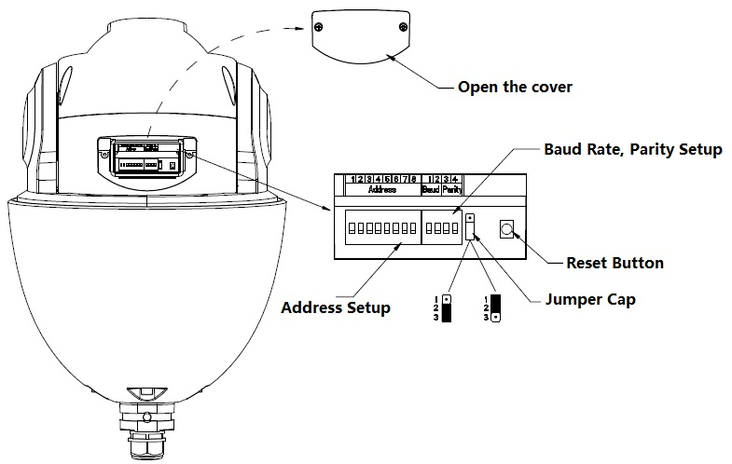
Figure 1-2

HDCVI Speed Dome
Open the cover of the speed dome; you can see there are two dial switch buttons on the PTZ mainboard. You can use them to set speed dome address, baud rate and HD/SD video mode. Please refer to Figure 1-3 for the dial switch address.
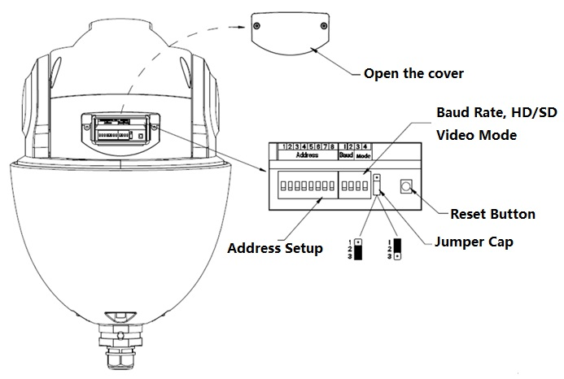
Figure 1-3
Note:
When HDCVI intelligent speed dome only uses coaxial control, dial-up and other related RS485 setup don’t have to be conducted.

Dial Switch Setup
Users must set the address, Baud rate or HD/SD video mode which is used by the speed dome before controlling it. Only after all these settings, can the speed dome respond to its control commands.
Note:
As for the wall-mounted speed dome, you need to install back the transparent cover component after taking out the EPE and setting the dial switch address.
Users must reboot the speed dome after resetting some specifications, which makes the new setup take effect.
There are two dial switch buttons on the speed dome PTZ which are used to confirm the speed dome address, baud rate, parity or HD/SD vide mode. It is 1 when you set the button as ON. For address setup dial switch, 1 is the lowest bit, 8 is the highest bit; for the Baud rate and parity setup dial switch, 1 is the lowest bit, 4 is the highest bit. (Intelligent speed dome self-adaptive PELCO-D, PELCO-P, industrial standard protocol, control protocol don’t need dial switch setup).

Address Setup
The speed dome uses dial switch to set address, the encode mode adopts binary system. 1 to 8 is valid bit. The highest address bit is 255; see Figure 1-4 for address and you can refer to the sheet 1-1 for more information.
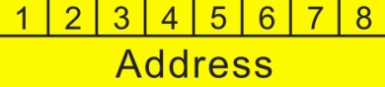
Figure 1-4
Address | 1 | 2 | 3 | 4 |  | 5 | 6 | 7 | 8
0 | OFF | OFF | OFF | OFF | OFF |  | OFF | OFF | OFF
1 | ON | OFF | OFF | OFF | OFF |  | OFF | OFF | OFF
2 | OFF | ON | OFF | OFF | OFF |  | OFF | OFF | OFF
3 | ON | ON | OFF | OFF | OFF |  | OFF | OFF | OFF
4 | OFF | OFF | ON | OFF | OFF |  | OFF | OFF | OFF
5 | ON | OFF | ON | OFF | OFF |  | OFF | OFF | OFF
6 | OFF | ON | ON | OFF | OFF |  | OFF | OFF | OFF
7 | ON | ON | ON | OFF | OFF |  | OFF | OFF | OFF
8 | OFF | OFF | OFF | ON | OFF |  | OFF | OFF | OFF
…… | …………………………………………………………………
254 | OFF | ON | ON | ON | ON |  | ON | ON | ON
255 | ON | ON | ON | ON | ON |  | ON | ON | ON
Sheet 1-1

Baud Rate, Parity Setup, HD/SD Video Mode Setup
The functions which need to be set are different for analog speed dome and HDCVI speed dome, which will be introduced respectively.

Analog Speed Dome
It is used to set speed dome Baud rate and parity. 1 and 2 bits are used to set Baud rate while 3 and 4 bits are used to set parity, see Figure 1-5.
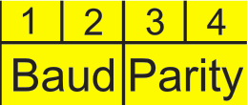
Figure 1-5
Please refer to the baud rate setup sheet1-2 for detailed information.
1 | 2 | Baud rate
OFF | OFF | 9600bps
ON | OFF | 4800bps
OFF | ON | 2400bps
ON | ON | 1200bps
Sheet 1-2
Please refer to the parity setup sheet 1-3 for detailed information.
3 | 4 | Parity
OFF | OFF | NONE
ON | OFF | EVEN
OFF | ON | ODD
ON | ON | NONE
Sheet 1-3

HDCVI Speed Dome
It is to set the speed dome baud rate and HD/SD video mode. From 1 to 4 dial switch, 1 and 2 bit are used to set Baud rate, 3 and 4 bit are used to set HD/SD video mode. See Figure 1-6 for Baud rate and mode; refer to sheet 1-4 and 1-5 for Baud rate and mode setup.
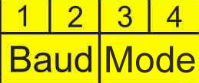
Figure 1-6
1 | 2 | Baud rate
OFF | OFF | 9600bps
ON | OFF | 4800bps
OFF | ON | 2400bps
ON | ON | 1200bps
Sheet 1-4
3 | 4 | HD/SD video mode
OFF | OFF | HD
ON | OFF | SD
OFF | ON | Self-adaptive
ON | ON | HD
Sheet 1-5

Terminal Matched Resistance Setup
The connection mode of device terminal 120Ω resistance is equipped on the power board. There are two connection modes which are shown in Figure 1-7.
Figure 1-7
The factory default connection mode is shown in Figure1-8; the jumper (connection board) is plugged into pin2 and pin 3, which means 120Ω resistance is not connected to the device.
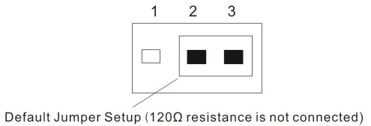
Figure 1-8
If you want to connect the 120Ω resistance, you have to pull the jumper out of pin 2 and pin 3, and connect to pin 1 and pin 2, then 120Ω resistance is connected to the circuit, see Figure 1-9.
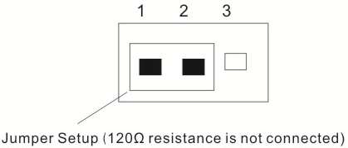
Figure 1-9

Reset and SD Card Installation (network speed dome)
You can see there is a RESET button and Micro-SD card slot on the PCB after you open the dial switch cover. See Figure 1-10. Reset button is used to reset network system. Micro-SD card is used to save the data.

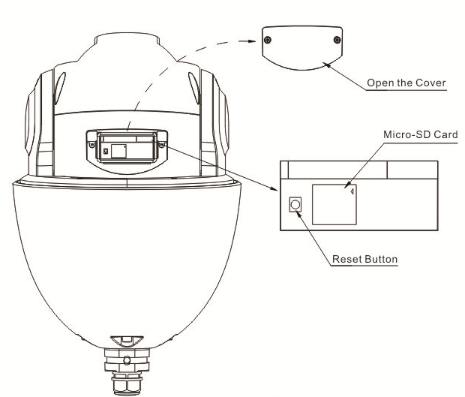
Figure 1-10

Speed Dome Installation

Note:
The installation of this section can be applied to IR Analog Intelligent and IR Network Intelligent Speed Dome.
The speed dome has various brackets suitable for different environments. For detailed information, please refer to chapter 2 to chapter 6. Here we are going to install the analog speed dome with the analog speed dome wall-mounted bracket.

Quick Installation Connector
Now you can install the quick installation connector. Please twist Teflon tape around the screw thread of the quick installation port and turn it into the screw thread of the wall mount bracket. Use M4 stainless screws to secure firmly. See Figure 1-11.

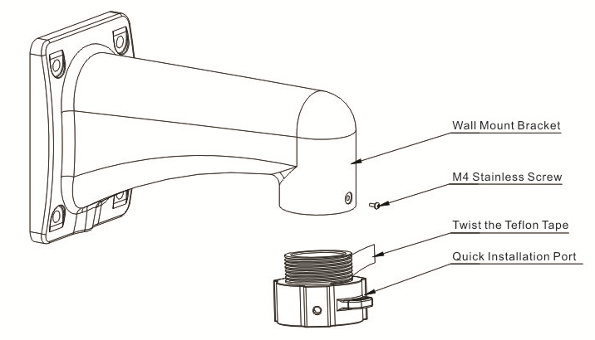
Figure 1-11

Cable Connection
- Connect the safety hook of the IR speed dome cover to the hook of the quick installation port.
- Connect the reserved integration cable of the wall mount bracket to the corresponding power cable, video/audio cable, RS485 control cable, alarm port, high frequency cable, fiber cable (if necessary) of the multiple-function composite cable of the IR speed dome. Paste the insulating tape in the connection position to do the proper waterproof work. See Figure 1-12.

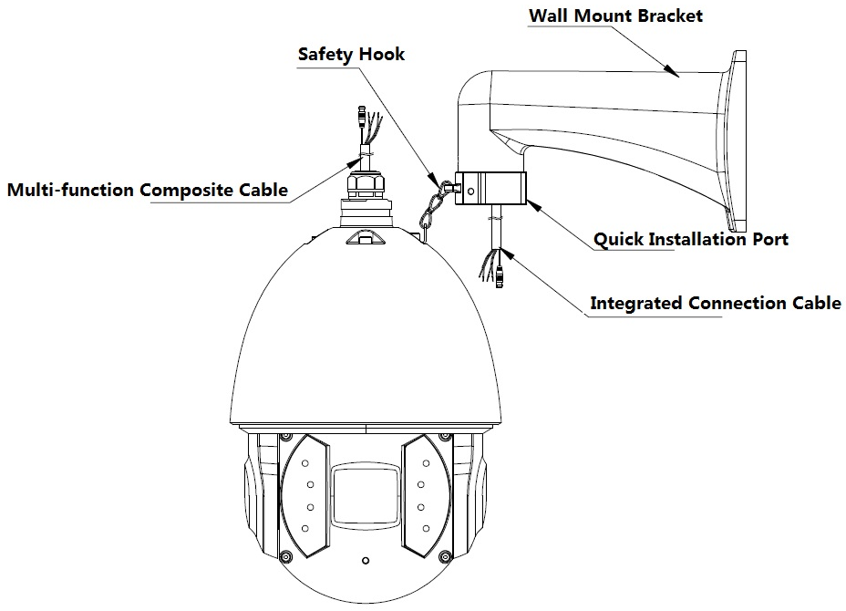
Figure 1-12
Note
The video port is covered the heat shrink tube of high shrinking ratio. After the video connection, please heat the tube to make sure the video port is damp proof and water proof.

Install the speed dome
Step 1
Pull the integration cable and multiple-function composite cable to the wall mount bracket slowly.
Step 2
Line up the straight edge of the flange of the IR speed dome to the straight edge of the quick installation port, and then push the speed dome to the bottom of the port slowly.
Step 3
Use your hands to turn the M6*14 stainless screw (with spring washer) to the Ф6.5 hole of the straight edge of the IR speed dome. Turn other two M6*14 stainless screws to groove of IR speed dome flange. Use the inner hex tool to fix these three stainless screws. Now you have completed the installation. See Figure 1-13.
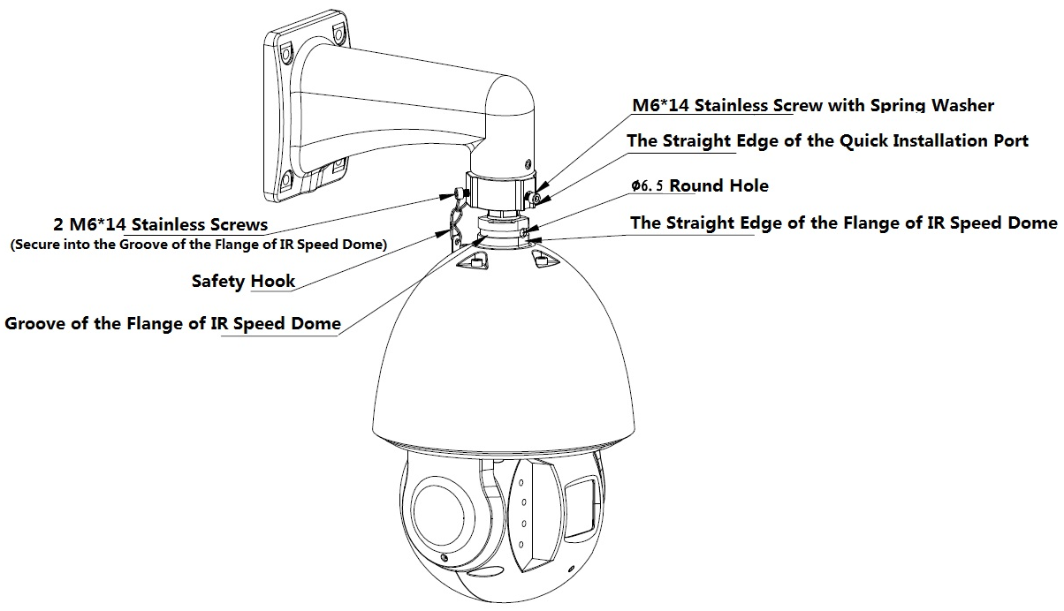
Figure 1-13
Step 4
Please make sure:
- The three stainless screws of the quick installation port are firmly secure.
- The IR speed dome is fixed.
- The speed dome is straight.
- The steel wire connection is firm.
After your installation, the interface is shown as in Figure 1-14.
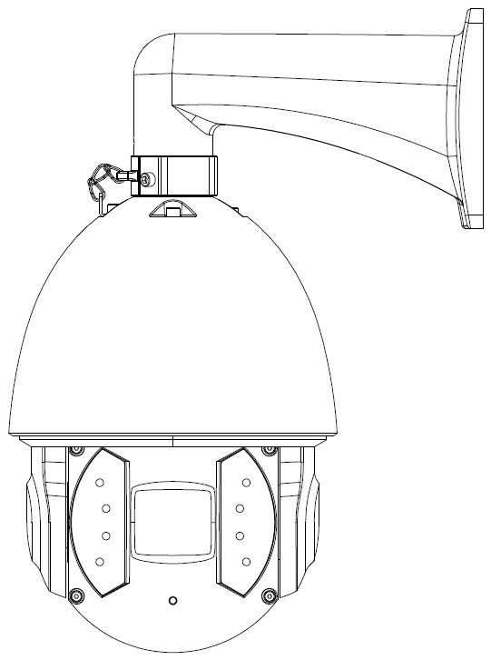
Figure 1-14

BRACKET DIMENSIONS

Wall Mount Bracket
The wall mount bracket dimensions are shown as below. See Figure 2-1.
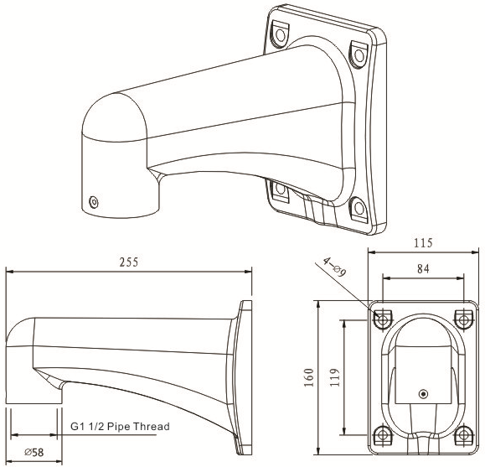
Figure 2-1

Hanging Mount Bracket (Multiple Lengths)
The hanging mount bracket is shown as below. See Figure 2-2.
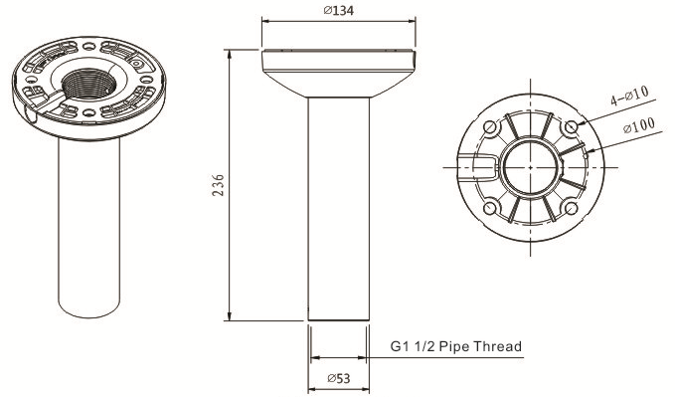
Figure 2-2
Note:
The bracket length setup values are:
200mm (default)
400mm (optional)
You just need to replace the connection pole

Corner Mount Bracket
The corner mount bracket is shown as below. See Figure 2-3.
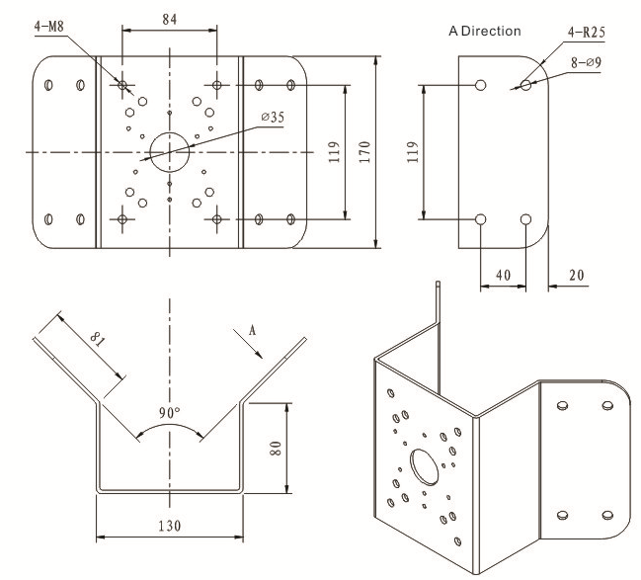
Figure 2-3

Pole Mount Bracket
The pole mount bracket is shown as below. See Figure 2-4.
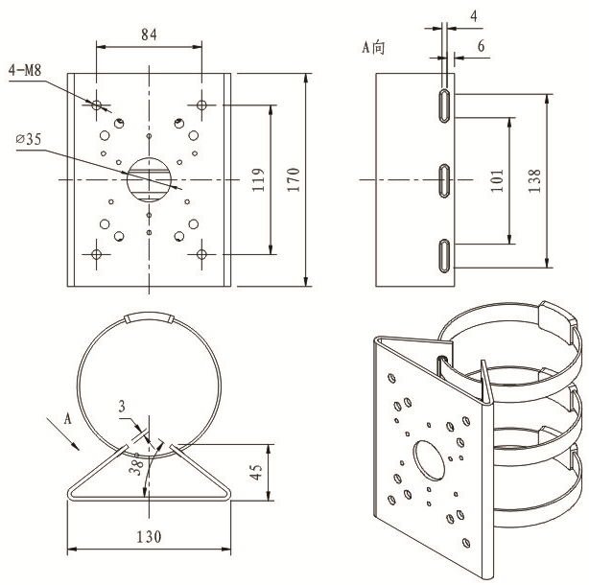
Figure 2-4

WALL MOUNT BRACKET INSTALLATION

Component Installation
Wall mount bracket is shown as below. See Figure 3-5.
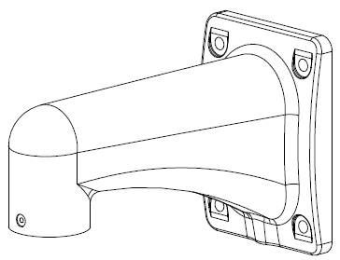
Figure 3-5

Installation

Installation Requirements
The wall mount speed dome can be installed in the hard construction wall in the indoor or outdoor environments. Before the installation, please make sure:
- The wall is thick enough to install the expansion bolt.
- The wall can at least sustain the 8x weight of the speed dome.

Installation Steps
Step 1
See Figure 3-6. Please draw four holes position in the wall according to the hole of the bottom of the wall mount bracket. Then you can dig four holes and insert the expansion bolts (not provided). Use four hex bolts and flat washer to fix the bracket in the expansion bolts.
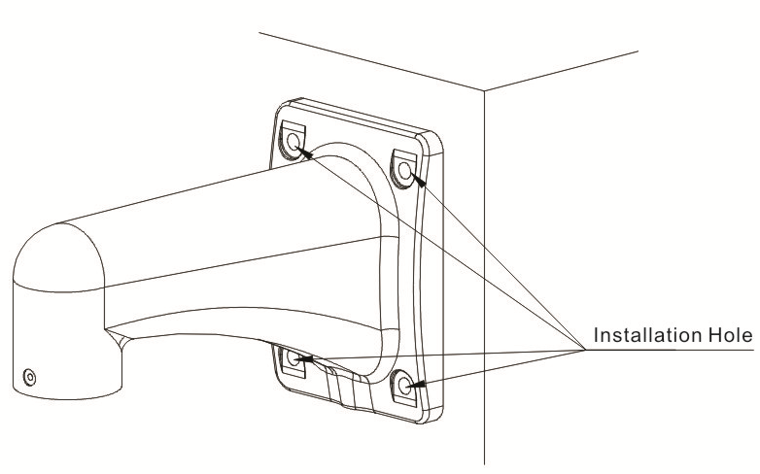
Figure 3-6
Step 2
Install the IR speed dome in the bracket. See Figure 3-7. Please refer to 1.6 Speed Dome Installation for more details.
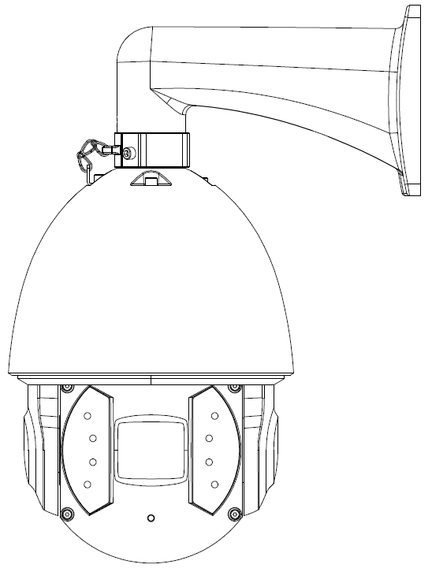
Figure 3-7

HANG MOUNT BRACKET INSTALLATION

Component Installation
Hang mount bracket and its components are shown as below. See Figure 4-8.
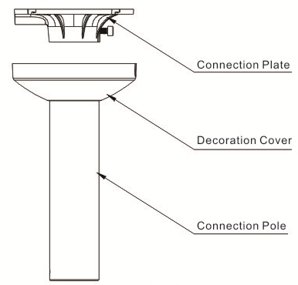
Figure 4-8

Installation

Installation Requirements
The hang mount speed dome can be installed in the hard construction wall in the indoor or outdoor environments. Before the installation, please make sure:
- The wall is thick enough to install the expansion bolt.
- The wall can at least sustain the 8x weight of the speed dome.

Installation Steps

Step 1
Loosen the M4 bolt in the connection plate to separate the connection plate and connection pole. Pull the integration cable through the airproof slot of the bottom of the connection plate and then connect to the centre hole of the flange. Please secure the connection plate in the ceiling. See Figure 4-2.
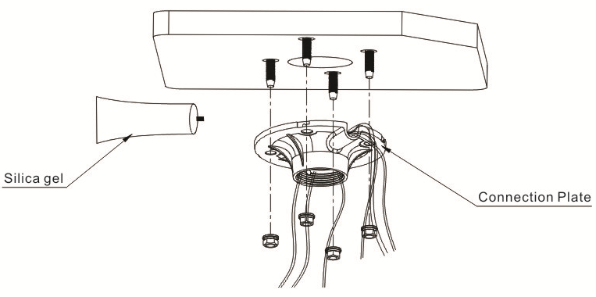
Figure 4-2
Please note, if the speed dome is installed in the outdoor environments, you need to paste the silica gel on the surface of the connection plate and the ceiling and the cable exit.

Step 2
Pull the cable through the connection pole and then secure the connection pole to the connection plate. Fix the M4 bolt. Push the decoration cover to the bottom. See Figure 4-3.
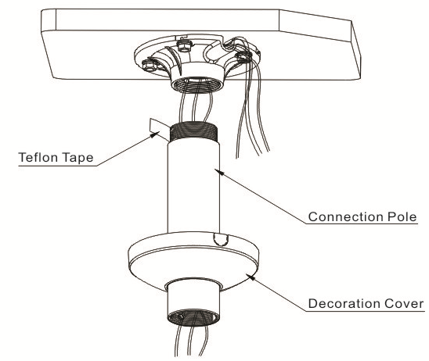
Figure 4-3
Please note, if the speed dome is installed in the outdoor environments, you need to paste enough Teflon tape at the top screw thread of the connection pole and then turn the connection pole to the connection plate firmly.

Step 3
Please refer to chapter 1.6 for detailed information about speed dome installation. See Figure 4-4.
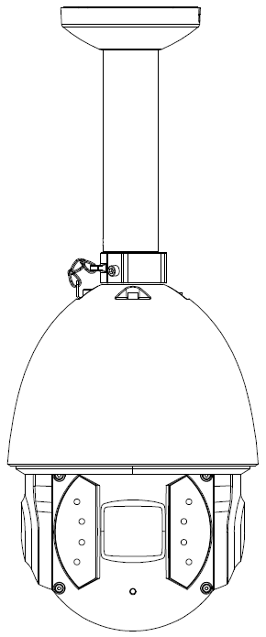
Figure 4-4

CORNER MOUNT BRACKET INSTALLATION

Component Installation
Corner mount bracket and its components are shown as below. See Figure 5-9.
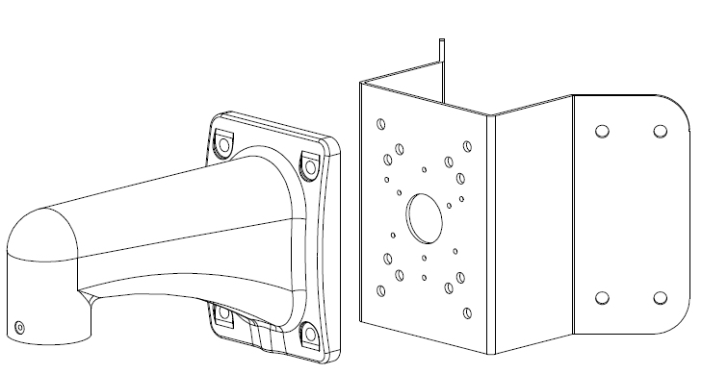
Figure 5-9

Installation

Installation Requirements
The corner mount speed dome can be installed in the hard construction wall in the indoor or outdoor environments where there is a 90 degrees angle. Before the installation, please make sure:
- The wall is thick enough to install the expansion bolt.
- The wall can at least sustain the 8x weight of the speed dome.

Installation Steps
Step 1
Please draw four holes position in the wall with a 90-degree angle according to the holes of the corner installation accessories. See Figure 5-2.Then you can dig four holes according to the holes of the corner mount accessories and insert the M8 expansion bolts. Pull the integration cable through the centre hole of the bottom of the corner bracket, the waterproof adhesive, and the centre of the bracket. Please reserve the enough cable connection length and then use the M8 expansion bolt to secure the corner mount bracket chassis on the wall.
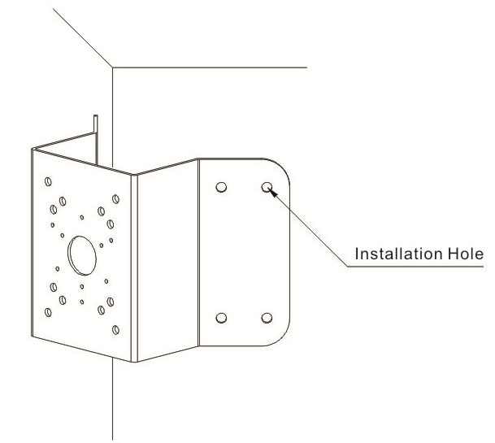

Figure 5-2
Step 2
Install speed dome according to Figure 5-3, please refer to 1.6 for more details about speed dome installation.
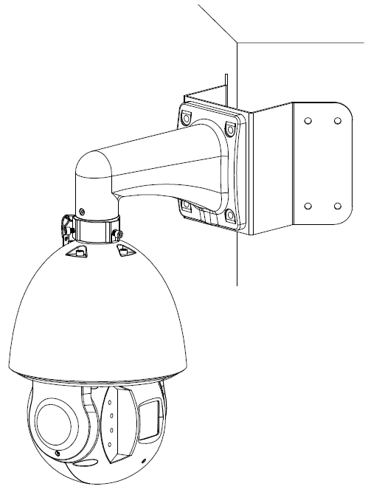
Figure 5-3

POLE MOUNT BRACKET INSTALLATION
Pole mount bracket and its components are shown as below. See Figure 6-10.
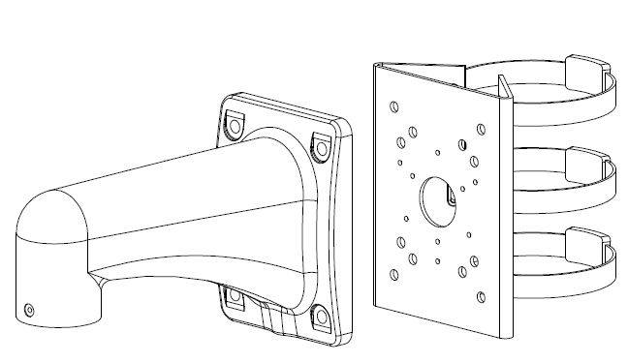
Figure 6-10

Installation

Installation Requirements
The pole mount speed dome can be installed in the hard construction wall in the indoor or outdoor environments.
Before the installation, please make sure:
The pole bracket can sustain the 8X weight of the speed dome.

The diameter of the pole structure shall comply with the installation dimension of the clamp. Default factory clamp is 5 inches for the column of φ80-130mm. It can work with the pole installation bracket. You can adjust the diameter and the value (clamp specification) is : φ59-82mm、φ84-108mm、φ80-130mm, φ130-152mm、φ155-178mm、φ180-203mm,φ194-216mm.
For special dimensions, please contact us for more information.

Installation Steps
Step 1
Please refer to Figure 6-2 to install clamp and pole bracket.
Pull the cable out of the pole accessories and then use clamp to fix the pole accessories to the pole. Finally, you can use glass cement to the output hole to secure waterproof.
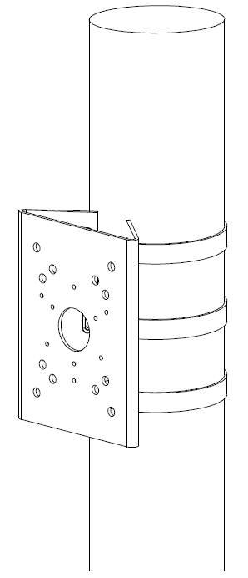
Figure 6-2
Note：
After the installation, please make sure the clamp is firmly secure in case it may result in clamp broken.
Step 2
Please refer to chapter 1.6 for detailed information about speed dome installation. See Figure 6-3.

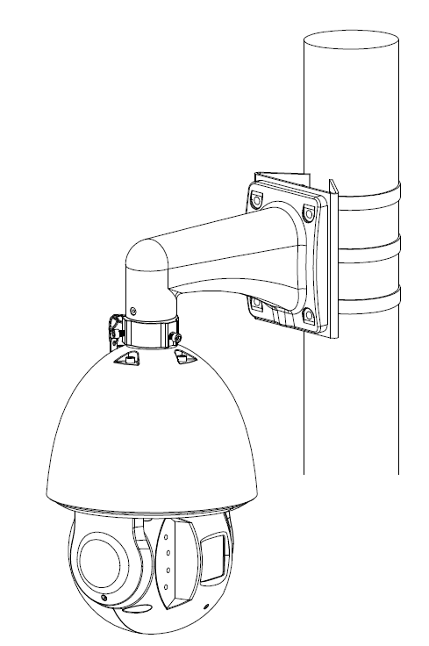

Figure 6-3

APPENDIX Ⅰ LIGHTNING PROOF AND SURGE PROTECTION
This series speed dome adopts TVS lighting protection technology. It can effectively prevent damages from various pulse signals below 6000W, such as sudden lighting and surge. While maintaining your local electrical safety code, you still need to take necessary precaution measures when installing the speed dome in the outdoor environment.

- The distance between the signal transmission cable and high-voltage device (or high-voltage cable) shall be at least 50 meters.
- Outdoor cable layout shall go under the penthouse if possible.
- For vast land, please use sealing steel tube under the land to implement cable layout and connects one point to the earth. Open floor cable layout is forbidden.
- In area of strong thunderstorm hit or near high sensitive voltage (such as near high-voltage transformer substation), you need to install additional high-power thunder protection device or lightning rod.
- The thunder protection and earth of the outdoor device and cable shall be considered in the building whole thunder protection and conform to your local national or industry standard.
- System shall adopt equal-potential wiring. The earth device shall meet anti-jamming and at the same time conforms to your local electrical safety code. The earth device shall not short circuit to N (neutral) line of high voltage power grid or mixed with other wires. When connect the system to the earth alone, the earth resistance shall not be more than 4Ω and earth cable cross-sectional area shall be below 25 mm². See Figure 7-1.
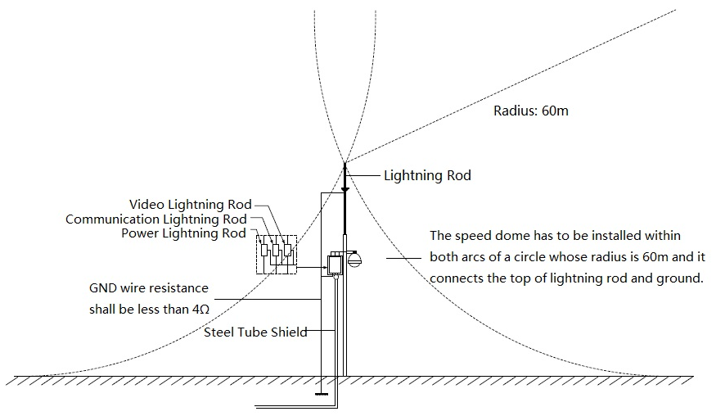
Figure 7-1

APPENDIX Ⅱ ABOUT RS485 BUS

RS485 Bus Main Feature
RS485 is semi duplex communication cable of impedance 120Ω. Its max load amount is 32 effective loads (including main control device and devices to be charged).

RS485 Bus Transmission Distance
When we take 0.56mm (24AWG) twisted-pair as communication cable, the max transmission distance (theoretically) are listed below (according to different baud rates).
Baud Rate | Max Distance
2400 BPS | 1800M
4800 BPS | 1200M
9600 BPS | 800M

In the following situations, the max transmission distance shall become shorter accordingly:
- The communication cable is a little bit thin;
- The surrounding environment has strong electromagnetic interference;
- There are too much devices connected to the RS485 bus;
And vice versa, the max transmission distance shall become longer.

The Problem in Practical Use
In practical usage, we usually adopt star type connection. The terminal resistance shall connect to the furthest two devices (Such as device 1# and device 15# in Figure 8-2 ). But this connection way does not conform to RS485 Bus standard. When the distances between devices are too long, the signal reflection occurs and anti-jamming decreases, thus the signal reliability becomes very low. You can see speed dome is not under control or speed dome is running automatically and can not stop.

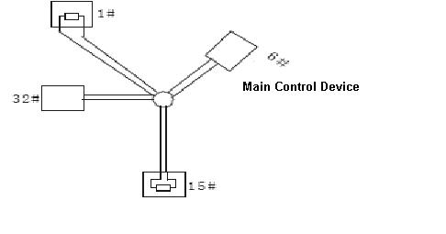
Figure 8-2
In this situation, we recommend RS485 distributor. This device can turn star type connection into the connection that conforms to RS485 bus industry standard, which can avoid the above mentioned problems and enhance communication reliability. See Figure 8-3.
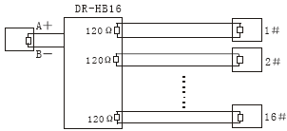
Figure 8-3

RS485 Bus FAQ
Phenomenon | Possible Reasons | Solution
Speed dome can run self-diagnosis but I can not control it. | - Host address(baud rate) and speed dome address(baud rate) are not match;  - Positive and negative end of RS485 Bus are misconnected;  - Connection cable is loose；  - RS485 Bus connection are cut off; | - Modify host or speed dome setup ；  - Switch RS485 positive end and negative end；  - Fix connection cable firmly；  - Replace RS485 Bus.
I can control the speed dome but is not smooth | - RS485 Bus connection are not good；  - One RS485 bus is off；  - The distance between host and speed dome is too far；  - Parallel connected too much speed domes. | - Connect RS 485 Bus again；  - Replace RS485 Bus；  - Add terminal matching resistance；  - Add RS485 distributor.

APPENDIX Ⅲ THE RELATIONSHIP BETWEEN THE 24V AC CABLE DIAMETER AND THE TRANSMISSION DISTANCE
It is the recommended transmission distance when the cable diameter is fixed and the 24V AC power consumption is below 10%. For the AC device, the max permission voltage power consumption is 10%. For example, when a device of rated power 20W installed from the transformer 141 inches (42m), then the min cable diameter is 0.8000mm.

mm  Feet（m）  w | 0.8000 | 1.000 | 1.250 | 2.000
5 | 488.52（148.90） | 763.31（232.66） | 1192.67（363.53） | 3053.25（930.63）
10 | 244.26（74.45） | 381.66（116.33） | 596.34（181.76） | 1526.62（465.31）
15 | 162.84（49.63） | 254.44（77.55） | 397.56（121.18） | 1017.75（310.21）
20 | 122.13（37.23） | 190.83（58.16） | 298.17（90.88） | 763.31（232.66）
25 | 97.70（29.78） | 152.66（46.53） | 238.53（72.71） | 610.65（186.13）
30 | 81.42（24.82） | 127.22（38.78） | 198.78（60.59） | 508.87（155.10）
35 | 69.79（21.27） | 109.04（33.24） | 170.38（51.93） | 436.18（132.95）
40 | 61.06（18.61） | 95.41（29.08） | 149.08（45.44） | 381.66（116.33）
45 | 54.28（16.54） | 84.81（25.85） | 132.52（40.39） | 339.25（103.40）
50 | 48.85（14.89） | 76.33（23.27） | 119.27（36.35） | 305.32（93.06）
55 | 44.41（13.54） | 69.39（21.15） | 108.42（33.05） | 277.57（84.60）
60 | 40.71（12.41） | 63.61（19.39） | 99.39（30.29） | 254.44（77.55）
65 | 37.58（11.45） | 58.72（17.90） | 91.74（27.96） | 234.87（71.59）
70 | 34.89（10.64） | 54.52（16.62） | 85.19（25.97） | 218.09（66.47）
75 | 32.57（9.93） | 50.89（15.51） | 79.51（24.24） | 203.55（62.04）
80 | 30.53（9.31） | 47.71（14.54） | 74.54（22.72） | 190.83（58.16）
85 | 28.74（8.76） | 44.90（13.69） | 70.16（21.38） | 179.60（54.74）
90 | 27.14（8.27） | 42.41（12.93） | 66.26（20.20） | 169.62（51.70）
95 | 25.71（7.84） | 40.17（12.25） | 62.77（19.13） | 160.70（48.98）
100 | 24.43（7.45） | 38.17（11.63） | 59.63（18.18） | 152.66（46.53）

APPENDIX Ⅳ THE RELATIONSHIP BETWEEN THE 12V DC CABLE DIAMETER AND THE TRANSMISSION DISTANCE
It is the recommended transmission distance when the cable diameter is fixed and the 12V DC power consumption is below 10%. For the DC device, the max permission voltage power consumption is 10%. The cables used in the following sheet are all copper wires. (the resistivity of copper is )
mm  Feet（m）  w | 0.8000 | 1.000 | 1.250 | 2.000
5 | 122.13（37.23） | 190.83（58.16） | 298.17（90.88） | 763.31（232.66）
10 | 61.06（18.61） | 95.41（29.08） | 149.08（45.44） | 381.66（116.33）
15 | 40.71（12.41） | 63.61（19.39） | 99.39（30.29） | 254.44（77.55）
20 | 30.53（9.31） | 47.71（14.54） | 74.54（22.72） | 190.83（58.16）
25 | 24.43（7.45） | 38.17（11.63） | 59.63（18.18） | 152.66（46.53）
30 | 20.35（6.20） | 31.80（9.69） | 49.69（15.15） | 127.22（38.78）
35 | 17.45（5.32） | 27.26（8.31） | 42.60（12.98） | 109.04（33.24）
40 | 15.27（4.65） | 23.85（7.27） | 37.27（11.36） | 95.41（29.08）
45 | 13.57（4.14） | 21.20（6.46） | 33.13（10.10） | 84.81（28.85）
50 | 12.21（3.72） | 19.08（5.82） | 29.82（9.09） | 76.33（23.27）
55 | 11.10（3.38） | 17.35（5.29） | 27.11（8.26） | 69.39（21.15）
60 | 10.18（3.10） | 15.90（4.85） | 24.85（7.57） | 63.61（19.39）
65 | 9.39（2.86） | 14.68（4.47） | 22.94（6.99） | 58.72（17.90）
70 | 8.72（2.66） | 13.63（4.15） | 21.30（6.49） | 54.52（16.62）
75 | 8.14（2.48） | 12.72（3.88） | 19.88（6.06） | 50.89（15.51）
80 | 7.63（2.33） | 11.93（3.64） | 18.64（5.68） | 47.71（14.54）
85 | 7.18（2.19） | 11.23（3.42） | 17.54（5.35） | 44.90（13.69）
90 | 6.78（2.07） | 10.60（3.23） | 16.56（5.05） | 42.41（12.93）
95 | 6.43（1.96） | 10.04（3.06） | 15.69（4.78） | 40.17（12.25）
100 | 6.11（1.86） | 9.54（2.91） | 14.91（4.54） | 38.17（11.63）

APPENDIX IV WIRE GAUGE REFERENCE SHEET
Metric bare wire diameter  （mm） | AWG | SWG | Bare wire cross section  （mm²）
0.050 | 43 | 47 | 0.00196
0.060 | 42 | 46 | 0.00283
0.070 | 41 | 45 | 0.00385
0.080 | 40 | 44 | 0.00503
0.090 | 39 | 43 | 0.00636
0.100 | 38 | 42 | 0.00785
0.110 | 37 | 41 | 0.00950
0.130 | 36 | 39 | 0.01327
0.140 | 35 |  | 0.01539
0.160 | 34 | 37 | 0.02011
0.180 | 33 |  | 0.02545
0.200 | 32 | 35 | 0.03142
0.230 | 31 |  | 0.04115
0.250 | 30 | 33 | 0.04909
0.290 | 29 | 31 | 0.06605
0.330 | 28 | 30 | 0.08553
0.350 | 27 | 29 | 0.09621
0.400 | 26 | 28 | 0.1257
0.450 | 25 |  | 0.1602
0.560 | 24 | 24 | 0.2463
0.600 | 23 | 23 | 0.2827
0.710 | 22 | 22 | 0.3958
0.750 | 21 |  | 0.4417
0.800 | 20 | 21 | 0.5027
0.900 | 19 | 20 | 0.6362
1.000 | 18 | 19 | 0.7854
1.250 | 16 | 18 | 1.2266
1.500 | 15 |  | 1.7663
2.000 | 12 | 14 | 3.1420
2.500 |  |  | 4.9080
3.000 |  |  | 7.0683

Note
- This manual is for reference only. Slight difference may be found in the user interface.
- All the designs and software here are subject to change without prior written notice.
- All trademarks and registered trademarks are the properties of their respective owners.
- If there is any uncertainty or controversy, please refer to the final explanation of us.
- Please visit our website or contact your local service engineer for more information.

