Dahua Network Speed Dome Web3.0 Operation Manual

Version 1.0.0
Dahua Technology CO., LTD
Table of Contents
1 Network Config 1
1.1 Network Connection 1
1.2 Log in 1
2 Live 5
2.1 Encode Setup 5
2.2 System Menu 6
2.3 Video Window Function Option 6
2.4 Video Window Setup 7
2.4.1 Image Adjustment 7
2.4.2 Original Size 8
2.4.3 Full Screen 8
2.4.4 Width and Height Ratio 8
2.4.5 Fluency Adjustment 8
2.4.6 Rule Info 8
2.4.7 PTZ 8
2.5 PTZ Configuration 9
2.5.1 PTZ Control 9
2.5.2 Virtual Joystick 9
2.5.3 PTZ Function 10
3 Playback 12
3.1 Playback 12
3.1.1 Function of Play 13
3.1.2 Playback File 13
3.1.3 Playback Cut (Clip) 16
3.1.4 Record Type 16
3.1.5 Progress Bar Time Format 16
3.1.6 Assistant Function 17
3.2 Picture Playback 17
3.2.1 Play 18
3.2.2 Playback File 18
3.2.3 Snapshot Type 19
4 Setup 20
4.1 Camera 20
4.1.1 Conditions 20
4.1.2 Video 28
4.2 IVS Setup 35
4.2.1 Global Setup 35
4.2.2 Scene Setup 36
4.2.3 Rule Setup 38
4.2.4 Parameter Setup 44
4.3 Network 45
4.3.1 TCP/IP 45
4.3.2 ONVIF 47
4.3.3 Connection 48
4.3.4 PPPoE 50
4.3.5 DDNS 51
4.3.6 IP filter 53
4.3.7 SMTP （e-mail) 54
4.3.8 UPnP 55
4.3.9 SNMP 56
4.3.10 Bonjour 59
4.3.11 Multicast 59
4.3.12 WIFI 60
4.3.13 802.1x 62
4.3.14 QoS 62
4.4 PTZ 63
4.4.1 Function 63
4.5 Event 73
4.5.1 Video detect 73
4.5.2 Abnormality 76
4.6 Storage Management 79
4.6.1 Schedule 79
4.6.2 Destination 83
4.6.3 Record control 85
4.7 System 86
4.7.1 General 86
4.7.2 Account 87
4.7.3 Default 91
4.7.4 Import/Export 92
4.7.5 Auto Maintenance 92
4.7.6 Upgrade 93
4.8 Information 94
4.8.1 Version 94
4.8.2 Log 94
4.8.3 Online User 95
5 Alarm 96
6 Log out 97

Important
The following functions are for reference only. Some series products may not support all the functions listed below.

Network Config

Network Connection
Speed dome and PC connection mainly has two ways. See Figure 1-1 and Figure 1-2.
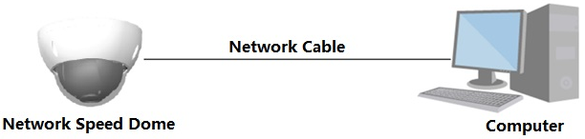
Figure 1-1
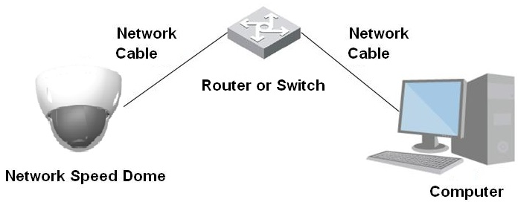
Figure 1-2
Before you access speed dome via the Internet, you need to have its IP address. You can use quick config tool to search IP of the speed dome. Please refer to Quick Configuration Tool manual.

Log in
Open IE and input speed dome address in the address bar.
For example, if your speed dome IP is 192.168.1.108, then please input http:// 192.168.1.108 in IE address bar. See Figure 1-3.

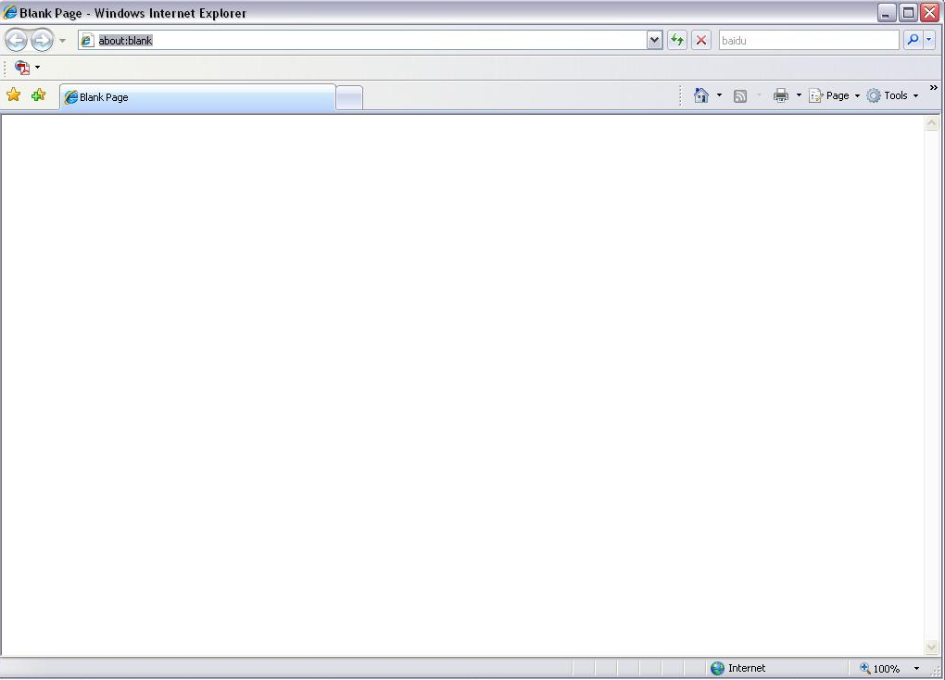
Input your IP address here
Figure 1-3
The login interface is shown as below. See Figure 1-4.
Please input your user name and password.
Default factory username is admin and password is admin.
Note: For security reasons, please modify your password after you first login.
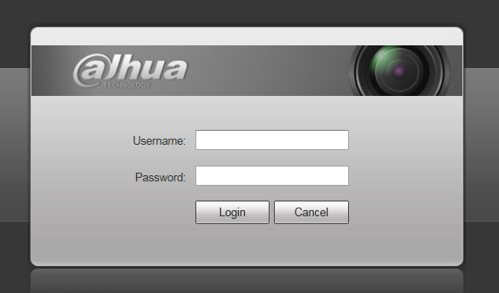
Figure 1-4
If it is your first time to login in, you may see the interface shown as in Figure 1-5.
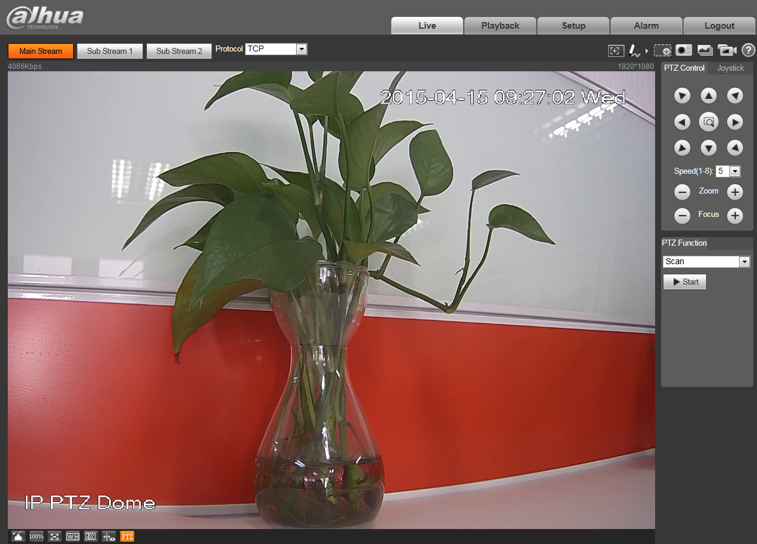
Figure 1-5
Click “Please click here to download and install the plug-in”. The system pops up warning information to ask you whether run or save this plug-in. Please download to your local computer and then click webplugin.exe; you can see an interface shown as in Figure 1-6.
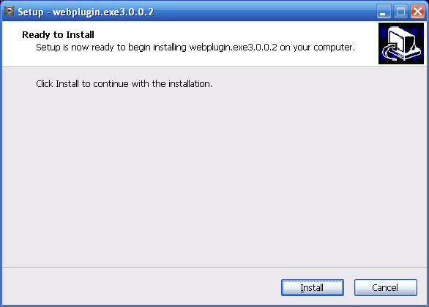
Figure 1-6
Click install, you will see Figure 1-7.
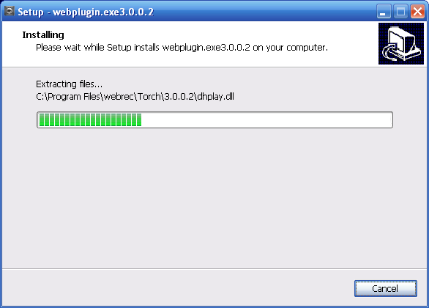
Figure 1-7
When plug-in installation is complete, the installation page closes automatically. The web-end will refresh automatically, and then you can view video captured by the camera.

Live
After you logged in, you can see the live monitor window. See Figure 2-8.
2
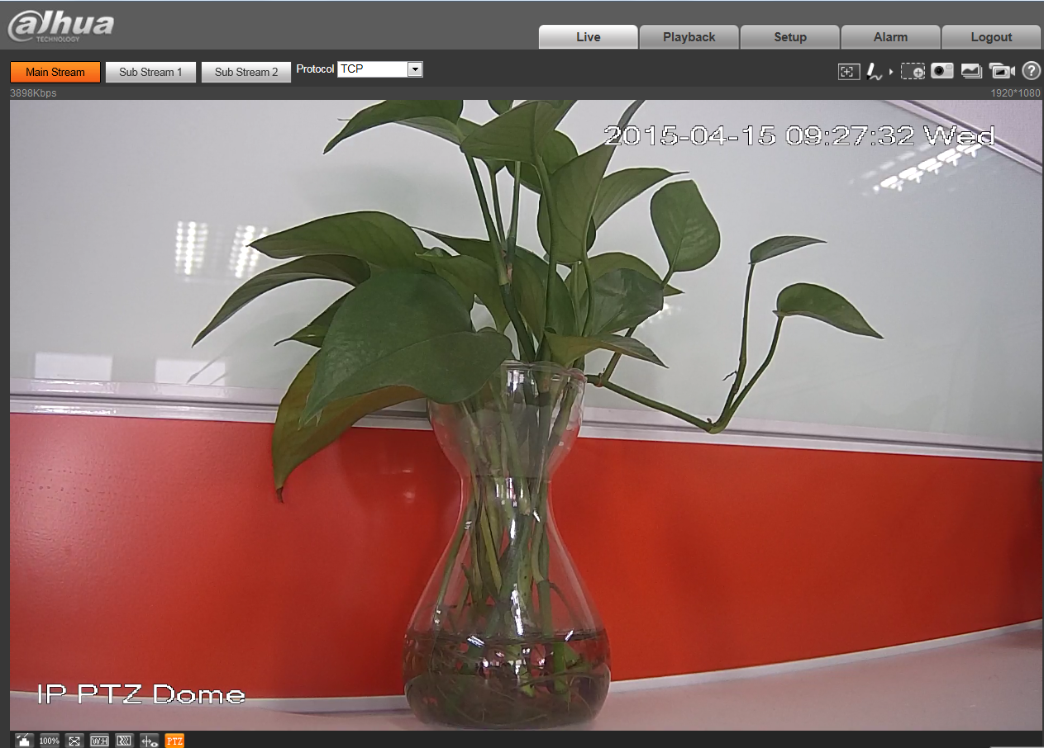

1
3
4
Figure 2-8
There are four sections:
- Section 1: Encode setup bar
- Section 2: System menu
- Section 3: Window function option bar
- Section 4: Window adjust bar

Encode Setup
The encode setup interface is shown as in Figure 2-9.
Figure 2-9
Please refer to the following sheet for detailed information.
Parameter | Function
Main stream | Streaming media protocol connection, under main stream config, monitor video or not. Generally for storage and monitor.
Sub (Extra) stream 1 | Streaming media protocol connection, under sub stream 1 config, monitor video or not. When network bandwidth is insufficient, it substitutes main stream for monitoring.
Sub (Extra) stream 2 | Streaming media protocol connection, under sub stream 2 config, monitor video or not. When network bandwidth is insufficient, it substitutes main stream for monitoring.
Protocol | You can select stream media protocol from the dropdown list.  There are three options: TCP/UDP/Multicast

System Menu
System menu is shown as in Figure 2-10.
Please refer to chapter 2 Live, chapter 3 Playback, chapter 4 Setup, chapter 5 Alarm, chapter 6 Log out for detailed information.
Figure 2-10

Video Window Function Option
The interface is shown as below. See Figure 2-11.
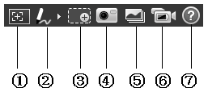
Figure 2-11
Please refer to the following sheet for detailed information.
SN | Parameter | Function
1 | Regional Focus | Click the button and use mouse to select an area in the box on the video screen, which will make the device auto focus in the selected box area.
2 | Remark | Click it and then select pen color, you can write down the mark information on the preview interface.
3 | Zoom | - When the video is in the original status, click it you can select any zone to zoom in. In the non-original status, you can drag the zoom-in zone in specified range. Right click mouse to restore previous status.  - Click it; you can use the middle button of the mouse to zoom in/out the video size.
4 | Snapshot | Click the button to snapshot, save picture to path in Chapter 4.1.2.5.
5 | Triple snap | Click it, system can snap at 1f/s. All images are saved to path in Chapter 4.1.2.5.
6 | Record | Click it, system can record. All images are saved to path in Chapter 4.1.2.5.
7 | Help | Click it to open help file.

Video Window Setup
The interface is shown as in Figure 2-12.
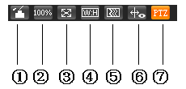
Figure 2-12

Image Adjustment
Click this button to display/hide image control interface. Click it to open picture setup interface. This interface is on the top right pane. See Figure 2-13

Parameter |  | Function
Video setup |  | It is to adjust monitor video brightness. | Note:  - All the operations here apply to WEB end only.  - Please go to Setup->Camera->Conditions to adjust corresponding items.
Video setup |  | It is to adjust monitor video contrastness.
Video setup |  | It is to adjust monitor video hue.
Video setup |  | It is to adjust monitor video saturation.
Video setup | Reset  Re | Restore brightness, contrastness saturation and hue to system default setup.
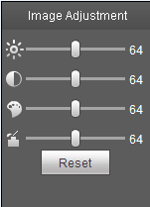
Figure 2-13

Original Size
Click this button to go to original size. It is to display the actual size of the video stream. It depends on the resolution of the bit stream.

Full Screen
Click it to go to full-screen mode. Double click the mouse or click the Esc button to exit the full screen.

Width and Height Ratio
Click it to restore original ratio or suitable window.

Fluency Adjustment
There are three levels of fluency for you to select (real-time, normal, fluent). The default is normal.

Rule Info
Click it to enable the function that the intelligent rule will be displayed in the live interface. The default is enable.

PTZ
Click it to open PTZ setup interface. Please refer to chapter 2.5 for detailed setup information.

PTZ Configuration

PTZ Control
Before PTZ operation, please make sure you have properly set PTZ protocol.
Parameter | Note
- Quick Position | Use mouse to draw a box in monitoring video, PTZ will rotate and focus to quickly positioning.
- PTZ direction | PTZ supports eight directions: left/right/up/down/upper left/upper right/bottom left/bottom right.
- Speed | It controls rotation speed. The longer the step length, the higher the speed. Step length control PTZ, zoom, focus and iris.
- Zoom/focus | Click to increase value and click  to decrease value.
The PTZ setup/Menu interface is shown as in Figure 2-14.
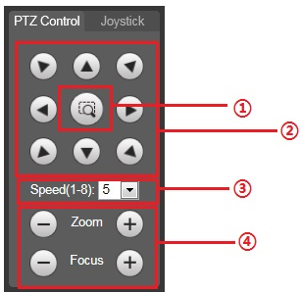
Figure 2-14

Virtual Joystick
The virtual joystick interface is shown as below. See Figure 2-15.
This function allows you to control the button in then center to simulate the joystick operation. You can use it to control device movement.
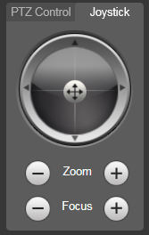
Figure 2-15

PTZ Function
Click PTZ set button, the interface is shown as in Figure 2-16. Here you can select scan, preset, tour pattern, assistant function and etc.
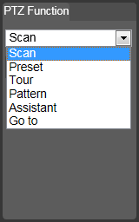
Figure 2-16
Please refer to the following sheet for PTZ setup information.
Parameter | Function
Scan | - Select Scan from the dropdown list, click Start button, you can begin scan operation. Default SN is 1.
Preset | - Input the preset value and then click View button, the camera turns to the corresponding position of the preset.
Tour | - Select Tour from the dropdown list and then click Start button, you can begin tour.
Pattern | - You can select Pattern from the dropdown list and then click Start button to begin PTZ movement.
Assistant | - Reserved assistant function.
Go to | - It is the accurate positioning function. Please input corresponding horizontal angle, tilt angle, and speed dome zoom speed and then click Goto button to go to a specified position.  - One unit of the horizontal angle or tile angle stands for 0.1 degree.
For detailed setup information, please go to Setup->PTZ->Function.
Click 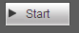 button to begin a PTZ operation. Now you can see it becomes Stop button. Click it again to stop current PTZ operation.

Playback
Web client playback supports video playback and picture playback.
Note:
Before playback, user shall set storage management as in Chapter 4.6.

Playback
The playback interface is shown as in Figure 3-17.
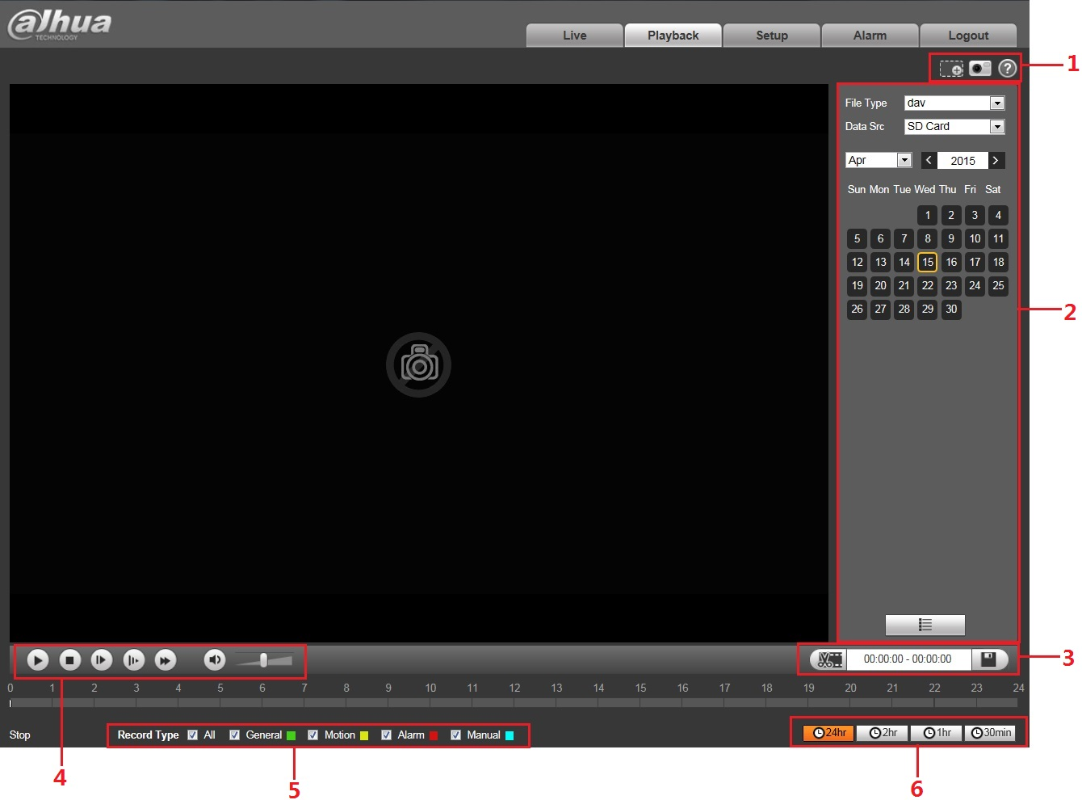
Figure 3-17
There are six sections:
- Section 1: Assistant function
- Section 2: Playback file
- Section 3: Clip
- Section 4: Playback bar
- Section 5: Record type
- Section 6: Progress bar time format

Function of Play
The function of play is shown as in Figure 3-18.
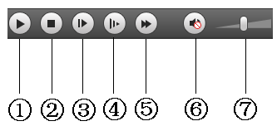
Figure 3-18

Parameter | Function
- Play | When you see this button, it means pause or not played record. Click this button, switch to normal play status.
- Stop | Click this button to stop playing.
- Frame by frame play | Click this button to go to next frame.  Note:  You shall pause record when you use this function.
- Slow | Click this button to play slowly.
- Quick | Click this button to play quickly.
- Mute | When this button displays, it means audio is silent. Click this button to switch back to normal.
- Volume | Left click mouse to adjust volume.

Playback File
In calendar, blue date represents data currently has video record or snapshot. See Figure 3-19.
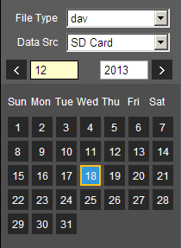
Figure 3-19

Parameter | Function
File Type | - Select “dav”, as video playback.  - Select “jpg” as picture playback.
Data Source | Default is SD card.

Click data in blue, time axis displays record file progress bar in color. While, green represents normal record, yellow represents motion detect record, red represents alarm record, and blue represents manual record.

- Click certain time on progress bar, playback starts from this time. See Figure 3-20.

Figure 3-20
- Click file list, select date file will be displayed in list.
- Double click file in list, playback this file and display file size, start time and end time.
See Figure 3-21.
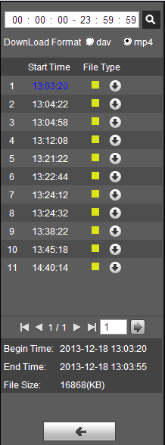
Figure 3-21

Parameter | Function
Search | It means records within searched start time and end time on the date.
Record Download Format | There are two formats: dav, mp4.
Download | - Record type is “dav”, click download button to download file to local.  - Record type is “mp4”, click download button and download file to path in Ch 5.1.2.5.  Note:  System does not support download and playback of MP4 file.
Back | Click back button to go to calendar interface.

Playback Cut (Clip)
Note:
Playback cut function will automatically pause playing record as playback cut and playback cannot be at the same time.

Click start time to cut on time axis. This time must be within progress bar range.

Move mouse to cut icon . You will be ask to select start time. Click cut icon as finish cutting.

Click playback cut end time on time axis. This time must be within progress bar range.

Move mouse to cut icon , you will be asked to select end time. Click cut icon as finish cutting.

Click Save button to save file cut to path in chapter 4.1.2.5. See Figure 3-22.
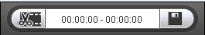
Figure 3-22

Record Type
Check record file type, only selected file will be displayed in progress bar and file list. See Figure 3-23.
Figure 3-23

Progress Bar Time Format
The interface is shown as in Figure 3-24.
Figure 3-24
Please refer to the following sheet for detailed information.

Parameter | Function
24 hours | Click it, means video in past 24 hours.
2 hours | Click it, means video in past 2 hours.
1 hour | Click it, means video in past 1 hour.
30 min | Click it, means video in past 30 min.

Assistant Function
Video playback assistant function is shown in Figure 3-25.

Figure 3-25
Please refer to the following sheet for detailed information.
Parameter | Function
Digital Zoom | - Click it, you can zoom in any area when then playback video is in original status. In non-original status, you can zoom in specified zone, Right click mouse to restore its original size.  - Click this button; you can scroll to zoom in/out video.
Snapshot | Click this button; you can snapshoot video under playback status. Snapshot will be saved to path in chapter 4.1.2.5.

Picture Playback
Web client picture playback interface has the following three functions. See Figure 3-26.
Parameter | Function
1 | Play function bar
2 | Playback file bar
3 | Snapshot type bar

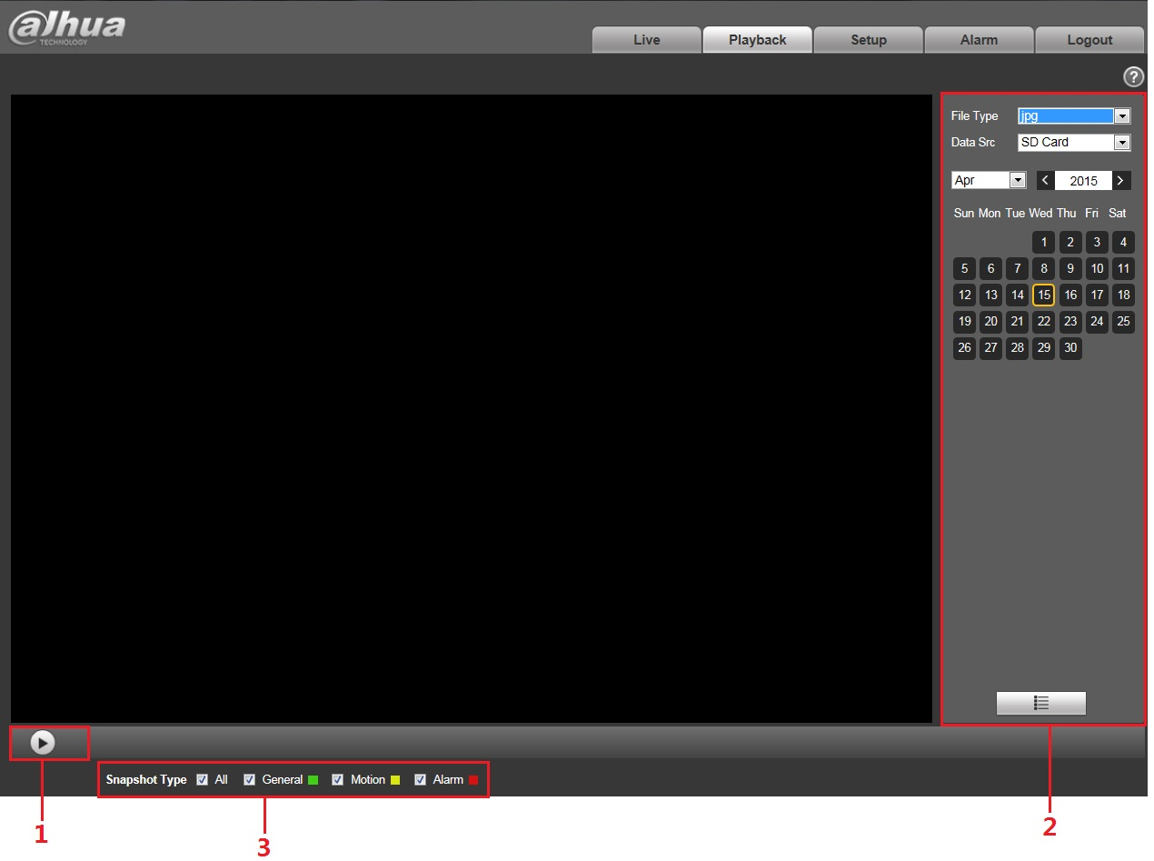
Figure 3-26

Play
The play button is shown as below. See Figure 3-27.

Figure 3-27
Default icon is, and it means pause or not played picture.
- Click play button to switch to normal play status. Icon becomes.
- Click it to pause.

Playback File
Step 1: Click file list, select snapshot file of the date.
Step 2: Double click file in list to play this snapshot.

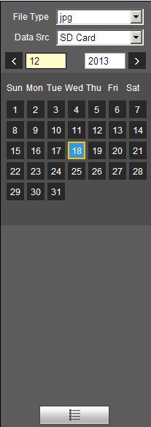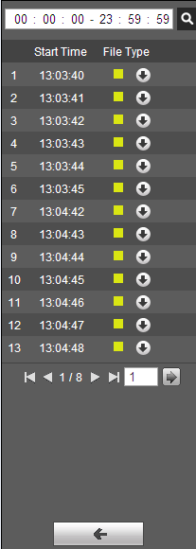
Figure 3-28 Figure 3-29
Please refer to the following sheet for detailed information.
Parameter | Function
Search | It means all snapshot files within the start time and end time of selected date.
Download | Click download button to download snapshot file to local.
Back | Click back button to return to calendar interface and re-select time.

Snapshot Type
Check snapshot file type, file list only displays file of selected type. See Figure 3-30.
Figure 3-30

Setup
Web client setup support camera, network, PTZ, event, storage, system and system info view.

Camera

Conditions
Here you can view device property information. Slight differences may be found due to different speed dome series. The setups become valid immediately after you set. See Figure 4-31.
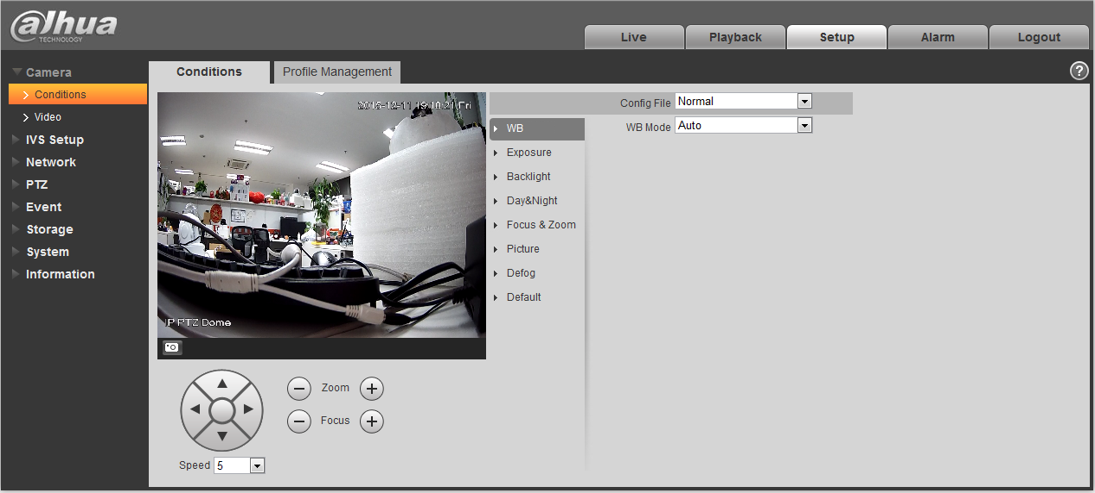
Figure 4-31
Please refer to the following sheet for detailed information.
Parameter | Function
Config File | Here you can set camera setup mode. It includes: normal/day/night.
White Balance | It is to set camera white balance. It includes: auto/manual/ATW/outdoor/indoor/outdoor auto/sodium light auto/sodium light.
Exposure | It is to set camera exposure mode. It includes: auto and manual
Backlight | It is to set camera backlight mode, including WDR, HLC, and BLC.
Day/Night | It is to set camera day/night switch mode.  The type includes: electronic/mechanical.  It includes four modes: auto/B&W/Color/Photosensor.
Zoom& Focus | It is to set camera zoom and focus mode. It is to set digital zoom/camera zoom rate. Focus mode includes: auto/manual/semi auto.
Picture | It is to set camera video. It includes: style/hue/brightness/saturation/ chroma control/gamma/picture flip/picture freeze/sharpness /sharpness control
Defog | It is to set the defog mode for the picture, including “Off” and “Auto”.
Default | It is to restore factory default setup.

Important
Please make sure your purchased camera supports all the functions listed here.

White Balance
White balance interface is shown as below. See Figure 4-32.
Figure 4-32
Please refer to the following sheet for detailed information.
Parameter | Function
WB mode | - It is to set camera white balance. It includes: auto/manual/ATW/outdoor/indoor/outdoor auto/sodium light auto/sodium light.  - For manual mode, you can input red gain and blue gain value.

Exposure
Exposure interface is shown as below. See Figure 4-33.
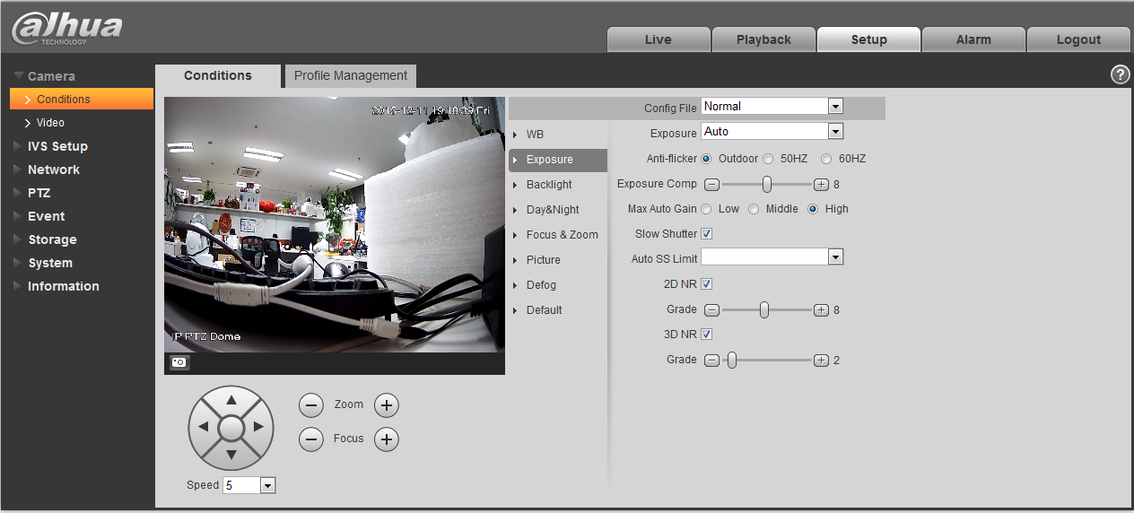
Figure 4-33
Please refer to the following sheet for detailed information.
Parameter | Function
Exposure mode | - It is to set camera exposure mode. It includes: auto and manual. The default setup is auto.  - For the auto exposure mode, the gain, shutter and iris are in auto mode.  - For manual exposure mode, the gain, shutter and iris are in manual mode.
Anti-flicker | - 50Hz：Under the condition of AC/50Hz, automatically adjust exposure and ensure there are no horizontal stripes in the image according to the scene brightness.  - 60Hz：Under the condition of AC/60Hz, automatically adjust exposure and ensure there are no horizontal stripes in the image according to the scene brightness.  - Outdoor：Able to switch exposure mode under this mode, and reach the effect of corresponding exposure mode.
Exposure compensation | It can adjust video whole brightness via setting exposure object brightness so that it can suit for different environments.
Gain level | It is to set video brightness under the low illumination environments.
Shutter | It is to set camera exposure time.
Slow exposure | If the light may change greatly, you can use slow exposure to get image so that the camera can get stable video.
Max Auto gain | It is to set camera max gain.
Slow shutter | In lower illumination environment, you can lower the cameras auto exposure time to capture the image and enhance the definition. For the moving object, the trail may appear. Please note it is valid in auto mode.
Auto Slow Shutter Min value | It is to set camera min shutter value.
2D NR | It is to control noise. The higher the level is; the small the noise is. Comparing with the previous one, the picture may become a little bit blurry.
3D NR | It is to control noise. The higher the level is; the small the noise is. Comparing with the previous one, there may appear some smear phenomenon.

Backlight
The backlight interface is shown as in Figure 4-34.
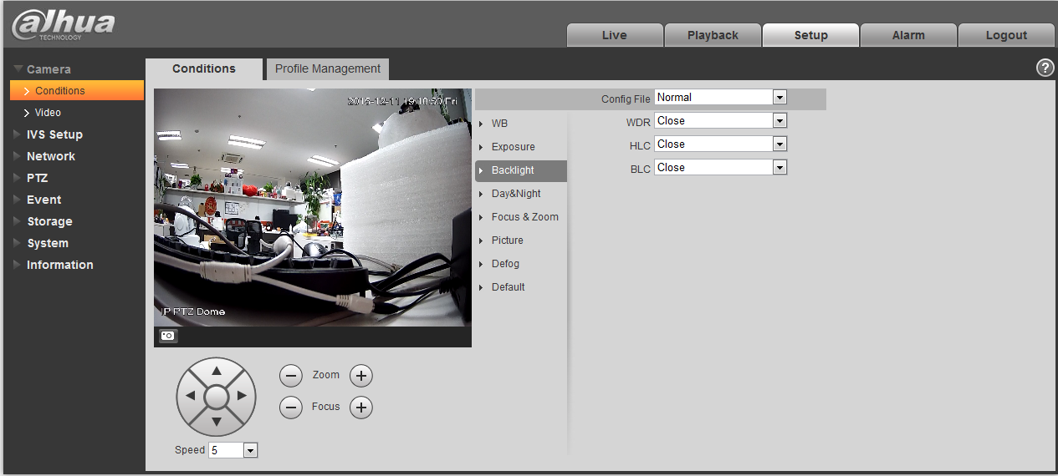
Figure 4-34
Please refer to the following sheet for detailed information.
Parameter | Function
WDR Mode | For the environments of strong contrast effect, it can auto adjust image contrast so that you can see the dark and bright section at the same time.
HLC | When there is strong light source in the environment, system can auto adjust video brightness to remove the over exposure effect.
BLC | For the environments of strong contrast effect, such as under the backlight environment, system can auto adjust image contrast to get clear object.

Day/Night
Important
Please make sure your purchased product camera supports this function.
The day/night mode is shown as in Figure 4-35.
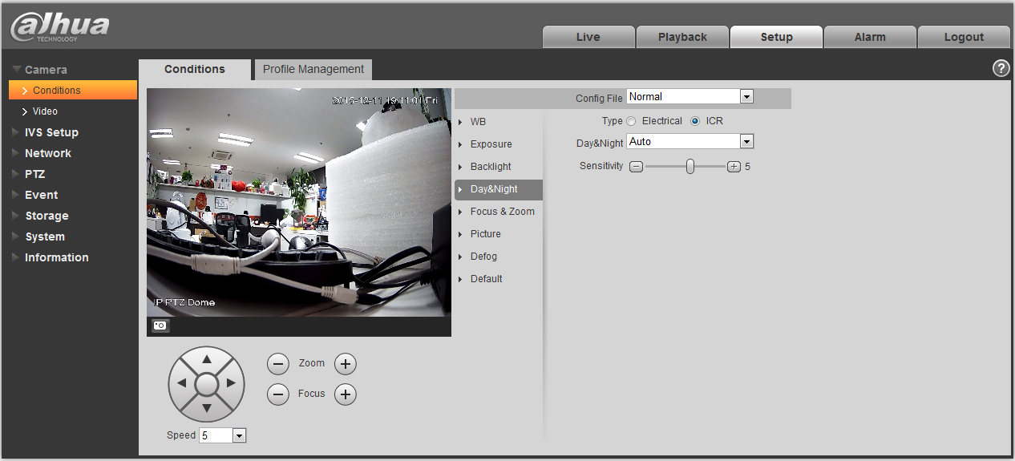
Figure 4-35
Please refer to the following sheet for detailed information.
Parameter | Function
Type | It is to set camera day/night type, including electronic, ICR.
Day/night | It is to set camera day/night mode.  The mode includes: B&W/color/auto.
Sensitivity | It is to camera day/night switch sensitivity.

Zoom &Focus
The zoom &focus interface is shown as in Figure 4-36.
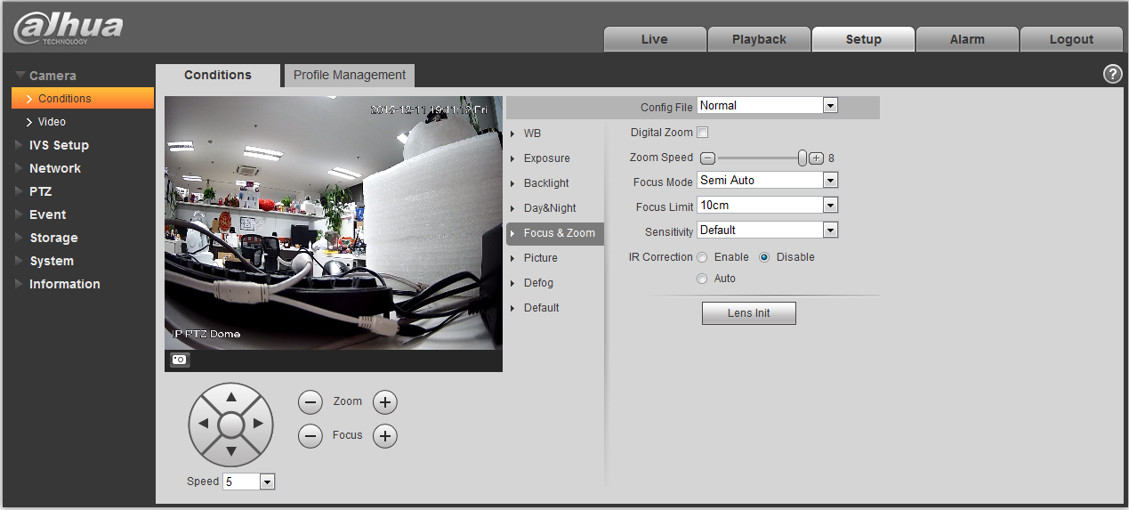
Figure 4-36
Please refer to the following sheet for detailed information.
Parameter | Function
Digital zoom | Check the box here to enable digital zoom function.
Zoom speed | It is to set camera zoom speed. The bigger the value is, the faster the speed is.
Focus mode | It is to set camera focus mode. It includes: auto/manual/semi auto.
Focus limit | It is to camera focus distance in case the focus distance is too small and the focus goes to the enclosure. At the same time, you can change focus distance to adjust focus speed.
Sensitivity | It is to set camera focus sensitivity. The higher the value is, the easier it is to activate focus. The lower the value is, the difficult it is to activate focus.
IR Correction | It is to set IR light focus correction function to enhance focus effect and remove the IR light effect on the focus.

Picture
Picture interface is shown as in Figure 4-37.
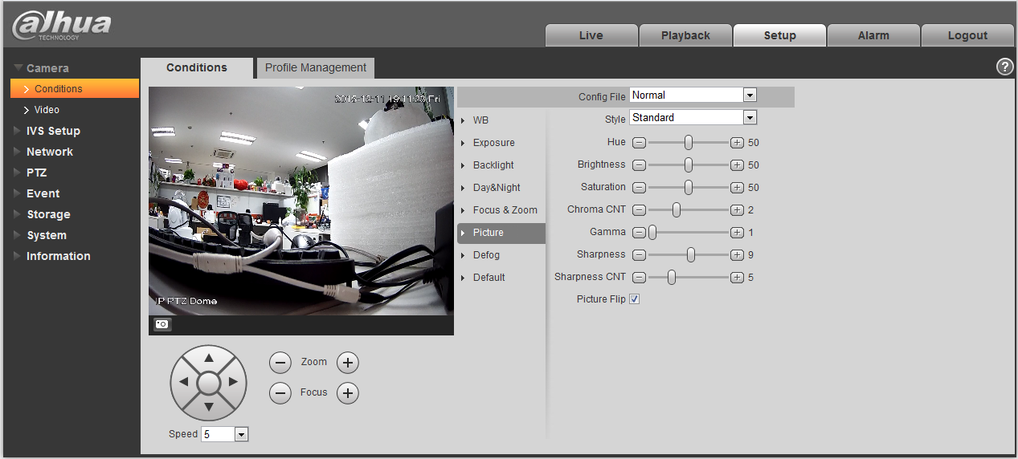
Figure 4-37
Please refer to the following sheet for detailed information.
Parameter | Function
Style | It is to set video style. It includes：Standard/soft/ flamboyant.
Hue | It is to set picture hue.
Brightness | It is to set video brightness. The higher is value is, the bright the video is.
Saturation | It is to set color purity. The higher the purity is, the more color the video is. The lower the purity is, the dark the video is.
Chroma control | It is to set video color control level. The higher the value is, the higher the control level is.
Gamma | It is to set image gamma value.
Sharpness | It is to set camera sharpness. The higher the sharpness is, the clearer the image is. The object edge becomes clear too.
Sharpness control level | It is to set camera control level. The higher the value is, the stronger the control level is.
Picture Flip | It is to set video display mode. It is to turn camera.

Defog
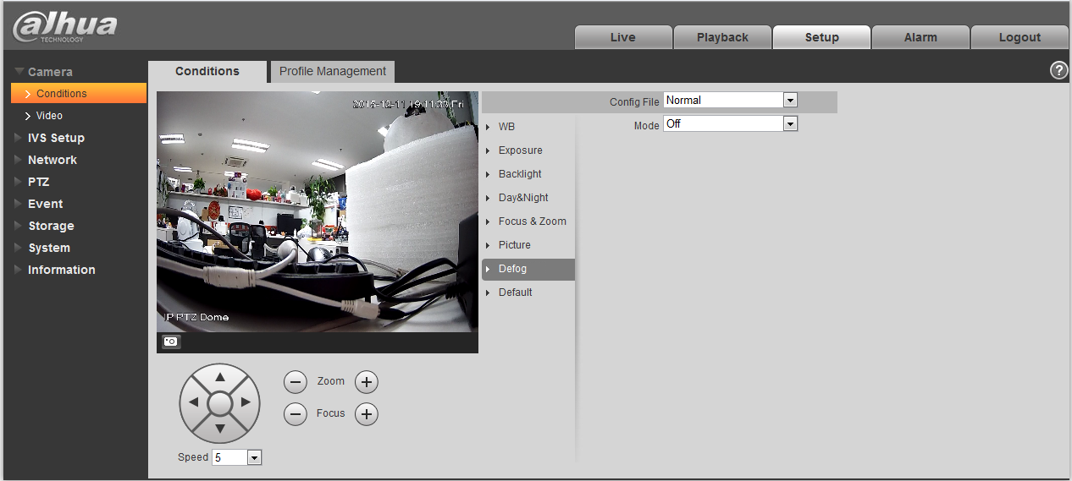
Figure 4-8
Parameter | Note
Mode | It is to set the camera defog mode, it includes: off and auto.

Default
Default interface is shown as in Figure 4-9.
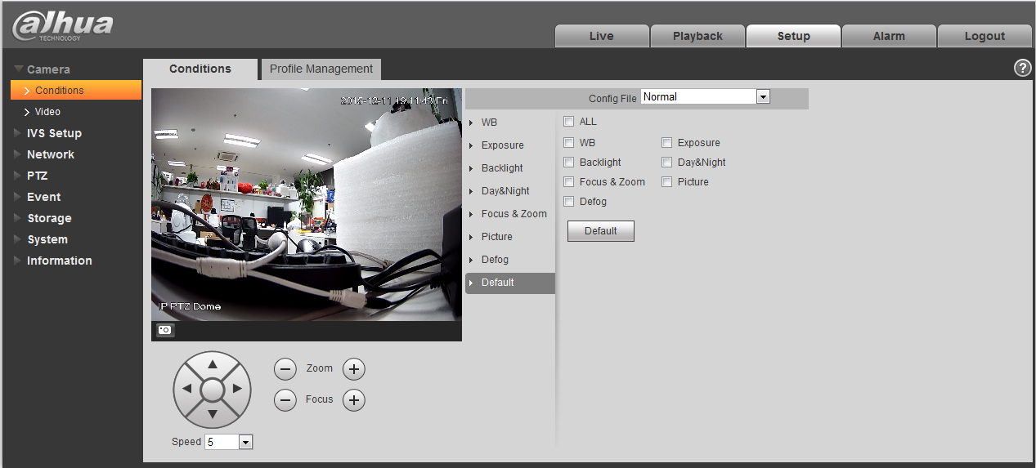
Figure 4-9
Please refer to the following sheet for detailed information.
Parameter | Function
Default | It is to restore camera parameter to factory default setup.

Profile Management
Profile management interface is shown as in Figure 4-10.
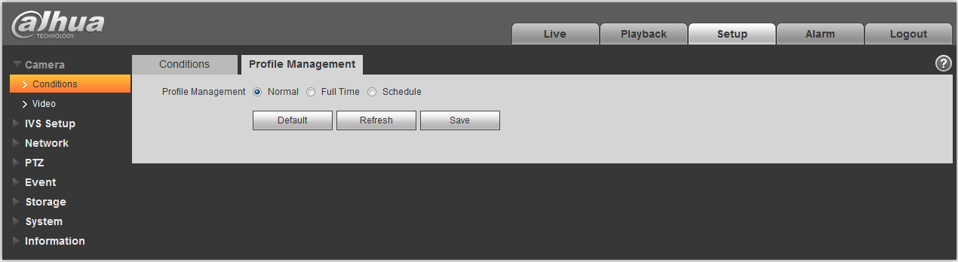
Figure 4-10
Please refer to the following sheet for detailed information.
Parameter | Function
Profile Management | There are three modes: normal/full-time/schedule. The default setup is normal.
Normal | It is to adopt the general parameter on the profile file.
Full-time | It is to adopt day or night general parameter on the profile file all the time.
Schedule | It is to adopt the day or night parameter on the profile file by time you set here.

Video

Video bit stream
The video bit stream interface is shown as below. See Figure 4-11.
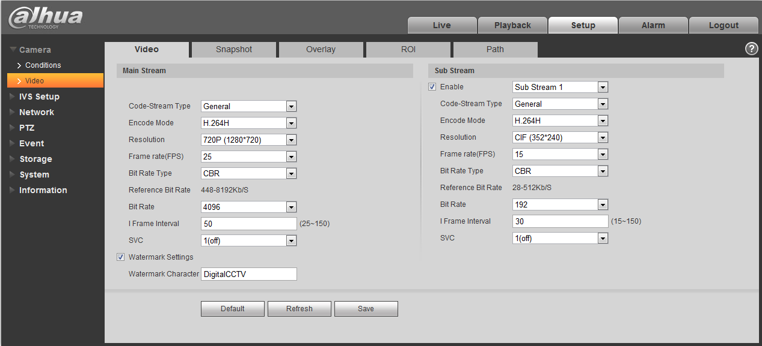
Figure 4-11
Please refer to the following sheet for detailed information.
Parameter | Function
Sub Stream Enable | Please check the box here to enable extra stream function.  This function is enabled by default.
Code-Stream Type | ACF means using different fps to record.  There are two options: VBR and CBR.  Please note, you can set video quality in VBR mode.
Encode mode | There are three options: H.264, H.264B, H.264H and MJPEG encode.  - H.264: Main Profile encode mode.  - H.264B: Baseline Profile encode mode.  - H.264H: High Profile encode mode.  - MJPEG: In this encode mode, the video needs large bit stream to guarantee the video definition. You can use the max bit stream value in the recommend bit to get the better video output effect.
Resolution | There are multiple resolutions. You can select from the dropdown list.  For each resolution, the recommended bit stream value is different.
Frame Rate | PAL: 1～25f/s，NTSC: 1～30f/s..  The frame rate may vary due to different resolutions.
Bit Rate Type | There are two options: VBR and CBR.  Please note, you can set video quality in VBR mode.  Under MJPEG mode, only CBR is available.
Recommended Bit | Recommended bit rate value according to the resolution and frame rate you have set.
Bit Rate | - In CBR, the bit rate here is the max value. In dynamic video, system needs to low frame rate or video quality to guarantee the value.  - The value is null in VBR mode.  - Please refer to recommend bit rate for the detailed information.
I Frame | Here you can set the P frame amount between two I frames. The value ranges from 1 to 150. Default value is 50.  Recommended value is frame rate *2.
Watermark Settings | By calibrating watermark, to see if video is modified. Select Watermark function. Default watermark is Digital CCTV.  Watermark character can only be number, letter, _, - within 128 characters.

Snapshot
The snapshot interface is shown as in Figure 4-12.
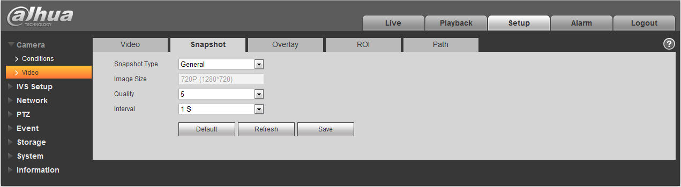
Figure 4-12
Please refer to the following sheet for detailed information.
Parameter | Function
Snapshot type | There are two modes: general (schedule) and Event (activation).
Image size | It is the same with the resolution of snapshot (main stream or sub stream).
Quality | It is to set the image quality. There are six levels.
Interval | It is to set snapshot frequency. The value ranges from 1s to 7s.

Video Overlay
The video overlay interface is shown as in Figure 4-13 to Figure 4-17.
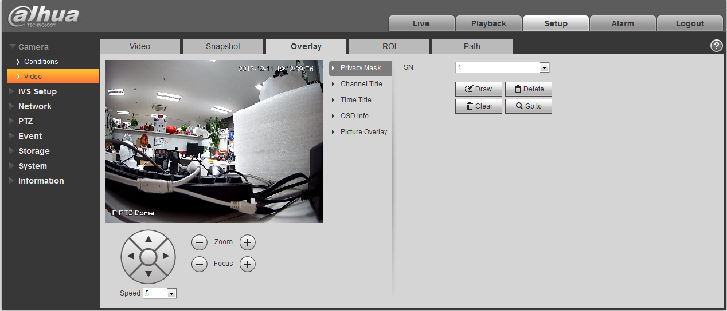
Figure 4-13
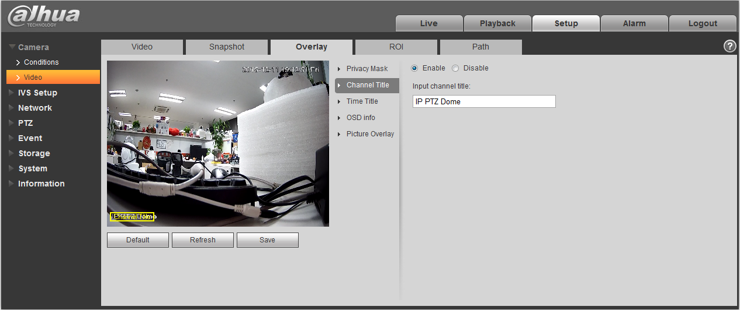
Figure 4-14
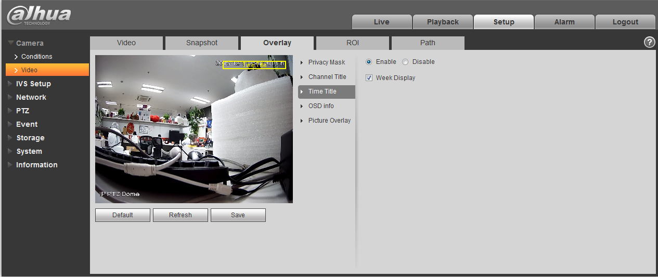
Figure 4-15

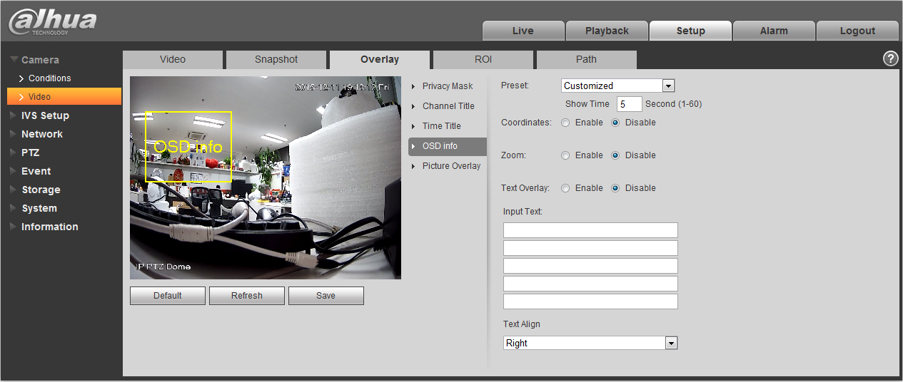
Figure 4-16

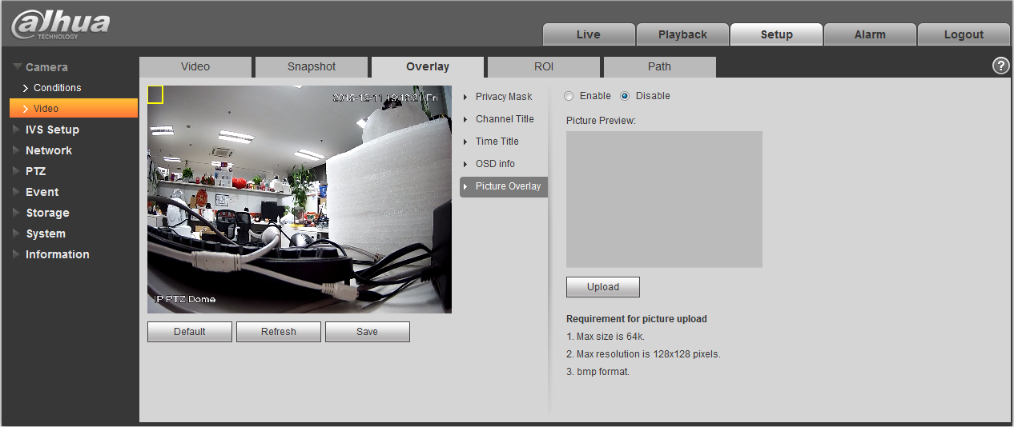
Figure 4-17

Please refer to the following sheet for detailed information.

Parameter | Function
Privacy Masking | - Select “privacy mask zone”, click “draw”, drag mouse on the video monitoring window and draw the corresponding privacy shielded zone of “privacy mask zone”.  - Select “privacy mask zone”, click “delete” to delete the corresponding privacy shielded zone of “privacy mask zone”.  - Click “clear” to clear all privacy mask zone(s) on the preview window.  - Select “privacy mask zone”, click “check” to check the corresponding privacy shielded zone of the “privacy mask zone”.
Channel Title | - You can enable this function so that system overlays channel information in video window. See Figure 4-.  - You can use the mouse to drag the channel tile position.
Time Title | - You can enable this function so that system overlays time information in video window. See Figure 4-.  - You can use the mouse to drag the time tile position.
OSD | - Select corresponding “enable” button, it will display preset, PTZ coordinate, location in video window. It won’t display if you select corresponding “disable” button. See Figure 4-.  - You can adjust preset, temperature, PTZ coordinate, location by dragging “OSD Info” box. Alignment include align left and align right.
Picture Overlay | - You can enable this function to display overlay picture. Click disable to turn it off. See Figure 4-.  - Click Upload Picture to overlay local picture into monitoring window. You can drag the yellow box to move it.  Note:  You cannot enable OSD and overlay at the same time.
Refresh | - Set channel title, time title, OSD info, picture overlay and save the change. You can click Refresh to see effect.

ROI

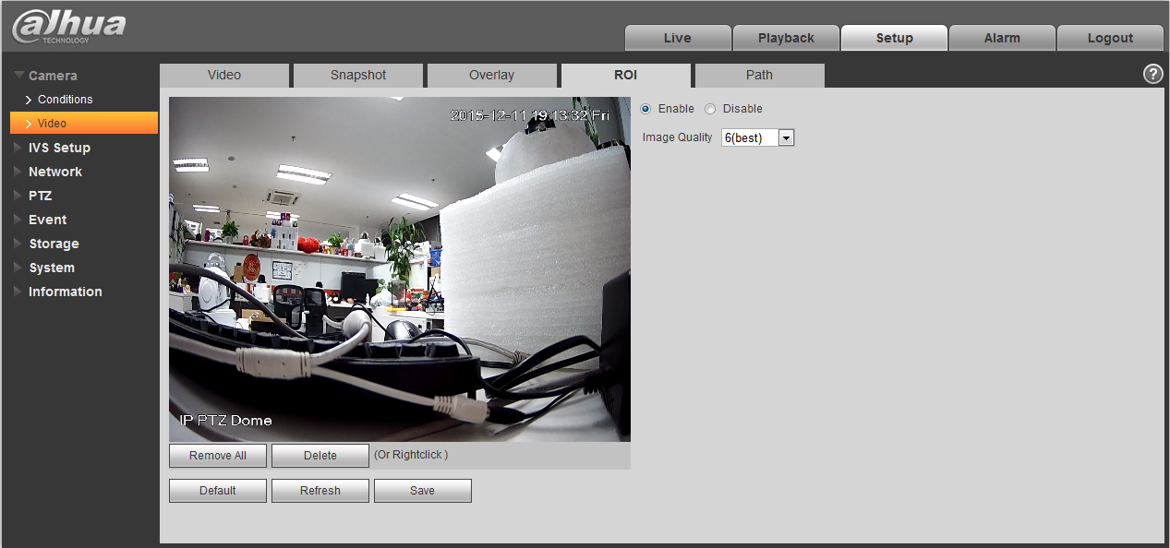
Figure 4-18
parameter | Note
Enable | Check “Enable” to display ROI in the video monitoring window; check “Disable”  not to display.
Image Quality | It is to set the image quality of the ROI, it ranges from 1~6.

Path
The storage path interface is shown as in Figure 4-17.
Here you can set snap image saved path and the record storage path.
- The default monitor image path is C:\Documents and Settings\Administrator\WebDownload\LivePicture.
- The default monitor record path is C:\Documents and Settings\Administrator\WebDownload\LiveRecord.
- The default playback snapshot path is C:\Documents and Settings\Administrator\WebDownload\PlayBackPicture.
- The default playback download path is C:\Documents and Settings\Administrator\WebDownload\PlayBackRecord.
- The default playback cut path is: C:\Documents and Settings\Administrator\WebDownload\PlayBackRecordCut.
Note:
Administrator is locally logged in PC account.
Please click the Save button to save current setup.
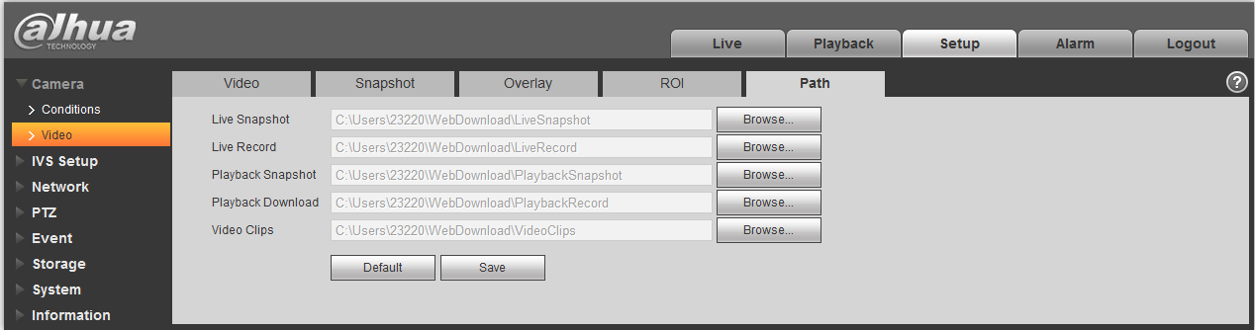
Figure 4-19

IVS Setup

Global Setup
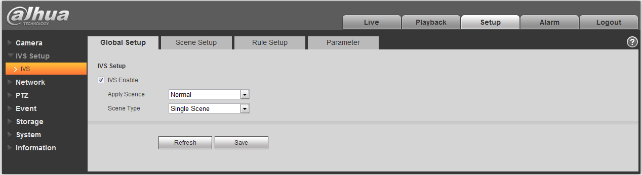
Figure 4-20

Parameter | Note
IVS Enable | Check it to enable IVS function.
Apply Scene | It can select normal scene and face detect, normal scene by default.
Scene Type | It is divided into single scene and multi-scene:  - Single scene: It realizes IVS to signel scene.  - Multi-scene: It realizes IVS to several scenes, tour switch between scenes.

Scene Setup
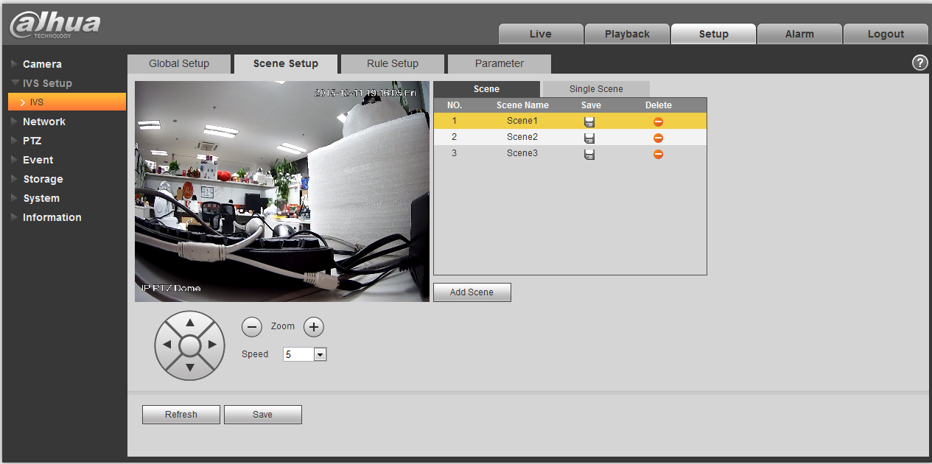
Figure 4-21
Parameter | Note
Add Scene | Click to add scene.
Zoom | Click  to zoom in the current scene, click  to zoom out the current scene.
PTZ | It can adjust the scene location via PTZ button .
Speed | It is to adjust the PTZ speed, it ranges from 1~8.

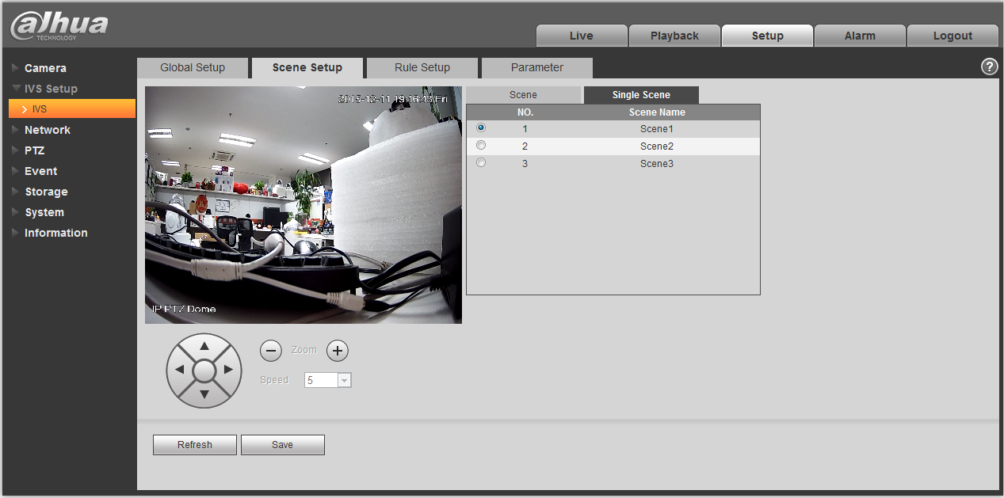
Figure 4-22
Single scene: Enter “Single Scene” page, click the button to select the scene which needs to be monitored.
Note:
It needs to select the “Single Scene” from “IVS Setup > Global Setup > Scene Type” .
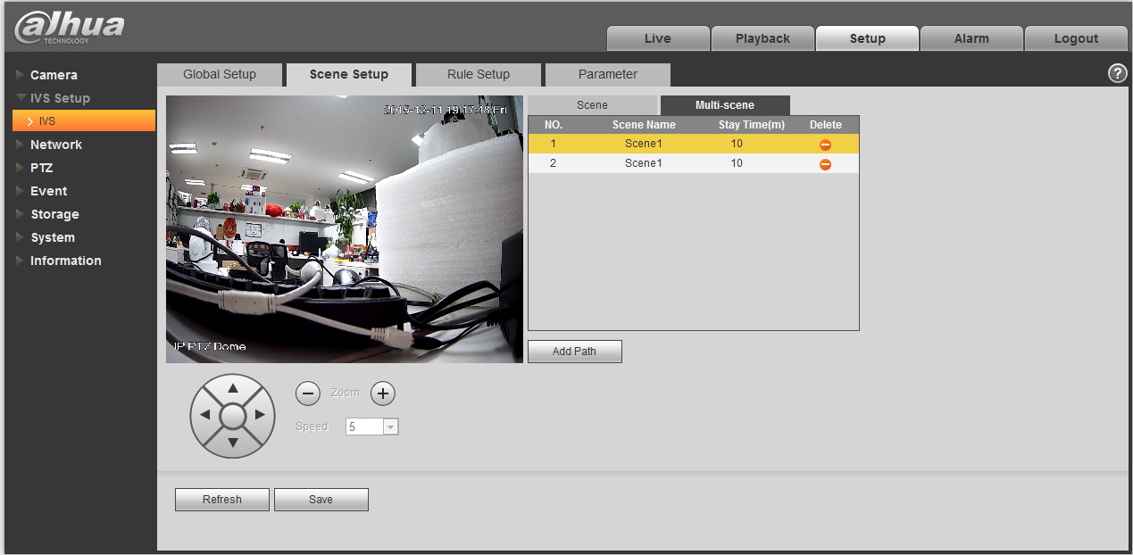
Figure 4-23

Multi-scene: Enter “Multi-scene” page, click to add tour scene, move the mouse to the location of “Scene Name”, select scene, move the mouse to “Stay Time” to set the stay time of the current scene.
Note:
It needs to select “Multi-scene” in the “IVS Setup > Global Setup > Scene Type”.

Rule Setup
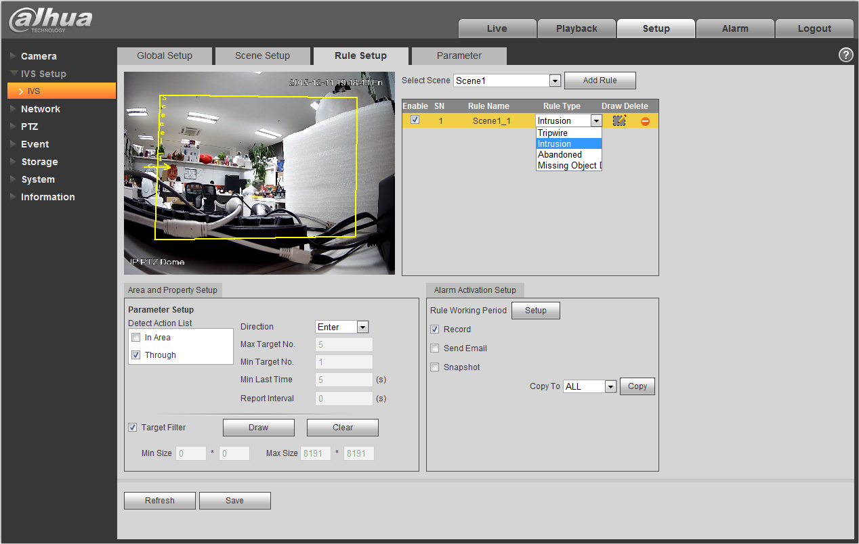
Figure 4-24
Parameter | Note
Select Scene | You can select the scene from the dropdown list so that you can add the corresponding rule.
Add Rule | Click to add a rule to the selected scene.
Enable | Check the box here to enable the rule.
Rule Name | Move your mouse to the “Rule Name” column to set a name.
Rule Type | Move your mouse to the “Rule Type” column to set the rule type. The option includes: Tripwire/Intrusion/Object abandoned/Missing object detection and etc.
Draw Rule | Click button to draw current rule.
Delete Rule | Click button to delete the selected rule.

Tripwire
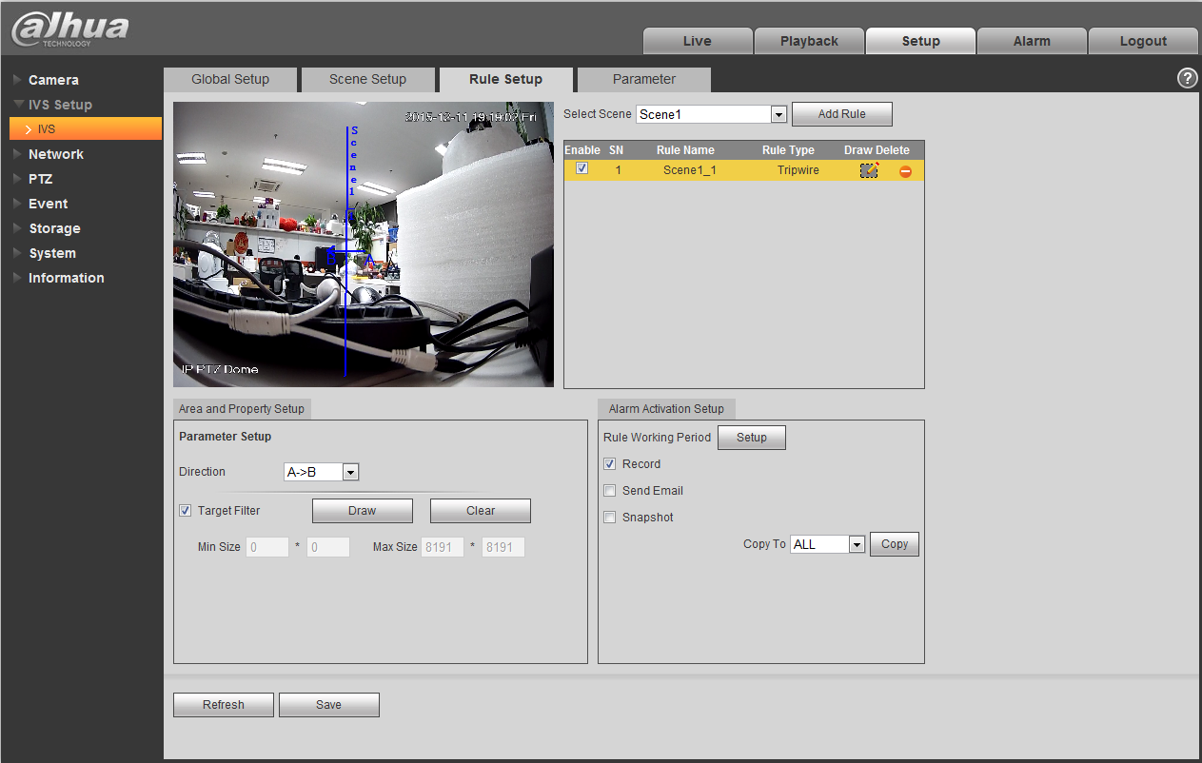
Figure 4-25
Parameter | Note
Direction | It is to select tripwire direction. The option includes: A->B、B->A、A<->B.
Target Filter | Check the box here to enable this function and then click button ，you can set the target filter model in this scene for this rule. Click the button ，you can remove selected target filter model.

Intrusion
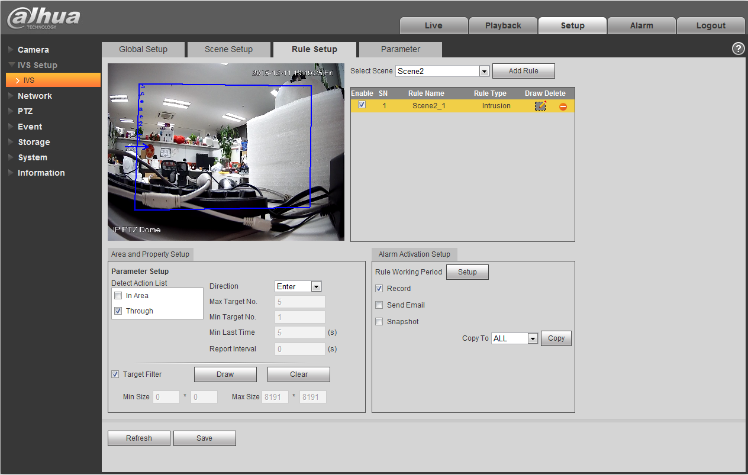
Figure 4-26
Parameter | Function
Detect action list | - In area: When the tracking object is in the detect zone and the stay time is more than the time threshold you set here, system can activate an alarm.  - Through area: System can generate an alarm when the tracking object is crossing the limit you set here.
Direction | It is for the Through area option in the Detect action list item. It is to set the cross direction. The option includes: Enter/Leave/Enter&Leave.
Max target No. | It is for the In area option in the Detect action list item. It is to set the max target No. of triggering alarm in area, System will not generate an alarm when the target No in the area is more than the max target No. that you have set.
Min target No. | It is for the In area option in the Detect action list item. It is to set the min target No. of triggering alarm in area, System will not generate an alarm when the target No in the area is less than the min target No. that you have set.
Min last time | It is for the In area option in the Detect action list item. Here is to set the min time between the target in the zone and an alarm activation occurrence.
Report interval | It is for the In area option in the Detect action list item. It is to set alarm period. System just alarms once if the value is 0 here.
Target filter | Check the box here to enable this function and then click button ，you can set the target filter model in this scene. Click the button ，you can remove selected target filter model.

Abandoned
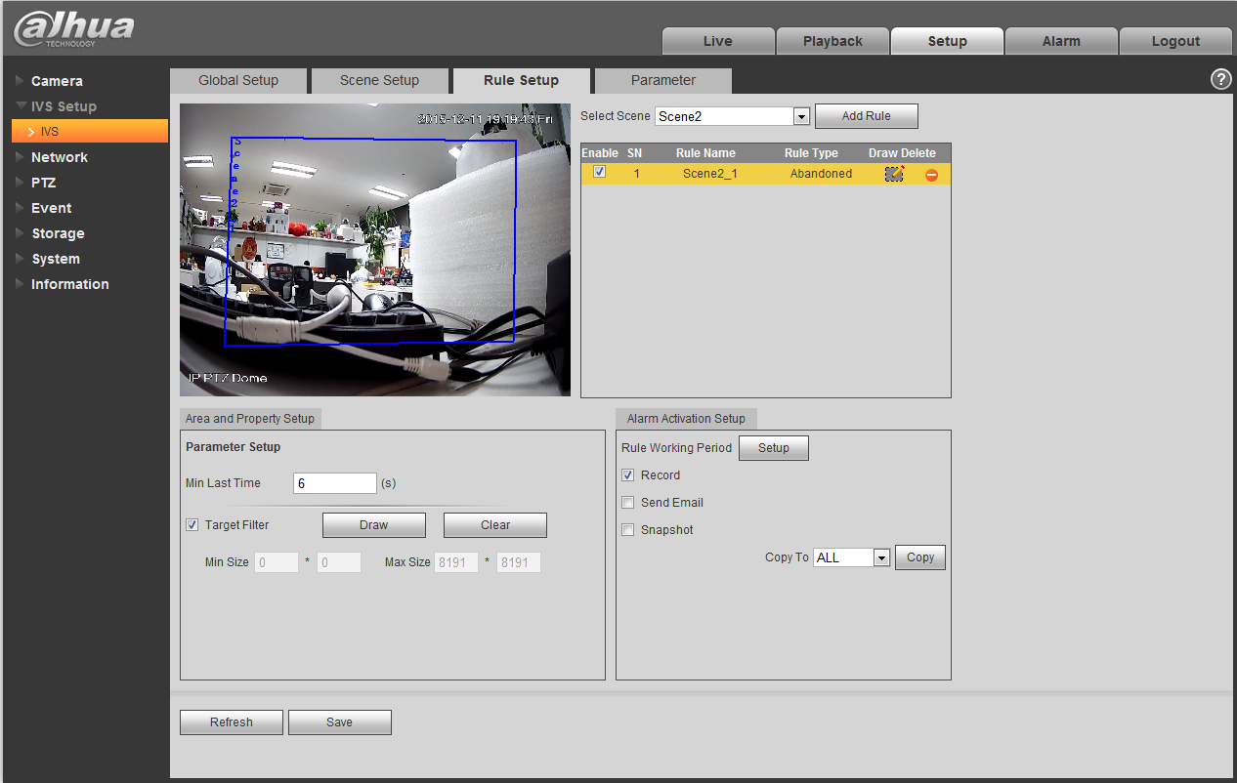
Figure 4-27
Parameter | Function
Min last time | It is to set the min time between the abandoned object occurrence and alarm activation.
Target filter | Check the box here to enable this function and then click button ，you can set the target filter model in this scene. Click the button ，you can remove selected target filter model.

Missing Object Detection
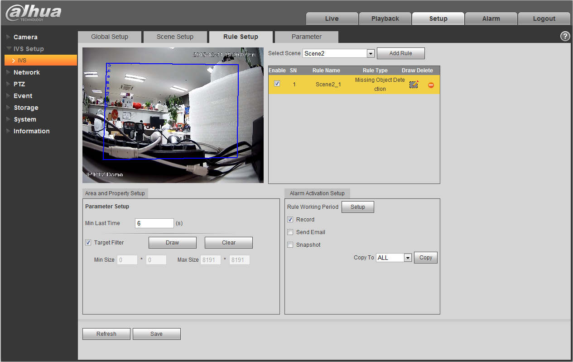
Figure 4-28
Parameter | Function
Min last time | It is to set the min time between the missing object occurrence and alarm activation.
Target filter | Check the box here to enable this function and then click button ，you can set the target filter model in this scene. Click the button ，you can remove selected target filter model.

Alarm Activation Setup
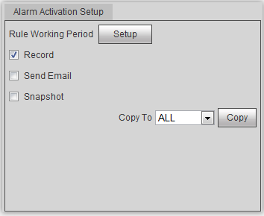
Figure 4-29
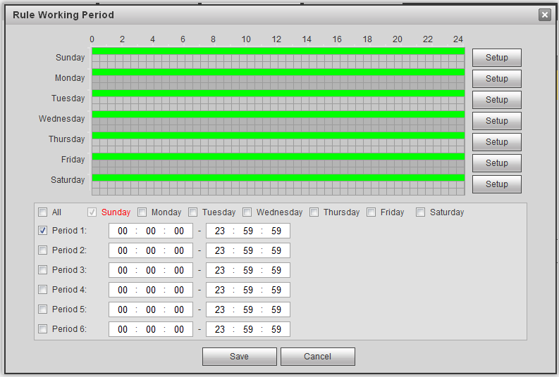
Figure 4-30

Parameter | Function
Rule Working Period | It is to set rule working period, click ‘Setup” button to open period setup menu to set.
Record | Check the box here so that the device can record when alarm activation occurred.
Send Email | Check the box here so that the device can send out an email to inform user  when alarm activation occurred.  Note:  Please note current function is null when the device is offline, or IP conflict  occurs.
Snapshot | Check the box here so that the device can snapshot when alarm activation occurred.
Copy | Select a rule name from the dropdown list and then click 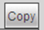 button; you can copy the alarm activation setup of current rule to the selected rule.

Parameter Setup
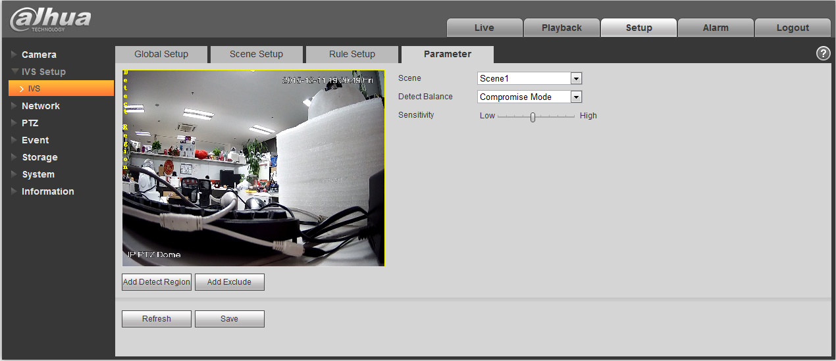
Figure 4-31

Parameter | Function
Scene | Please select corresponding scene to set parameter.
Detect balance | There are three modes: compromise mode, omission detect less and error detect less.
Sensitivity | The level ranges from 1 to 10. The default setup is 5. The higher the sensitivity is, the easier for the device to detect the low contrast object and small object. At the same time, the error detect may become more.
Add detect region | Click button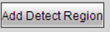, you can draw a detection zone.
Add excluded region | Click button 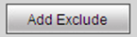，you can draw the privacy mask (shield) zone.

Network

TCP/IP
The TCP/IP interface is shown as in Figure 4-32. It supports IPv4 and IPv6. IPv4 supports static IP and DHCP. IPv6 supports static IP only. When you manually modify IP address, WEB will automatically jump to the new IP address.
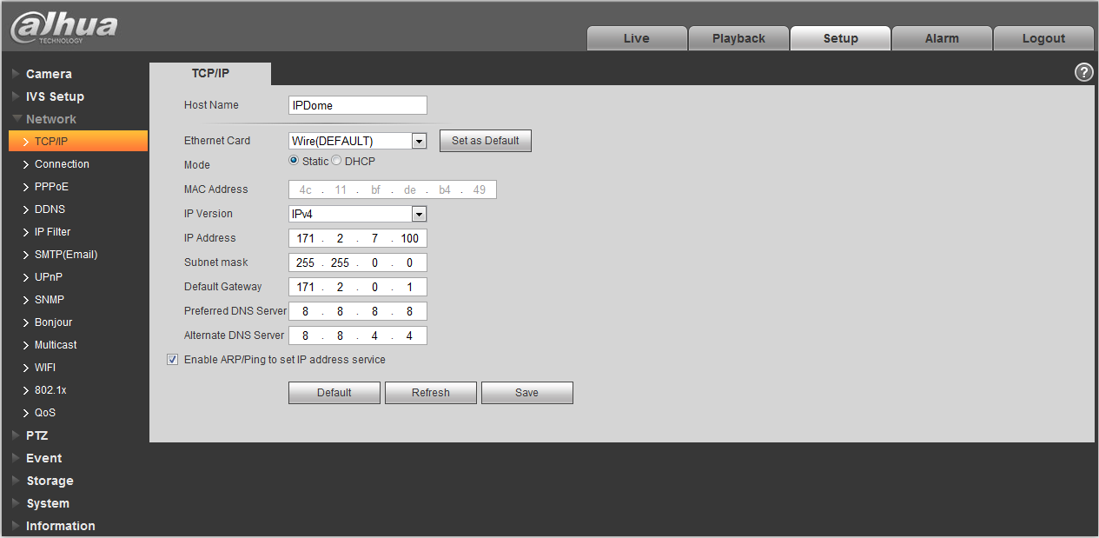
Figure 4-32
Please refer to the following sheet for detailed information.
Parameter | Function
Host Name | It is to set current host device name. It max supports 15 characters.
Ethernet Card | Please select the Ethernet port. Default is wired.  Please note you can modify the default Ethernet card if there is more than one card. .  Please note the device needs to reboot to activate the new setup once you modify the default setup.
Mode | There are two modes: static mode and the DHCP mode. Select DHCP mode, it auto searches IP, and you cannot set IP/subnet mask/gateway. Select static mode, you must manually set IP/subnet mask/gateway.
Mac Address | It is to display hose Mac address.
IP Version | It is to select IP version. IPV4 or IPV6.  You can access the IP address of these two versions.
IP Address | Please use the keyboard to input the corresponding number to modify the IP address and then set the corresponding subnet mask and the default gateway.
Preferred DNS | DNS IP address.
Alternate DNS | Alternate DNS IP address.
Enable ARP/Ping set device IP address service. | You can use ARP/Ping command to modify or set the device IP address if you know the device MAC address.  Before the operation, please make sure the speed dome and the PC in the same LAN. This function is on by default.  You can refer to the steps listed below.  Step 1: Get an IP address. Set the speed dome and the PC in the same LAN.  Step 2: Get the physical address from the label of the speed dome.  Step 3: Go to the Run interface and then input the following commands.  arp –s <IP Address> <MAC>  ping –l 480 –t <IP Address>  Such as：arp -s 192.168.0.125 11-40-8c-18-10-11  ping -l 480 -t 192.168.0.125  Step 4: Reboot the device.  Step 5: You can see the setup is OK if you can see there are output information such as “Reply from 192.168.0.125 …” from the command output lines. Now you can close the command line.  Step 6: Open the browse and then input http://<IP address>. Click the Enter button, you can access now.

ONVIF
ONVIF(Open Network Video Interface Forum), this specification describes the model, port, data type and data interaction mode of network video. ONVIF specification’s aim is to realize a framework agreement of network video to make the network video products (including video front end, video device and etc) from different manufacturers completely compatible.

ONVIF function is “disable” by default, see Figure 4-33 for more information.
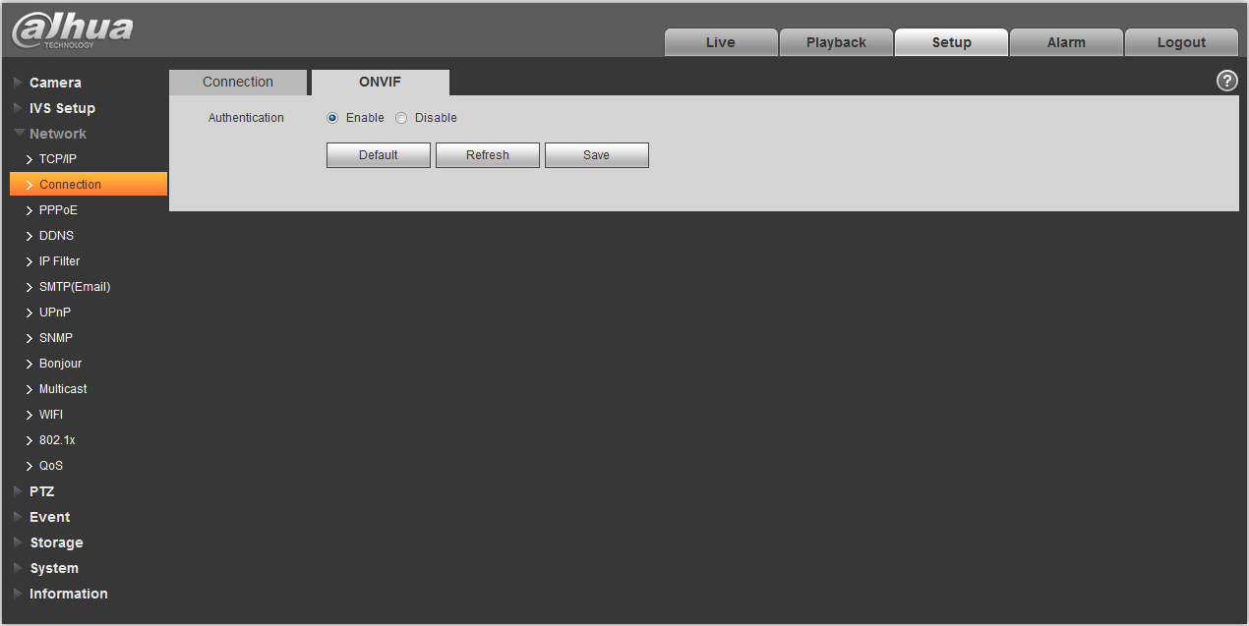
Figure 4-33

Connection

Connection
The connection interface is shown as in Figure 4-34.
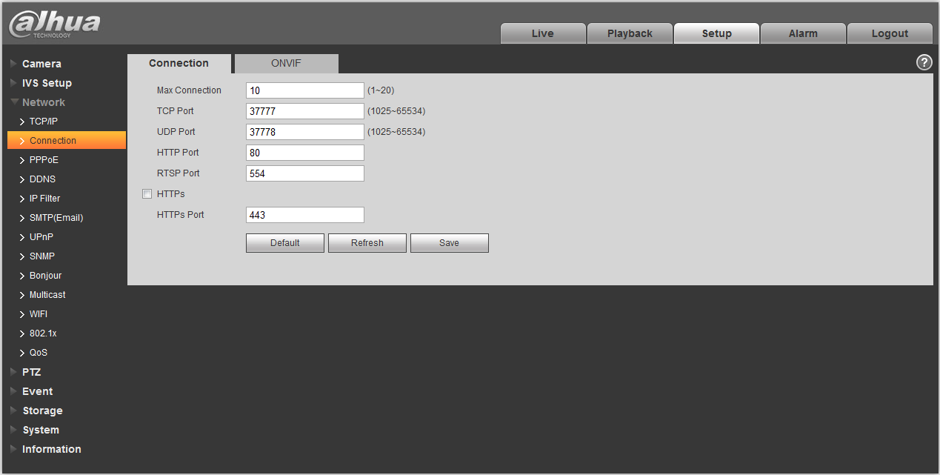
Figure 4-34
Please refer to the following sheet for detailed information.
Parameter | Function
Max connection | It is the max Web connection for the same device. The value ranges from 1 to 20. Default connection amount is 10.
TCP port | Port range is 1025~65534. The default value is 37777. You can input the actual port number if necessary.
UDP port | Port range is 1025~65534. The default value is 37778. You can input the actual port number if necessary.
HTTP port | Port range is 1025~65524. The default value is 80. You can input the actual port number if necessary.
RTSP port | - The default value is 554. Please leave blank if use default. User uses QuickTime or VLC can play the following formats. BlackBerry can play too.  - Real-time monitoring URL format, please require real-time RTSP media server, require channel no., bit stream type in URL. You may need username and password.  - User uses BlackBerry need to set encode mode to H.264B, resolution to CIF and turn off audio.  URL format is:  rtsp://username:password@ip:port/cam/realmonitor?channel=1&subtype=0  username/password/IP and port.  The IP is device IP and the port default value is 554. You can leave it in blank if it is the default value.  Follow standard RTP protocol and when encode mode is MJPEG; the max resolution only supports 2040*2040.
HTTPs Enable | Check HTTPs enable, login as https://ip:port. Protect data. Default port is https://ip . It is disabled by default.
HTTPs Port | HTTPs communication port, range is 1025~65534, default is 443.
Note:
- 0～1024, 37780～37880, 1900, 3800, 5000, 5050, 9999, 37776, 39999, 42323 are all special ports. User cannot modify them.
- Avoid using default port value of other ports.

ONVIF
ONVIF (Open Network Video Interface Forum) describes network video model, port, data type and data switch modes. ONVIF standard targets to create a network video frame protocol that communicates network video products from different manufacturers. See Figure 4-35.

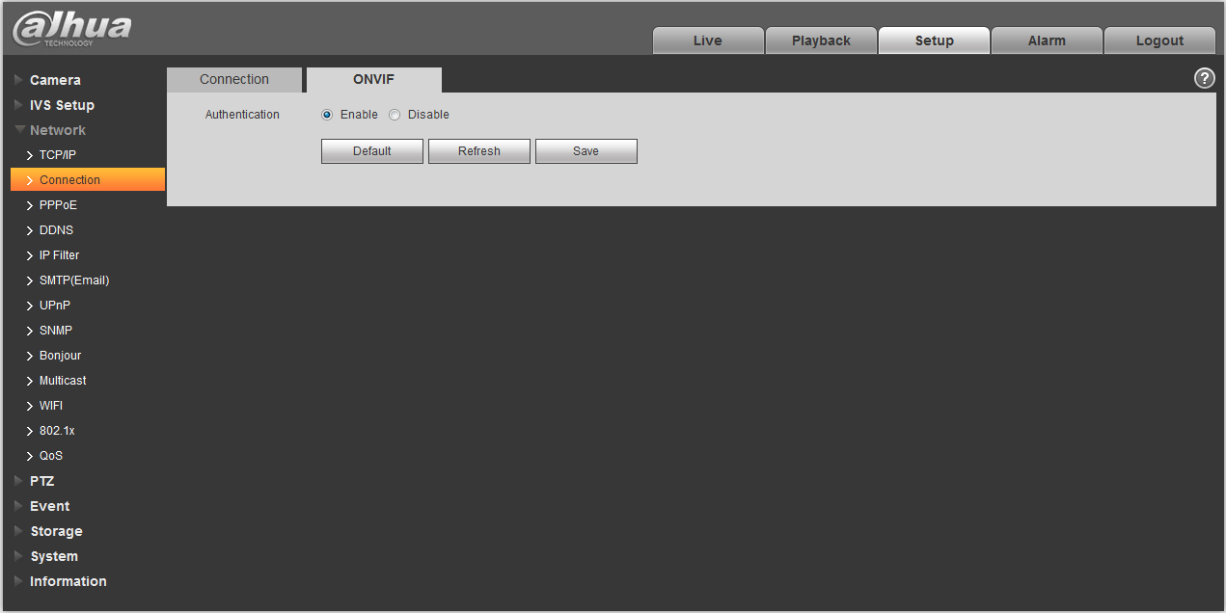
Figure 4-35
Please refer to the following sheet for detailed information.
Parameter | Function
Authentication | The login authentication is off by default.

PPPoE
The PPPoE interface is shown as in Figure 4-36.
Input the PPPoE user name and password you get from the IPS (internet service provider) and enable PPPoE function. Please save current setup and then reboot the device to get the setup activated.
Device connects to the internet via PPPoE after reboot. You can get the IP address in the WAN from the IP address column. When PPPoE is on, please disable UPnP to avoid influence on dial-up.
When you Check PPPoE enable, please disable UPnP.
Please note, you need to go to the IP address item to via the device current device information. You can access the client-end via this address.
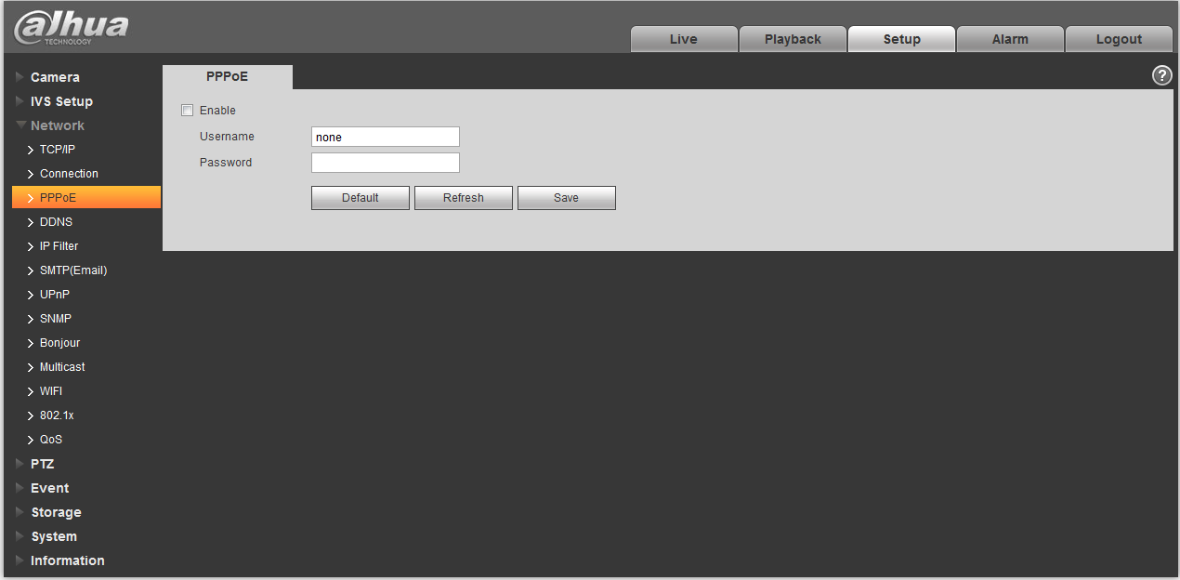
Figure 4-36

DDNS
The DDNS interface is shown as in Figure 4-37.
The DDNS is to set to connect the various servers so that you can access the system via the server. Please go to the corresponding service website to apply a domain name and then access the system via the domain. It works even your IP address has changed. When the device connects to WLAN, you should disable UPnP.
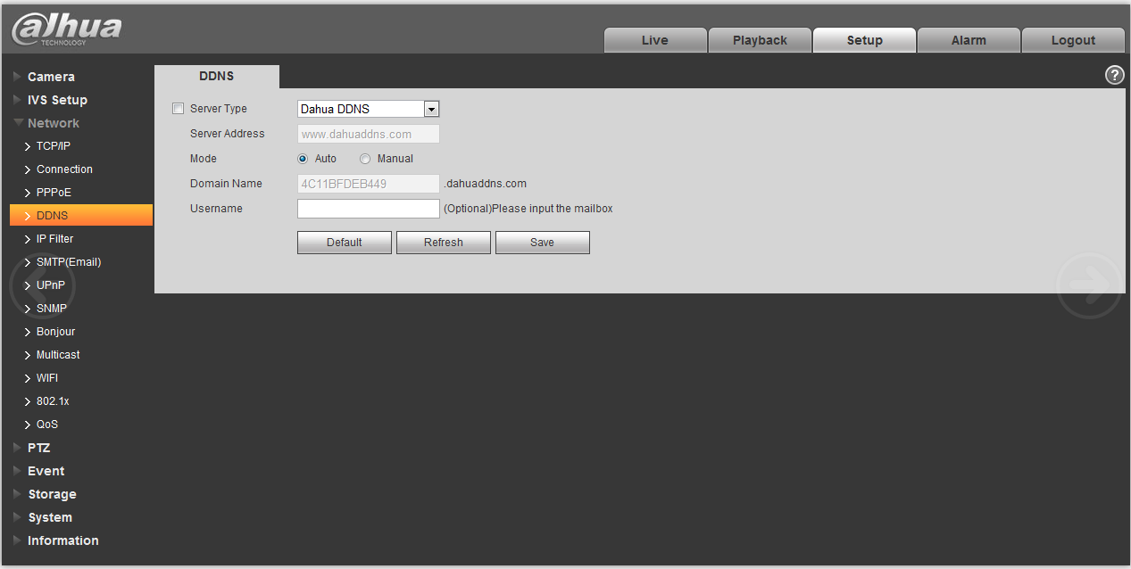
Figure 4-37
Please refer to the following sheet for detailed information.
Parameter | Function
Server Type | You can select DDNS protocol from the dropdown list: CN99 DDNS, NO-IP DDNS, Dyndns DDNS, and Dahua DDNS. The Dahua DDNS protocol means you use your self-defined private protocol to realize DDNS function.
Server Address | DDNS server IP address
Domain Name | Your self-defined domain name.
Username | The user name you input to log in the server.
Password | The password you input to log in the server.
Update period | Device sends out alive signal to the server regularly. Default is 10min.

The Dahua DDNS interface is shown as in Figure 4-38.
Figure 4-38
Please refer to the following sheet for detailed information.
Parameter | Function
Server Type | You can select DDNS protocol from the dropdown list and then enable DDNS function. The Dahua DDNS means you use your self-defined private protocol to realize DDNS function.
Server Address | DDNS server IP address. Under DDNS the default server address is www.dahuaddns.com
Mode | The default is auto, and you can select manual.
Domain Name | Auto and self-defined domain names are both MAC address.quickddns.com. You can self-define prefix.
Test | It is to test domain name. It is available only under manual mode.
Username | The user name you input to log in the server. Optional.

IP filter
The IP filter interface is shown as in Figure 4-39.
You can enable IP filter function so that some specified IP/MAC user can access the speed dome .
You can add IP address or IP address section.
If you do not check the box here, it means there is on access limit.
Here you can add IP address and MAC address. You must add these addresses before enabling the trusted sites.
Please note: You must set MAC address in the same network segment.
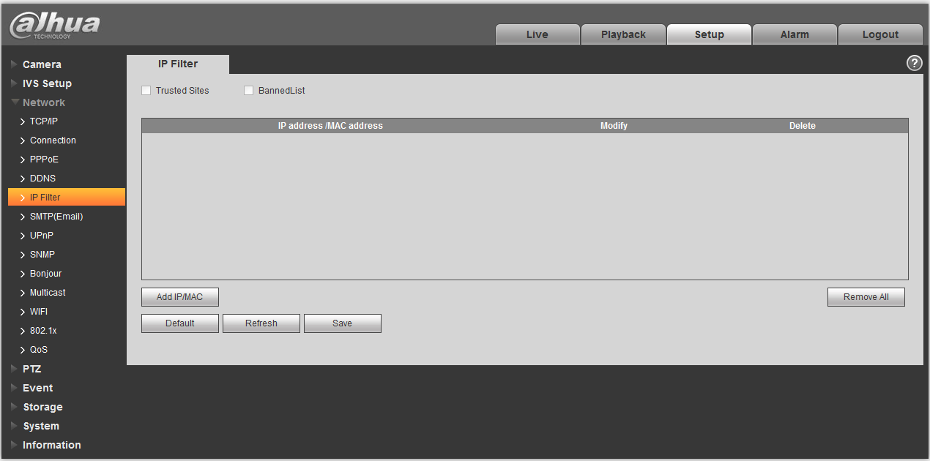
Figure 4-39

SMTP （e-mail)
The SMTP interface is shown as in Figure 4-40.
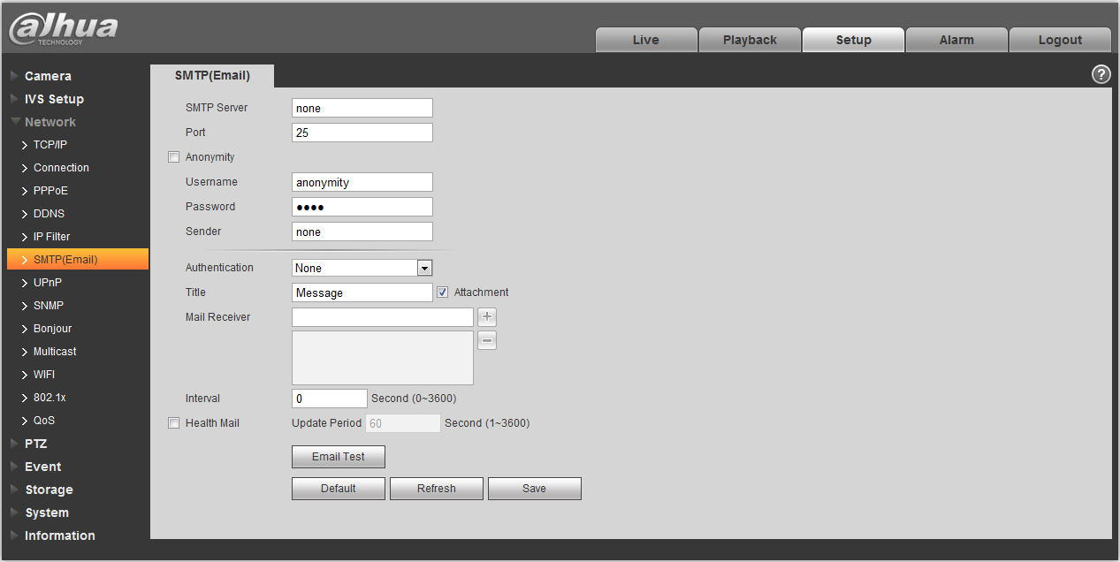
Figure 4-40
Please refer to the following sheet for detailed information.
Parameter | Function
SMTP Server | Input server address and then enable this function.
Port | Default value is 25. You can modify it if necessary.
Anonymity | For the server supports the anonymity function. You can auto login anonymously. You do not need to input the user name, password and the sender information.
User Name | The user name of the sender email account.
Password | The password of sender email account.
Sender | Sender email address.
Authentication (Encryption mode) | You can select SSL, TLS or none.
Title (Subject) | Input email subject here.
Attachment | System can send out the email of the snapshot picture once you check the box here.
Mail receiver | Input receiver email address here. Max three addresses.
Interval | The send interval ranges from 0 to 3600 seconds. 0 means there is no interval.  Please note system will not send out the email immediately when the alarm occurs. When the alarm, motion detection or the abnormity event activates the email, system sends out the email according to the interval you specified here. This function is very useful when there are too many emails activated by the abnormity events, which may result in heavy load for the email server.
Health mail enable | Please check the box here to enable this function.
Email test | The system will automatically sent out a email once to test the connection is OK or not .Before the email test, please save the email setup information.

UPnP
It allows you to establish the mapping relationship between the LAN and the public network.
Here you can also add, modify or remove UPnP item. For UPnP on different routers, you must disable UPnP function. See Figure 4-41.
In the Windows OS, From Start->Control Panel->Add or remove programs. Click the “Add/Remove Windows Components” and then select the “Network Services” from the Windows Components Wizard.
Click the Details button and then check the “Internet Gateway Device Discovery and Control client” and “UPnP User Interface”. Please click OK to begin installation.
Enable UPnP from the Web. If your UPnP is enabled in the Windows OS, the speed dome can auto detect it via the “My Network Places”.
Under manual mode, you can add, delete or modify mapping. Under auto mode, select idle port for auto port mapping without user modification.

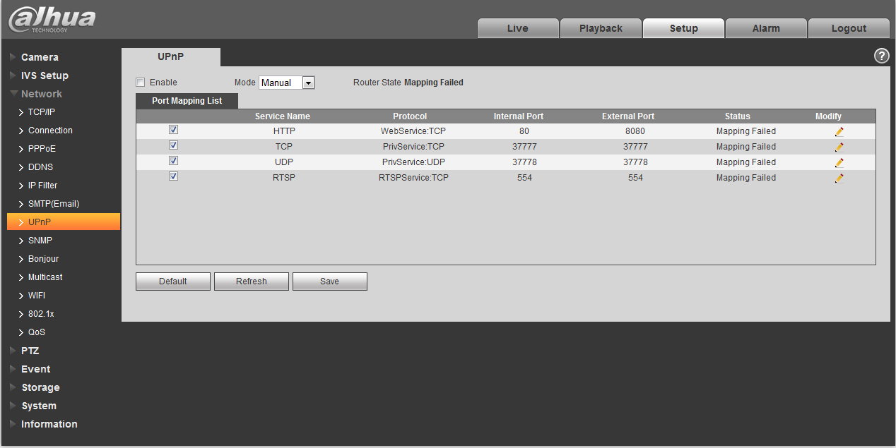
Figure 4-41

SNMP
The SNMP interface is shown as in Figure 4-42.
The SNMP allows the communication between the network management work station software and the proxy of the managed device. Please install the software such as MG MibBrowser 8.0c software or establish the SNMP service before you use this function. You need to reboot the device to activate the new setup.
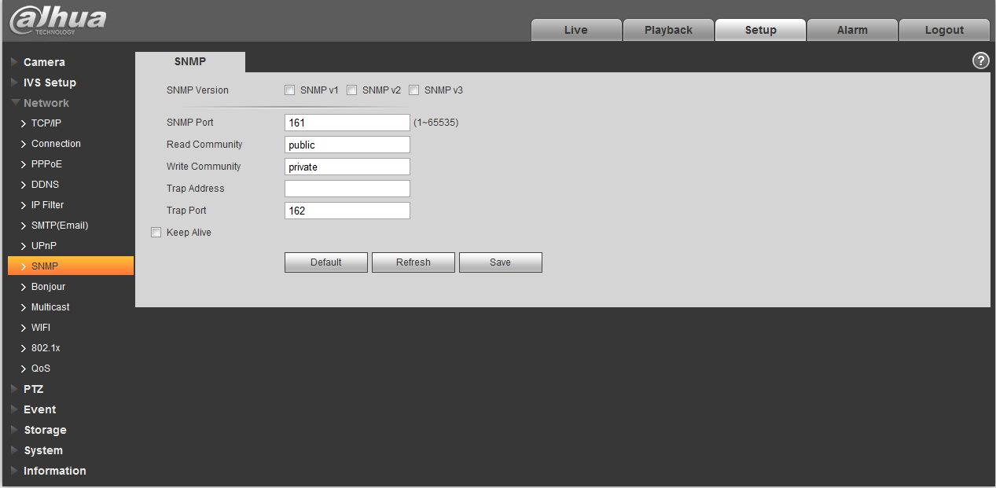
Figure 4-42
Please refer to the following sheet for detailed information.
Parameter | Function
SNMP Version | - Check SNMP v1, device only process v1 info.  - Check SNMP v2, device only process v2 info.  - Check SNMP v3, can set username, password and encryption method. Server calibrate corresponding username, password and encryption method too access device and v1/v2 are unavailable.
SNMP port | The listening port of the proxy program of the device. It is a UDP port not a TCP port. The value ranges from 1 to 65535. The default value is 161
Community | It is a string, as command between management and proxy, , defining a proxy, and a manager’s authentication.
Read community | Read-only access to all SNMP targets, default is public.  Note: Only number, letter, _, and – supported.
Write community | Read/write access to all SNMP targets, default is private.  Note: Only number, letter, _, and – supported.
Trap address | The destination address of the Trap information from the proxy program of the device.
Trap | SNMP trap is a proxy message sent to admin as important event notice or status change.
Trap Address | Address where to send Trap message.
Trap Port | Port which send Trap message, default is 162, range 1~65535.
Check SNMP v3 version and SNMP port, read community, write community, Trap address, Trap port are same with SNMP v1 and SNMP v2 versions. Only when SNMP version is SNMP v3, user need to configure parameter in chart. See Figure 4-43.
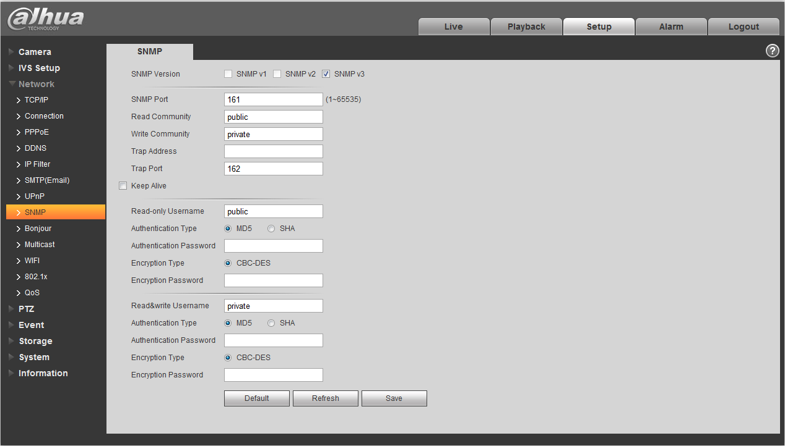
Figure 4-43
Please refer to the following sheet for detailed information.
Parameter | Function
SNMP Version | SNMP v3
Read-only Username | Default is public.  Note:  Name only can be number, letter and underline.
Read/Write Username | Default is private.  Note:  Name only can be number, letter and underline.
Authentication | You may select MD5 or SHA, default is MD5.
Authentication Password | Password not less than 8 characters.
Encryption | Default is CBC-DES.
Encryption Password | Password not less than 8 characters.

Bonjour
The Bonjour interface is shown as below. See Figure 4-44.
Bonjour is based on the multicast DNS service from the Apple. The Bonjour device can automatically broadcast its service information and listen to the service information from other device.
You can use the browse of the Bonjour service in the same LAN to search the speed dome device and then access if you do not know the speed dome information such as IP address.
You can view the server name when the speed dome is detected by the Bonjour. Please note the safari browse support this function. Click the “Display All Bookmarks: and open the Bonjour, system can auto detect the speed dome of the Bonjour function in the LAN.
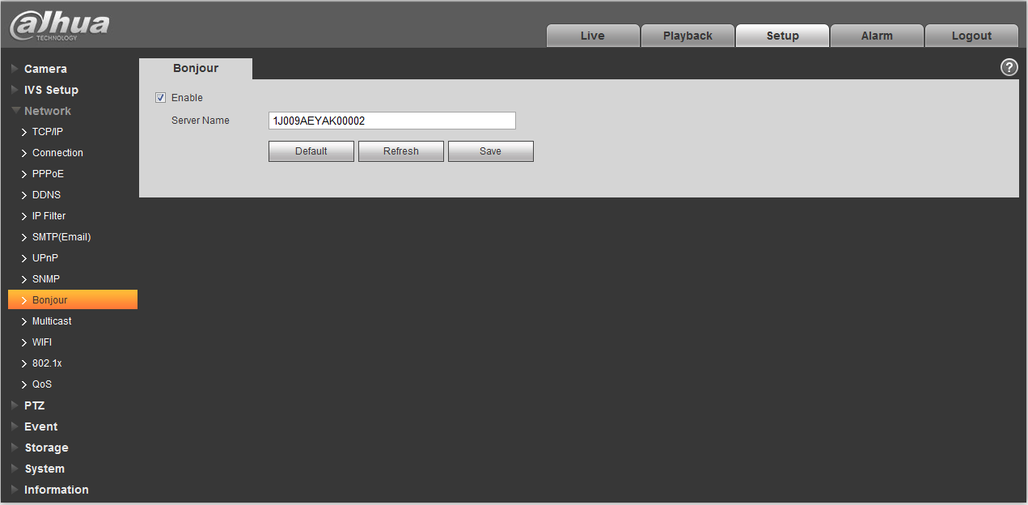
Figure 4-44

Multicast
The multicast interface is shown as in Figure 4-45.
Multicast is a transmission mode of data packet. When there is multiple-host to receive the same data packet, multiple-cast is the best option to reduce the broad width and the CPU load. The source host can just send out one data to transit. This function also depends on the relationship of the group member and group of the outer.
Note:
- Open preview, streaming media protocol, select multicast, and monitor via multicast format.
- Here you can set multicast address and port. You also need to go to Live interface to set the protocol as Multicast.
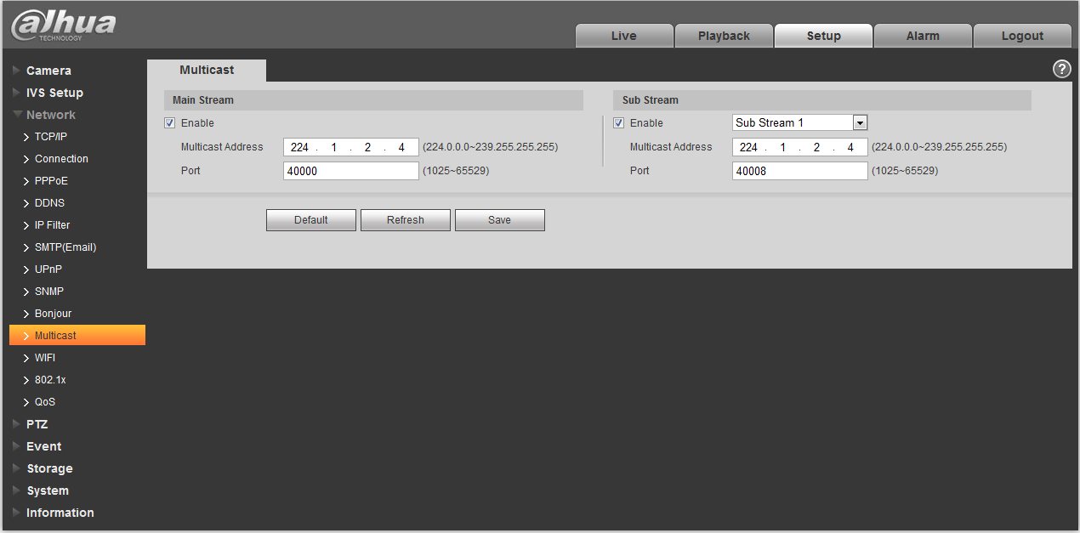
Figure 4-45
Please refer to the following sheet for detailed information.
Parameter | Function
Enable | Select to enable multicast function. Main stream and sub stream cannot be used at the same time.
Multicast address | Main/sub stream multicast default address is 224.1.2.4 and its range is 224.0.0.0～239.255.255.255.
Port | Multicast port. Main stream is 40000, sub stream is 40002 and the range is 1025～65534.

WIFI
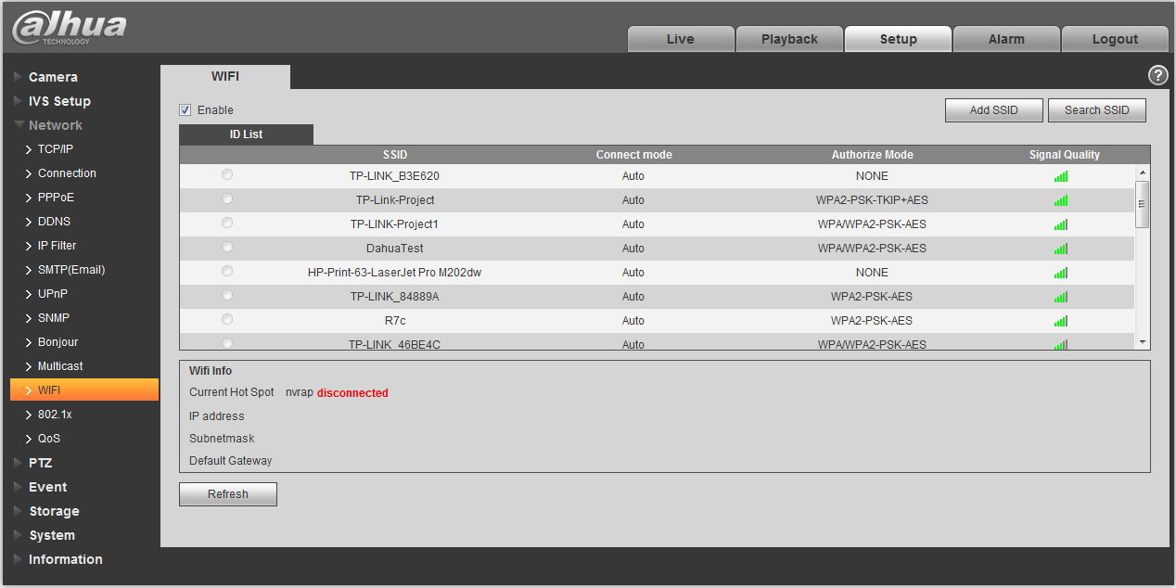
Figure 4-46
Parameter | Note
Enable | Check “Enable” to enable WIFI function.
Add SSID | After it is enables, click “Add SSID”, add network ID in the dialog box, then it needs to click “Search SSID” to confirm if the network ID is available. It means the network ID is available if it can search the hotspot of the wireless network.
Search SSID | After it is enabled, click “Search SSID’, then it will display the wireless network hotspot in the current environment for the network camera in the list, double click one of the item to pop up the signal intensity and authentication method, please enter password if necessary.

Note:
- Please keep the password index number same as that of the router when entering the password. Please click “Connect” directly.
- The WIFI information column can display the name, state and IP info of the hotspot which is being connected. Generally it needs some time to connect to WIFI hotspot according to the network signal intensity, so generally it needs to click “Refresh” after it is reconnected, in this way the WIFI work information column can guarantee the realtime display of working state.

802.1x
802.1x (port based network access control protocol) supports manual selection of authentication method to control if device connected to LAN can join the LAN. It well supports authentication, charging, safety and management requirement of network. See Figure 4-47.
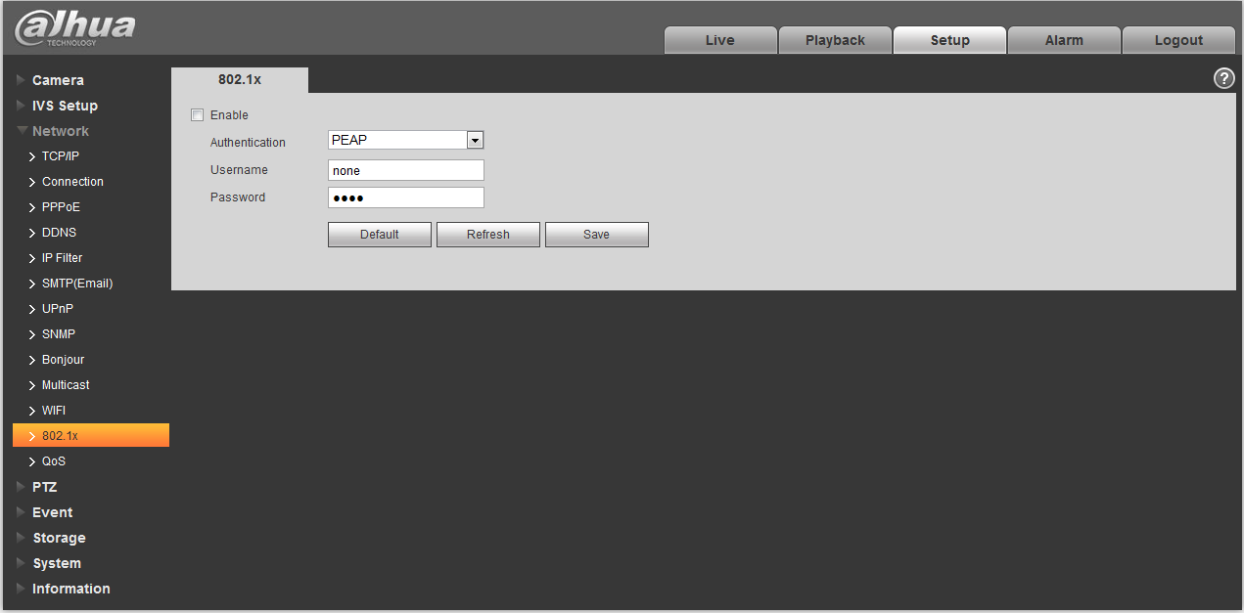
Figure 4-47
Please refer to the following sheet for detailed information.
Parameter | Function
Authentication | PEAP (protected EAP protocol).
Username | It needs the username to login, which is authenticated by the server.
Password | Please input password here.

QoS
The QoS interface is shown as below. See Figure 4-48.
Qos (Quality of Service) is network security mechanism. It is a technology to fix the network delay and jam problem and etc. For the network service, the quality of service includes the transmission bandwidth, delay, the packet loss and etc. We can guarantee the transmission bandwidth, lower the delay, reduce the loss of the data packet and anti-dither to enhance the quality.
We can set the DSCP (Differentiated Services Code Point) of the IP to distinguish the data packet so that the router or the hub can provide different services for various data packets. It can select the different queues according to the priority (64 different priority levels) of the packets and select the bandwidth of the each queue. Level 0 is the lowest, and level 63 is the highest. It can also discard at the different ratio when the broad bandwidth is jam.
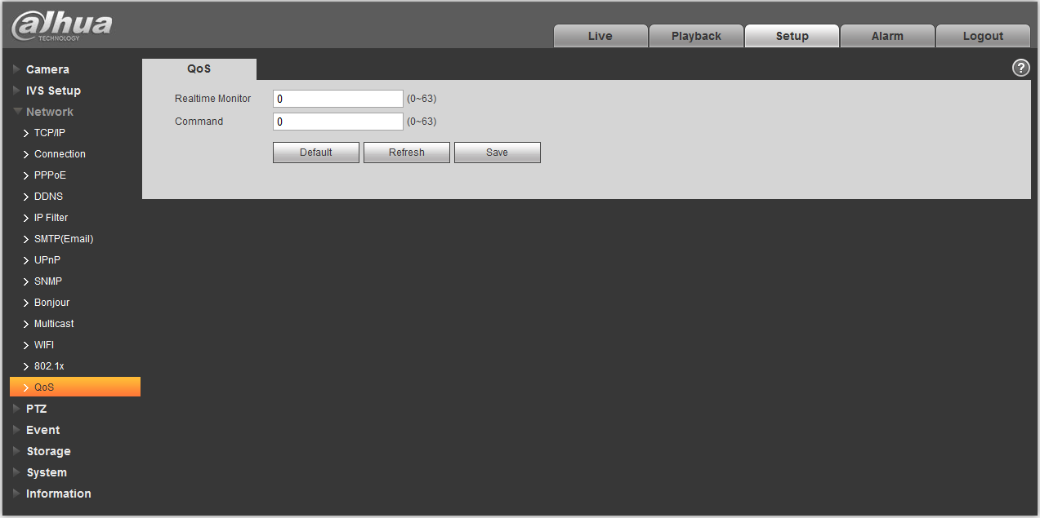
Figure 4-48
Please refer to the following sheet for detailed information.
Parameter | Function
Real-time monitor | The value ranges from 0 to 63. The router or the switcher can provide different service for various data packets.
Command | The value ranges from 0 to 63. The router or the switcher can provide different service for various data packets.

PTZ

Function
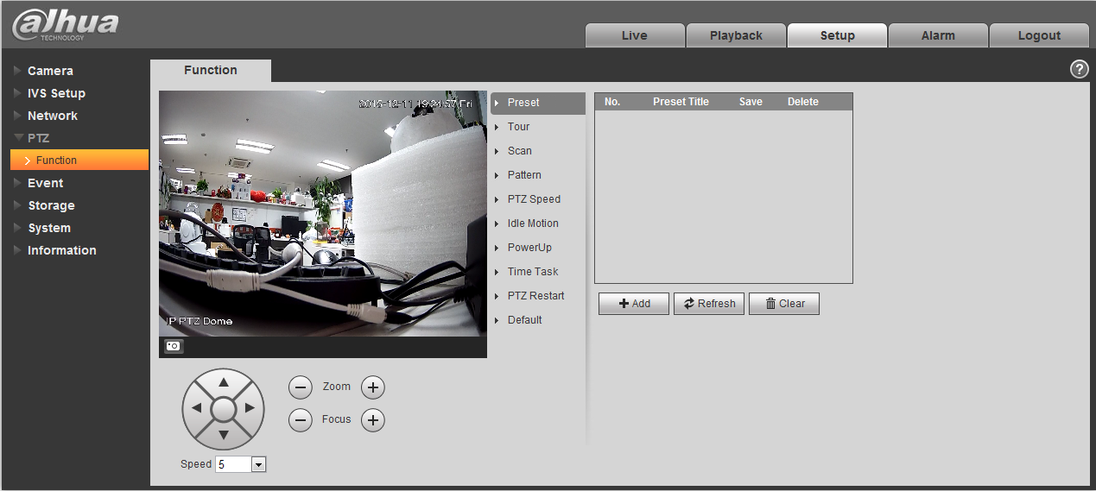
Figure 4-49
In this part, you can operate the PTZ of the camera and control PTZ movement.

Parameter | Function
Preset | Set camera preset.
Tour | Set camera tour. Max 8 tours.
Scan | Set camera scan.
Pattern | Set camera pattern.
PTZ speed | Set PTZ movement speed.
Idle motion | Set camera idle operation.
Power up | Set camera operation when system boots up.
Time Task | Set camera time task.
PTZ restart | Restart camera PTZ.
Default | Restore camera PTZ default setup.

Preset
Preset interface is shown as in Figure 4-50.
Figure 4-50
Please refer to the following sheet for detailed information.
Parameter | Function
Preset No. | Set preset No. It becomes valid after you set.
Preset title | Set preset name. You can input self-defined preset name here.
Delete | Delete corresponding preset.
Save | Save current preset setup.
Add | Click it to add a new preset.
Clear | Clear all presets setup.

Tour
Tour interface is shown as below. See Figure 4-51.
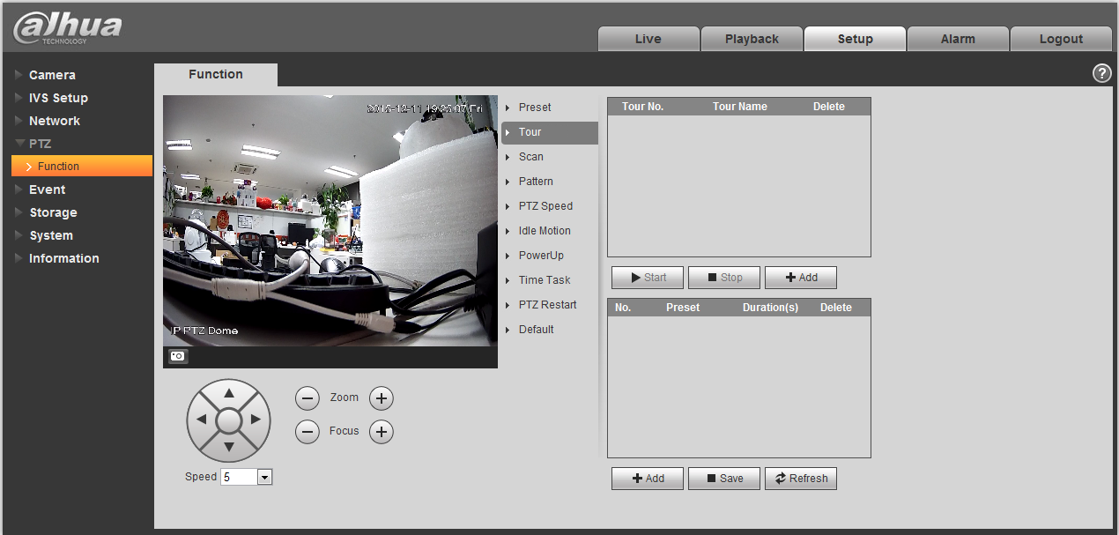
Figure 4-51
Please refer to the following sheet for detailed information.
Parameter | Function
Tour No. | System auto allocates.
Tour title | Set tour name. You can input self-defined tour name here.
Start | Begin tour.  Please note this function is null if you have not set a tour.
Stop | Stop tour  Please note this function is null if you have not set a tour
Add | Click it to add a new tour.
Preset | Click Add button, you can add a new tour. The default preset value is 1.  Double click tour No, you can see a dropdown list for you to select.  Please set presets before you use tour function.
Duration (Interval) | It is to set the staying time of the tour.
Save | Click it to save current setup.
Refresh | Refresh current interface.

Scan
Scan interface is shown as below. See Figure 4-52.
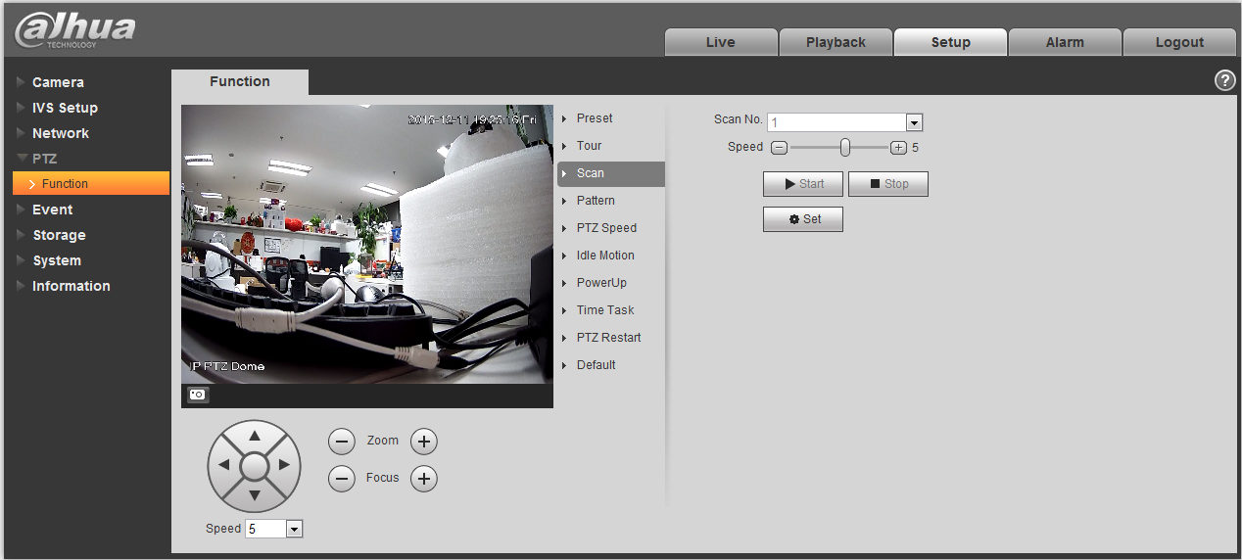
Figure 4-52
Please refer to the following sheet for detailed information.
Parameter | Function
Scan No. | System auto allocates.
Speed | Set scan speed here.  You cannot set speed when camera is running scan.
Start | Begin scan.  Please note this function is null if you have not set a scan.
Stop | Stop scan  Please note this function is null if you have not set a scan
Set | Click set button, you can set left limit and right limit.
Left limit | Set camera left limit.
Right limit | Set camera right limit.

Pattern
Pattern interface is shown as below. See Figure 4-53.
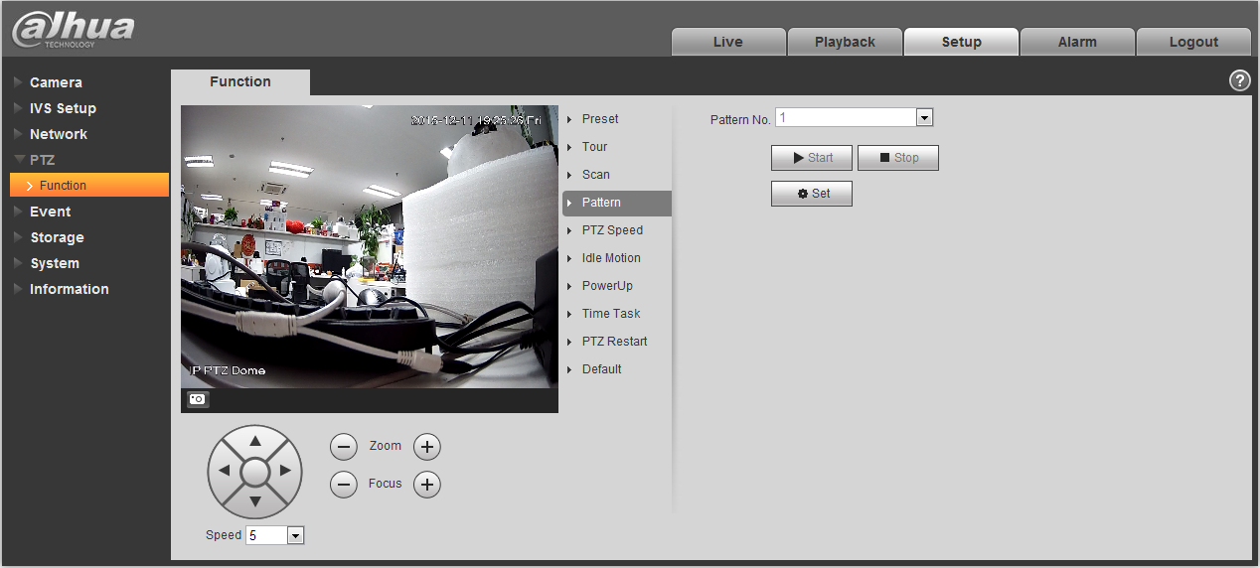
Figure 4-53
Please refer to the following sheet for detailed information.
Parameter | Function
Pattern No. | System auto allocates.
Start | Begin pattern.  Please note this function is null if you have not set a pattern.
Stop | Stop pattern  Please note this function is null if you have not set a pattern
Set | Click it you can see start/stop record buttons.
Start record | Click it to begin recording pattern setup.
Stop record | Click it to stop recording pattern setup.

PTZ speed
PTZ speed interface is shown as below. See Figure 4-54.
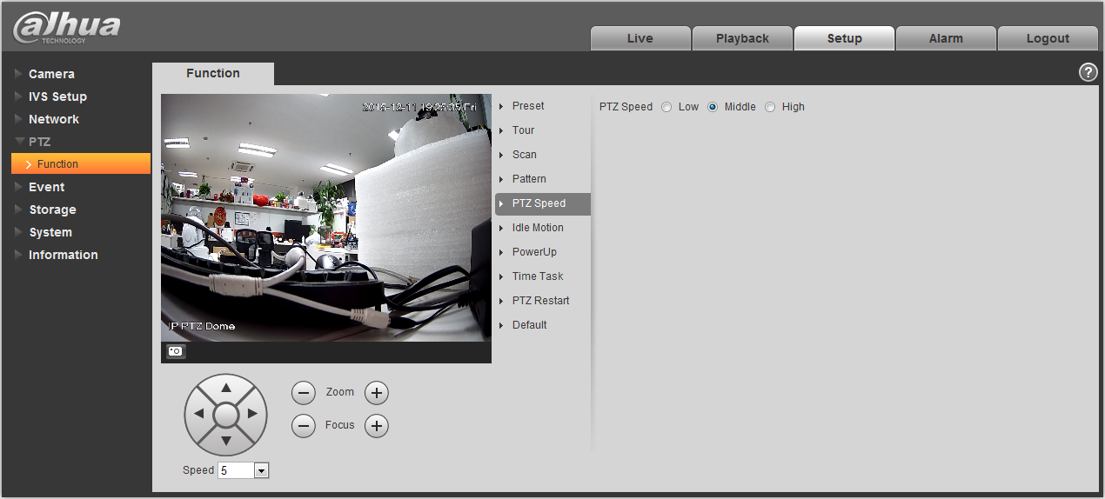
Figure 4-54
Please refer to the following sheet for detailed information.
Parameter | Function
PTZ speed | Here you can set camera PTZ speed.

Idle Motion
Idle motion interface is shown as below. See Figure 4-55.
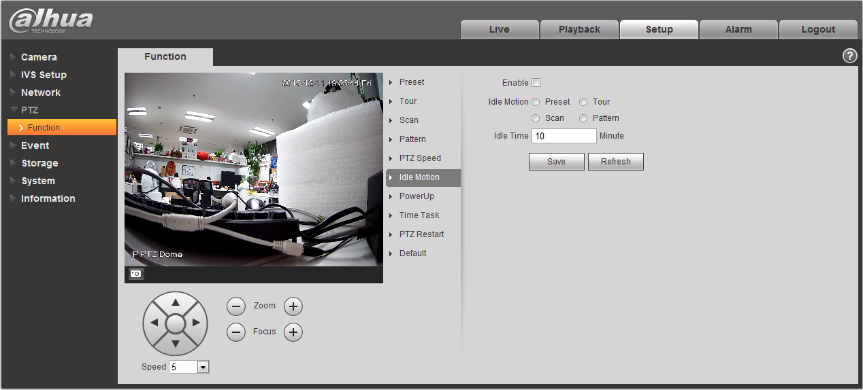
Figure 4-55
Please refer to the following sheet for detailed information.
Parameter | Function
Enable | Check the box here to enable idle motion function.
Idle Motion | Here you can set preset, scan, pattern, tour.  Please note you need to set the corresponding operation first if you want to use this function.
Idle time | Set idle time.

Power up
Power up interface is shown as below. See Figure 4-56.
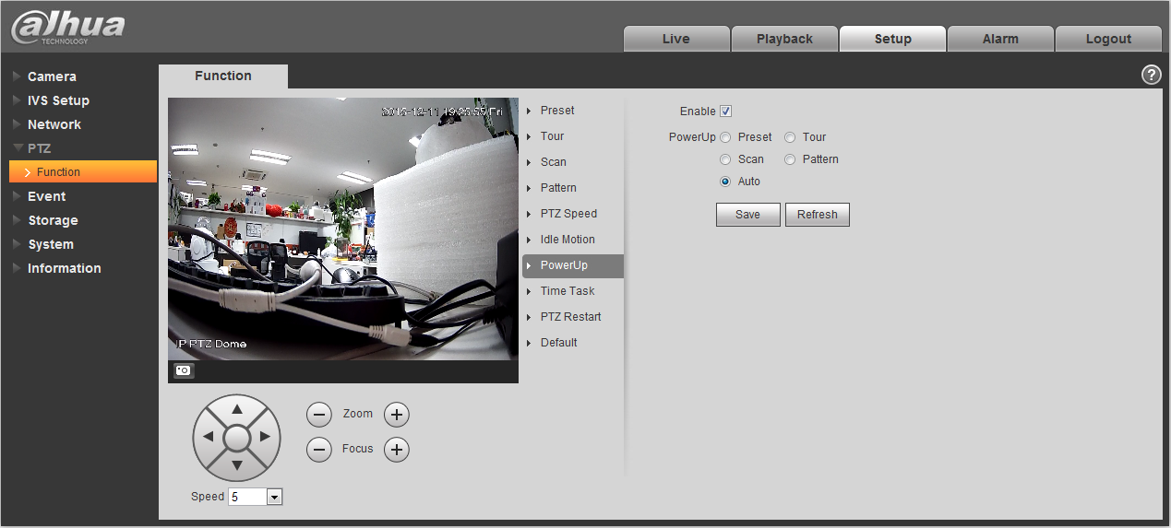
Figure 4-56
Please refer to the following sheet for detailed information.
Parameter | Function
Enable | Check the box here to enable power up function.
Power up | Here you can set preset, scan, pattern, tour and auto.  Please note you need to set the corresponding function first if you want to use it.

Time Task
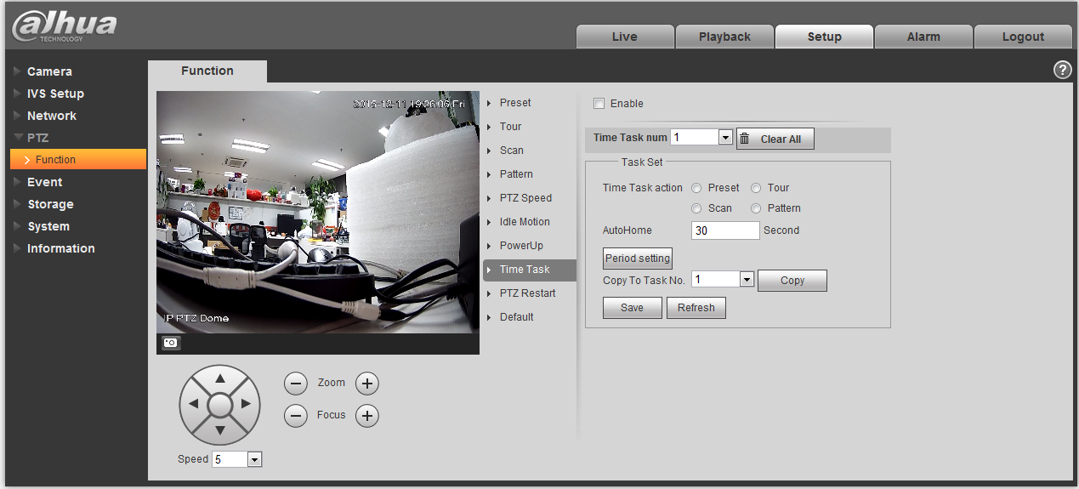
Figure 4-57
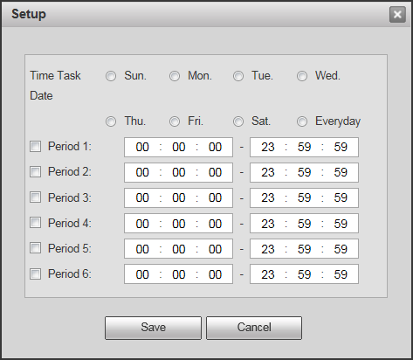
Figure 4-58

Parameter | Note
Enable | It is to enable time task function.
Task Action | It is to set the time task action, such as preset, tour, scan and pattern.
Auto Home | When call PTZ artificially and interrupt time task, it can auto restore the time that time task needs.
Period Setting | It is to set the exact period of time task, click “setting” to set.
Copy to Task No | Click “Copy” to copy the well-set task information to the designated task  number.

PTZ Restart
PTZ restart interface is shown as below. See Figure 4-59.
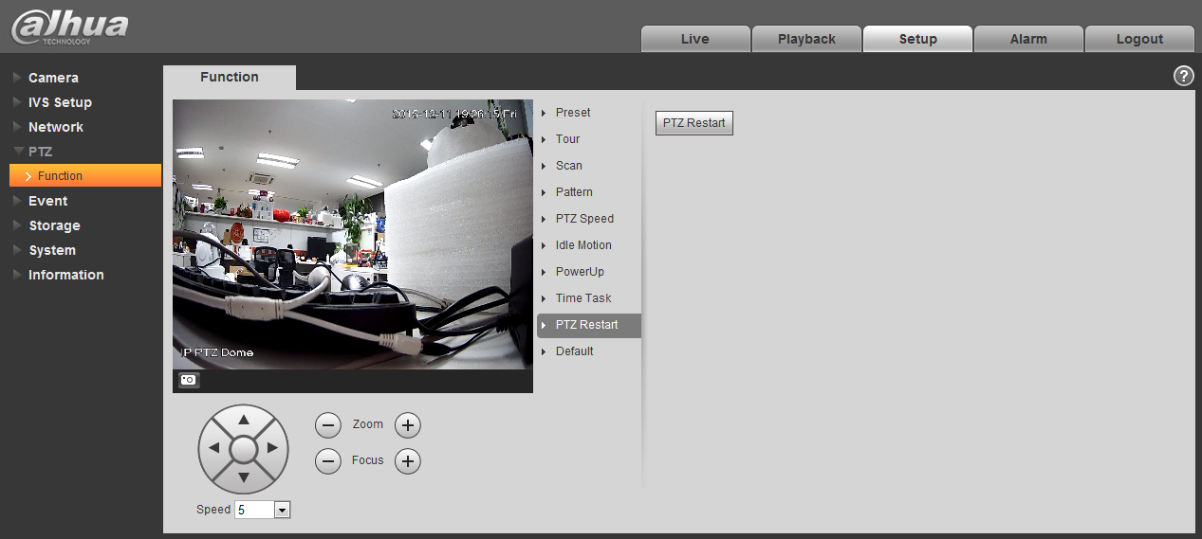
Figure 4-59
Please refer to the following sheet for detailed information.
Parameter | Function
PTZ restart | It is to reboot PTZ.

Default
Default interface is shown as below. See Figure 4-60.
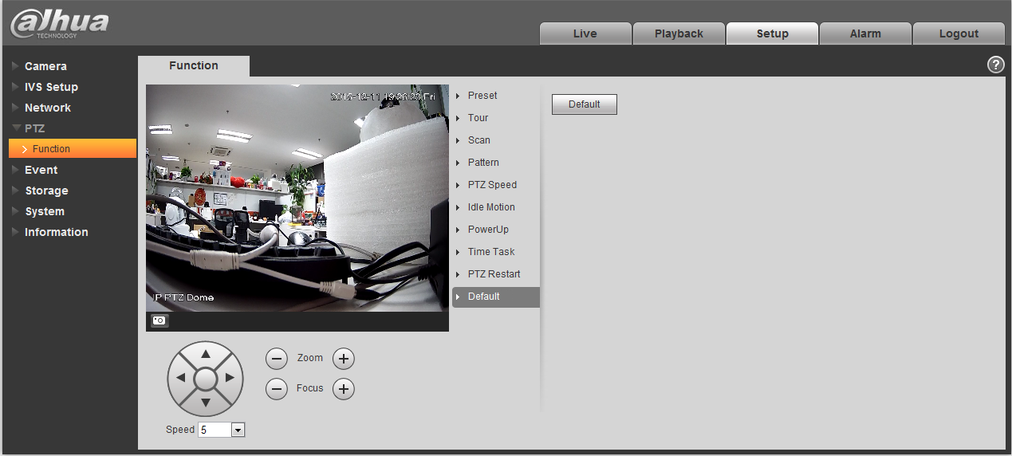
Figure 4-60
Please refer to the following sheet for detailed information.
Parameter | Function
Default | Restore PTZ factory default setup.

Event

Video detect

Motion Detect
The motion detect interface is shown as in Figure 4-61 through Figure 4-64.
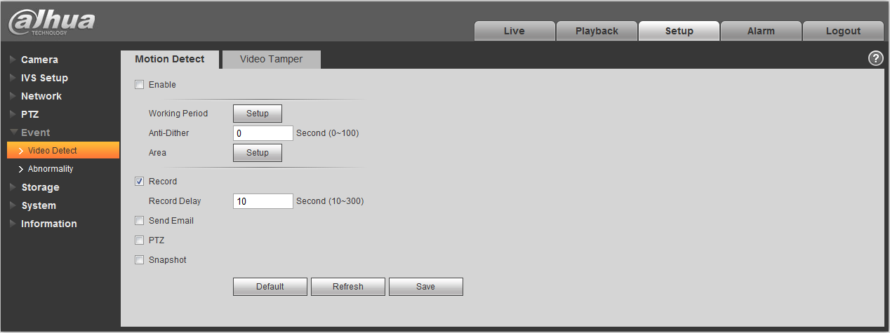
Figure 4-61
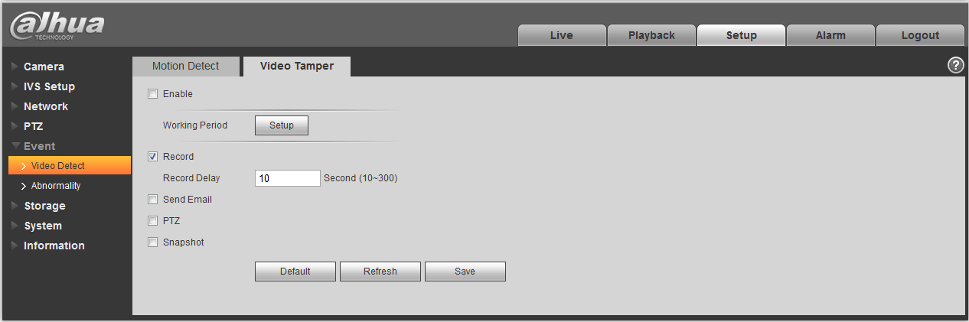
Figure 4-62
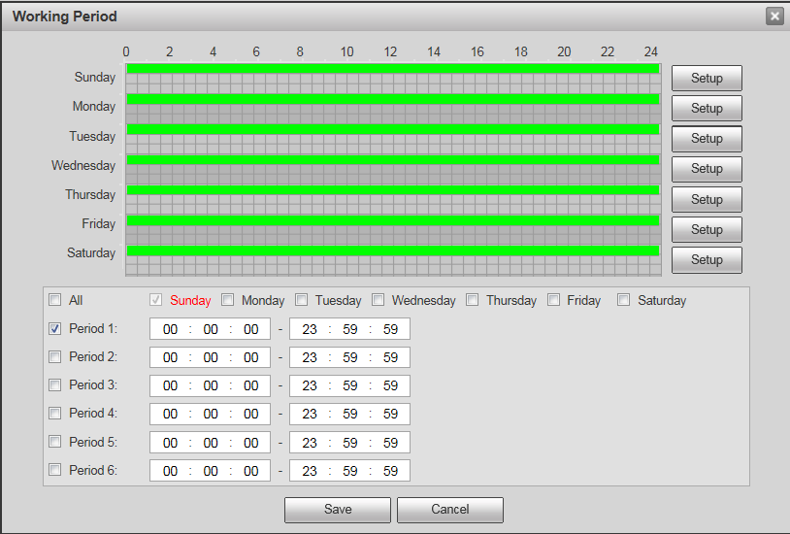
Figure 4-63
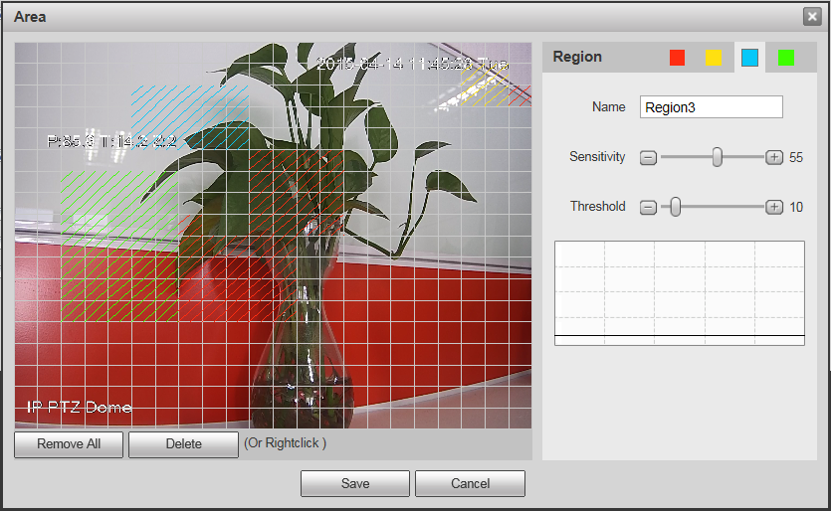
Figure 4-64
Please refer to the following sheet for detailed information.
Parameter | Function
Enable | You need to check the box to enable motion detection function.
Working Period | Here you can set arm/disarm period. Click set button to open period setup menu. See Figure 4-.  There are six periods every day for setup and you must check box in front of each period to enable it.  Note: Period setup can be done by dragging mouse while not release left mouse.
Anti-dither | System only memorizes one event during the anti-dither period. The value ranges from 0s to 100s.
Area | Here you can set motion detection region and its sensitivity and area. (The higher the sensitivity is, the easier to trigger motion detect; the smaller the area, the easier to trigger motion detect.) The default covers all regions. You must click save before enabling your setup. See Figure 4-.
Record | Check it and so when alarm occurs, system will auto record. You shall set record period in Storage>Schedule and select auto record in record control interface.
Record Delay | System can delay the record for specified time after alarm ended. The value ranges from 10s to 300s.
Send Email | If you enabled this function, System can send out email to alert you when alarm occurs and ends. User can set email address in Network>SMTP.
PTZ | - Here you can set PTZ movement when alarm occurs. Such as go to preset x when there is an alarm.  - The event type includes: preset, tour and pattern.
Snapshot | You need to check the box here so that system can backup motion detection snapshot file. You shall set snapshot period in Storage>Schedule.
The zone setup interface is shown as Figure 4-. Different colors represent different areas. Each area can set different detection zones. Detection zone cam be irregular and discontinuous. If device monitoring zone is large, user can sub-divide the area into several zones for better motion detect.
Please refer to the following sheet for detailed information.
Parameter | Function
Name | Default area name includes Region0, Region1, Region2, Region3 and custom.
Sensitivity | It is sensitivity of brightness as motion detection is more possible to be trigger with high sensitivity. You can set up to four areas. The range is 0~100. The recommenced value is 30~70.
Area threshold | It is to check target object area related to detection area. The lower the area threshold, the easier to trigger motion detection. You can set up to four areas. The range is 0~100. The recommenced value is 0~10.
Waveform | Red means motion detect is triggered. Green means motion detect is not triggered.
Delete all | Clear all areas.
Delete | Delete selected area.

Abnormality
Abnormality includes SD Card (Figure 4-65 to Figure 4-67), network (Figure 4-68 to Figure 4-69), and Unauthorized Access (Figure 4-70).
Note: Only device with SD card function has these three statuses: No SD card, capacity warning, and SD card error.
Device without SD card function does not have the above three statuses. 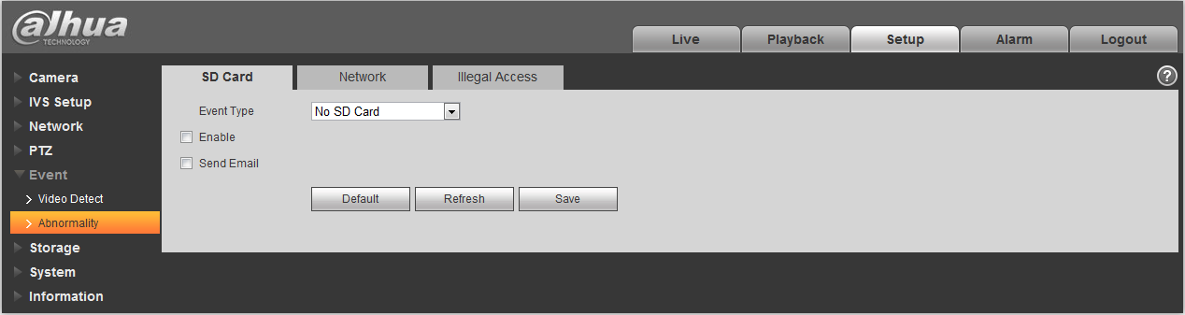
Figure 4-65
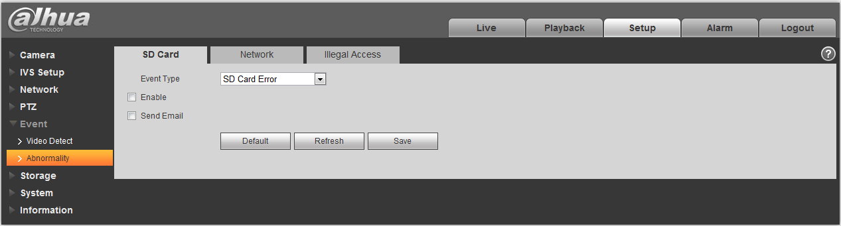
Figure 4-66
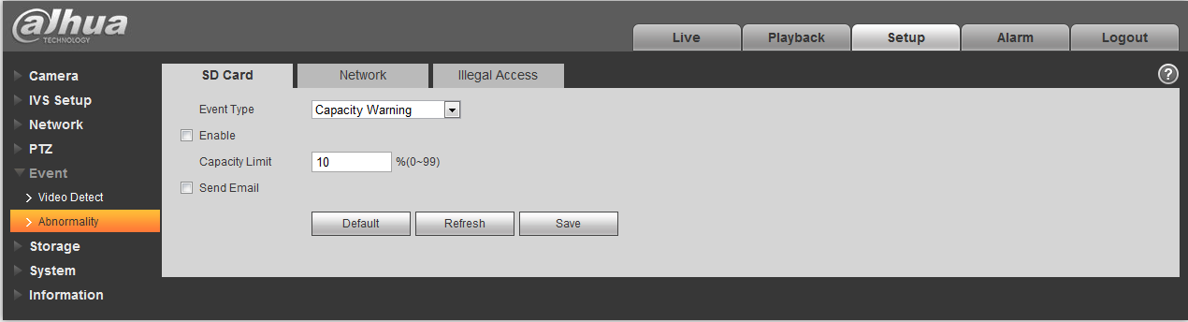
Figure 4-67
Please refer to the following sheet for detailed information.
Parameter | Function
Event Type | There are three kinds of events for SD card abnormality alarm: No SD card, Capacity Warning, SD card error.
Enable | Check to alarm when SD card is abnormal.
Send email | After you enabled this function, the system can send out email to alarm the specified user.  This function is invalid when network is offline or IP conflict occurs.
SD Card Capacity Limit | User can set SD card capacity that is left free. When SD card space left is smaller than this limit, alarm occurs.
When device is offline or IP conflicts, you can go to Figure 4-68 and Figure 4-69 to set.
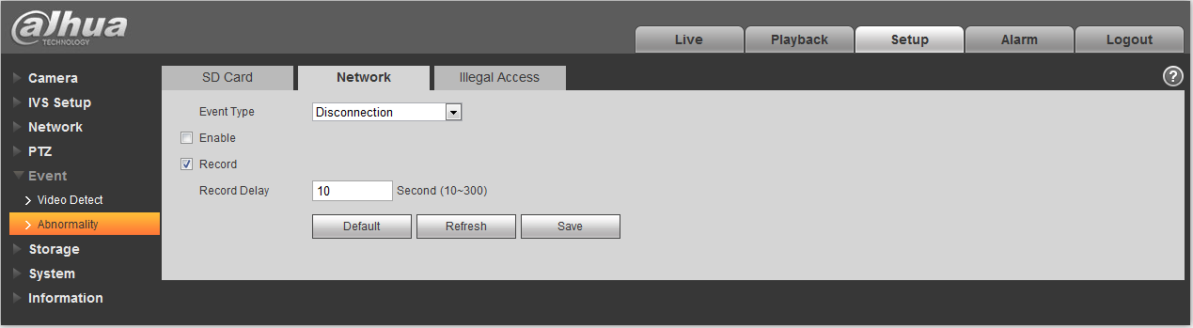
Figure 4-68
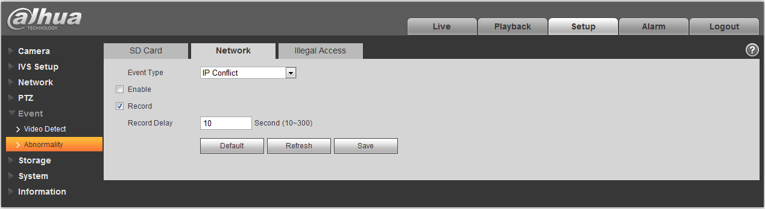
Figure 4-69
When login password keep been wrong for a few times, unauthorized access alarm occurs. This operation is similar to SD card error. Allow login error times as when it exceeds this limit, user account will be locked. See Figure 4-70.
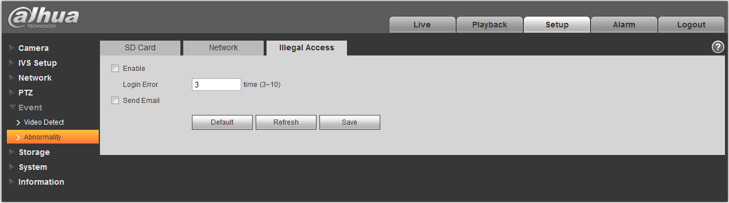
Figure 4-70

Storage Management

Schedule
Before schedule setup, user must set record mode is auto or manual.
Note:
If record mode in record control is off, then device will not snapshoot according to schedule.

Record Schedule
Record schedule steps:
- Click Record Schedule, see Figure 4-71.
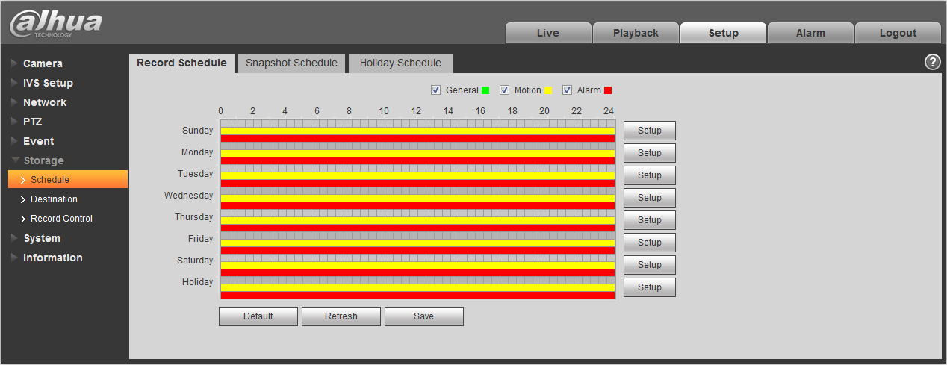
Figure 4-71
- From Monday to Sunday select record time, click setup on the right. See Figure 4-72.
- Set period according to actual need. There are six periods available each day.
- By checking or cancel, you can add or delete three types of record schedule: General, Motion, and Alarm.
Note:
Period setup can be done by dragging in record schedule interface while not releasing left mouse.
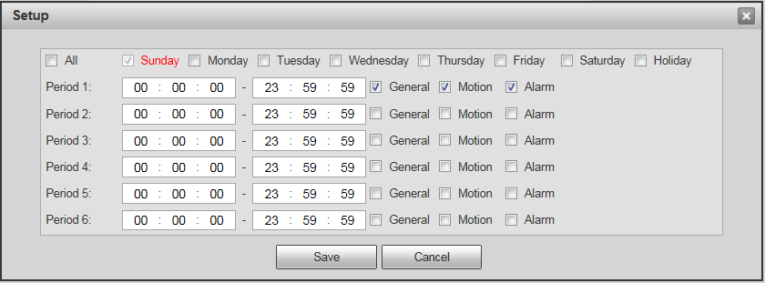
Figure 4-72
- Click OK, return to record schedule interface. See Figure 4-73.
- Green color stands for the general record/snapshot.
- Yellow color stands for the motion detect record/snapshot.
- Red color stands for the alarm record/snapshot.
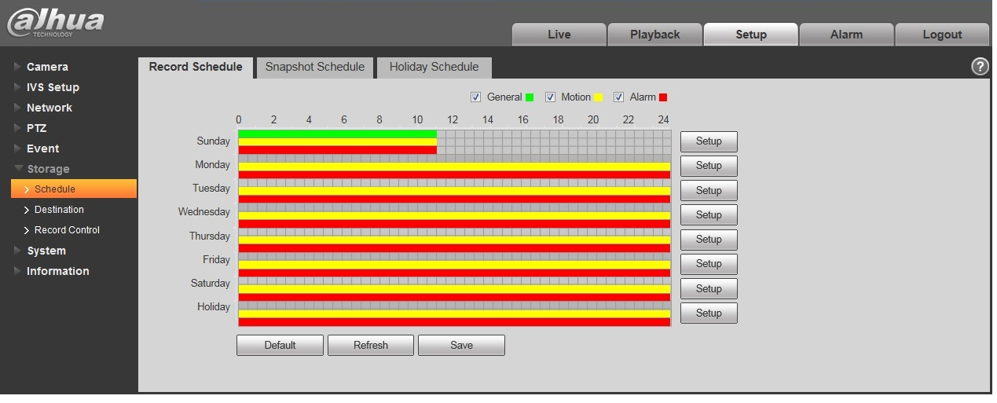
Figure 4-73
- In record schedule interface, click OK. System prompts it is successfully saved.

Snapshot Schedule
Snapshot setup as:
- Click Snapshot Schedule tab, see Figure 4-74.
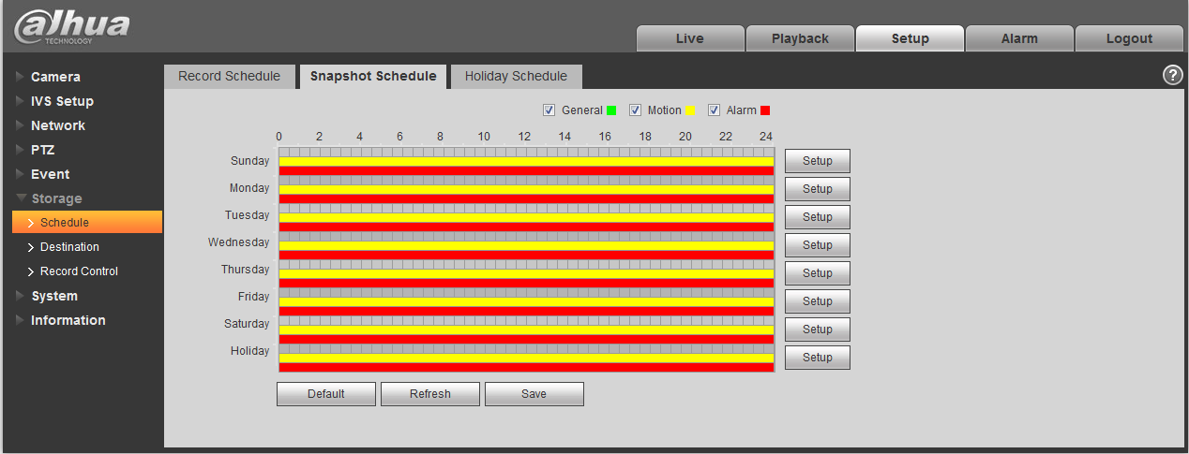
Figure 4-74

- From Monday to Sunday select snapshot time, click setup on the right. See Figure 4-75.
- Set snapshot period according to actual need. There are six periods available each day.
- By checking or cancel, user can add or delete three types of snapshot schedule: General, Motion and Alarm.
Note: Period setup can be done by dragging in snapshot schedule interface while not releasing left mouse.
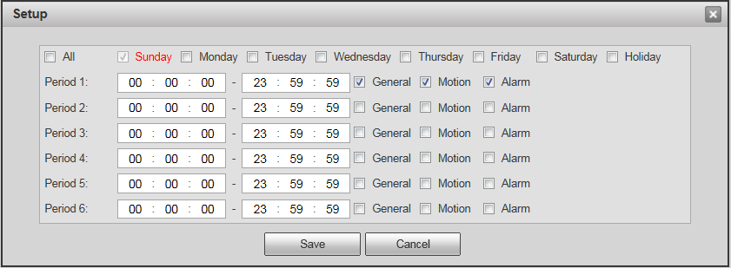
Figure 4-75
- Click OK, return to snapshot schedule interface. See Figure 4-76.
- Green color stands for the general record/snapshot.
- Yellow color stands for the motion detect record/snapshot.
- Red color stands for the alarm record/snapshot.
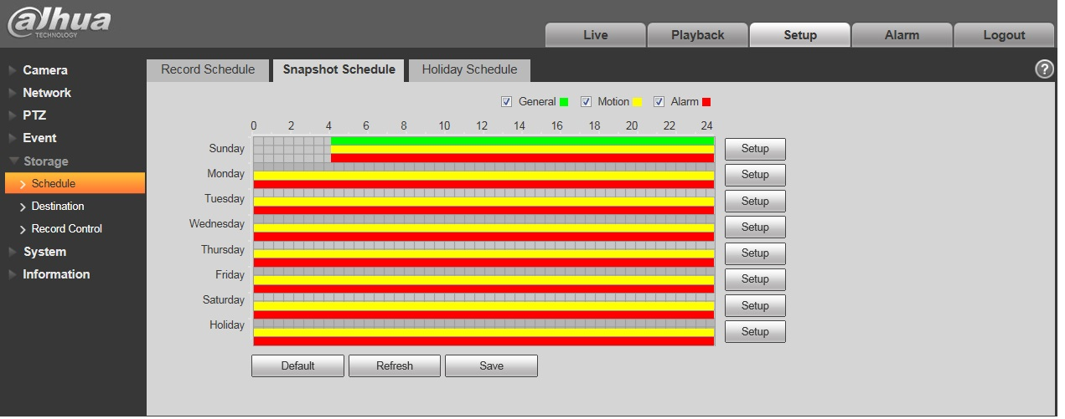
Figure 4-76
- In snapshot interface, click OK. System prompts it is successfully saved.

Holiday Schedule
Holiday schedule can set specific date as holiday.
- Click Holiday Schedule tab. See Figure 4-77.
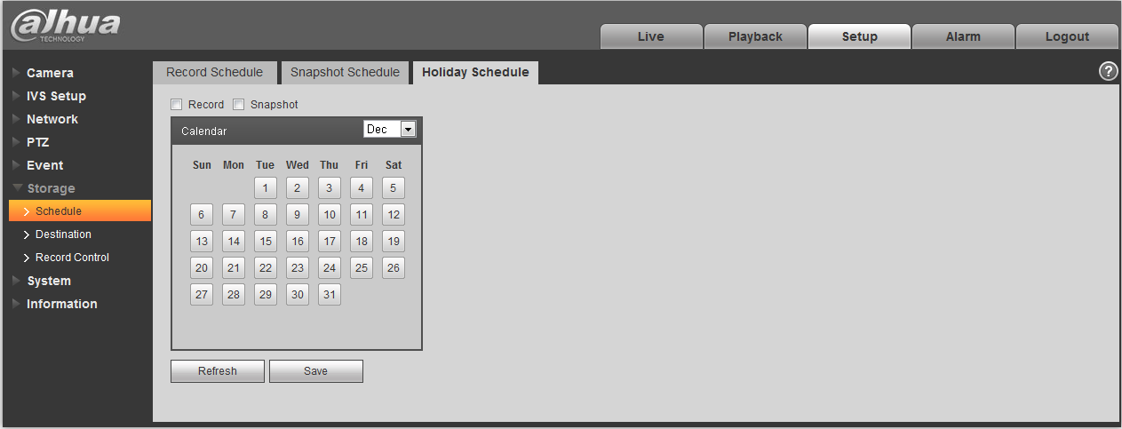
Figure 4-77
- Select date to set as holiday. The selected date will be highlighted in yellow.
- Check Record/Snapshot, click Save. System prompts it is successfully saved.
- Check Record Schedule/Snapshot Schedule interface, click setup next to Holiday, refer to setup of Monday to Sunday.
- Complete setup of holiday, then it records/snapshots according to date in holiday schedule.

Destination

Path
The destination interface is shown as in Figure 4-78.
Path can config record and snapshot storage path. There are three options: Local, FTP and NAS. You can only select one mode. System can save according to the event types. It is corresponding to the three modes (general/motion/alarm) in the Schedule interface. Please check the box to enable the save functions.
Note: Only device supports SD card has local.
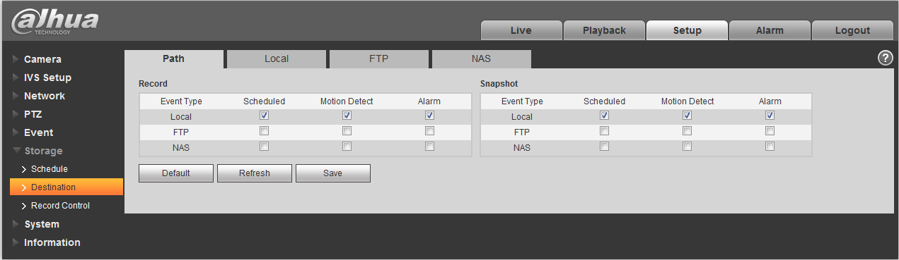
Figure 4-78
Please refer to the following sheet for detailed information.
Parameter | Function
Event Type | It includes: scheduled, motion detect and alarm.
Local | It saved in the SD card.
FTP | It saved in the FTP server.
NAS | It saved in NAS disk.

Local
The local interface is shown as in Figure 4-79.
Here you can view local Micro SD card or NAS disk information. You can also operate the read-only, write-only, hot swap and format operation.
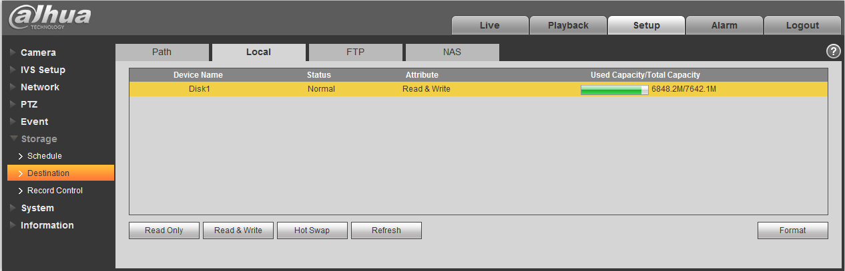
Figure 4-79

FTP
The FTP interface is shown as in Figure 4-80.
You need to check the box to enable the FTP function. When network disconnect occurred or there is malfunction. Emergency storage can save the record/snapshot picture to the local SD card.
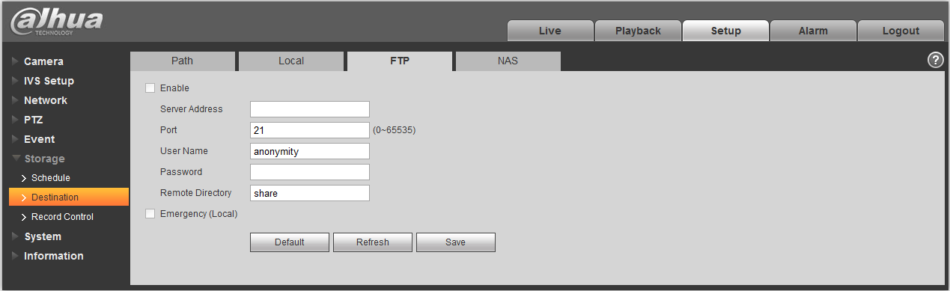
Figure 4-80

NAS
You need to check the box to enable the NAS function. Select NAS storage as to same file to NAS disk. See Figure 4-81.
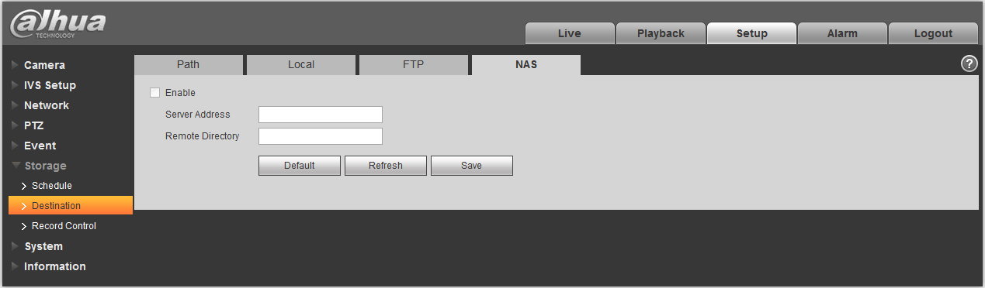
Figure 4-81

Record control
The record control interface is shown as in Figure 4-82.
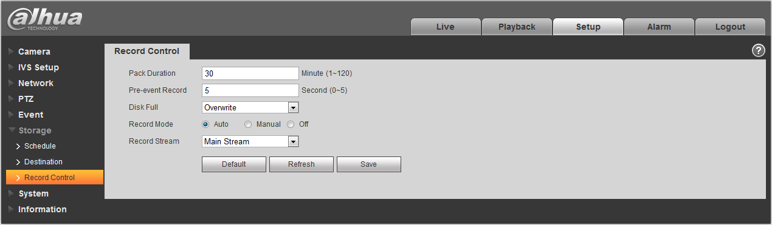
Figure 4-82
Please refer to the following sheet for detailed information.
Parameter | Function
Pack Duration | Here you can select file size within 1min~120min. Default setup is 8 minutes.
Pre-record | Please input pre-record value here.  For example, system can record the four seconds video in the buffer. The record begins from the fifth second.  Note:  Configure pre-record time, when alarm or motion detection occurs, if there is no record, system will record the preceding n seconds record.
Disk Full | There are two options: stop recording or overwrite the previous files when HDD is full.  - Stop: Current working HDD is overwriting or current HDD is full, it will stop record.  - Overwrite: Current working HDD is full; it will overwrite the previous file.
Record mode | There are three modes: Auto/manual/close.
Record stream | There are two options: main stream and sub stream.

System

General
The General interface is shown as in Figure 4-83.
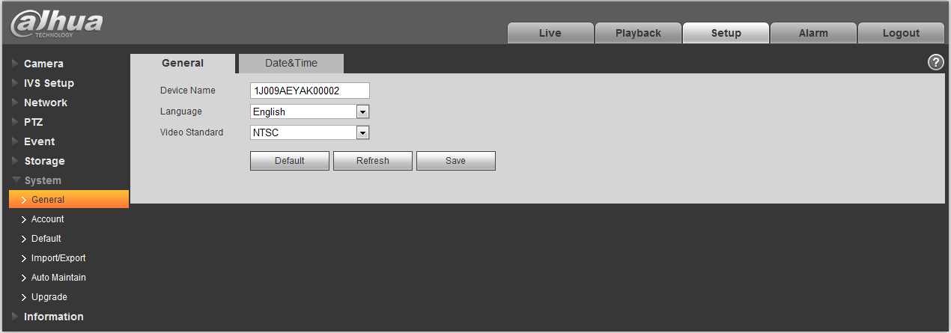
Figure 4-83
Please refer to the following sheet for detailed information.
Parameter | Function
Device Name | It is to set device name.
Video Standard | This is to display video standard such as PAL.
Language | You can select the language from the dropdown list.
The date and time interface is shown as in Figure 4-84.
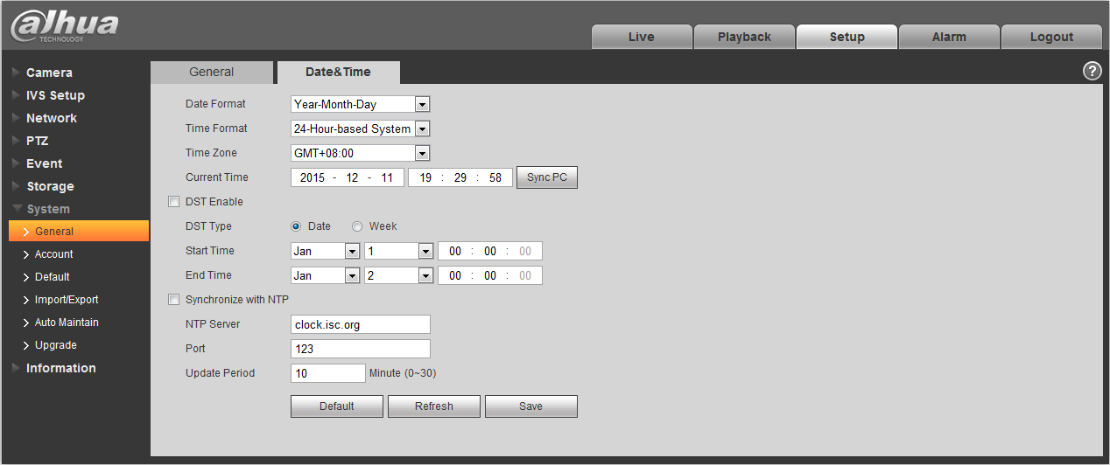
Figure 4-84
Please refer to the following sheet for detailed information.
Parameter | Function
Date format | Here you can select date format from the dropdown list.
Time Format | There are two options: 24-H and 12-H.
Time zone | The time zone of the device.
System time | It is to set system time. It becomes valid after you set.
Sync PC | You can click this button to save the system time as your PC current time.
DST | Here you can set day night save time begin time and end time. You can set according to the date format or according to the week format.
NTP | You can check the box to enable NTP function.
NTP server | You can set the time server address.
Port | It is to set the time server port.
Update period | It is to set the sync periods between the device and the time server.

Account
- For the character in the following user name or the user group name, system max supports 15-digits. The valid string includes: character, number, and underline.
- Password can be 0~32 characters in number and letter only. User can modify other user’s password.
- The user amount is 18 and the group amount is 8 when the device is shipped out of the factory. The factory default setup includes two levels: user and admin. You can set the corresponding group and then set the rights for the respective user in the specified groups.
- User management adopts group/user modes. The user name and the group name shall be unique. One user shall be included in only one group.
- Currently logged in user cannot change his/her own right.

Username
In this interface you can enable anonymity login, add/remove user and modify user name. See Figure 4-85.
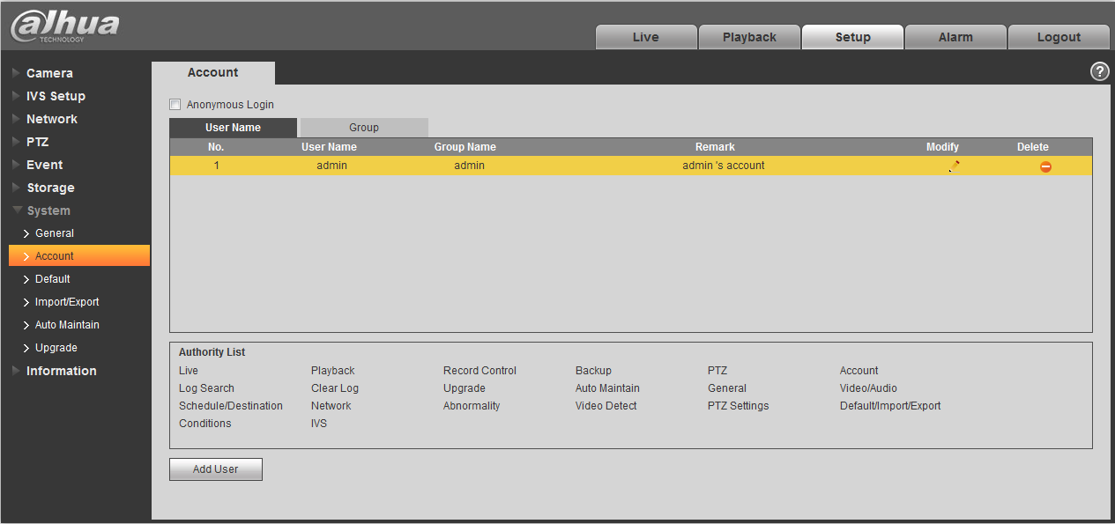
Figure 4-85
Enable anonymity login: Enable anonymity login, and input IP. No username or password is required, you can log in by anonymity (with limited rights). You can click logout to end your session.
Add user: It is to add a name to group and set the user rights. See Figure 4-86.
There is a user called admin during initialization, see Figure 4-86, and enter user name and password to select which group it belongs to.
Here you can input the user name and password and then select one group for current user.
Please note the user rights shall not exceed the group right setup.
For convenient setup, please make sure the general user has the lower rights setup than the admin.
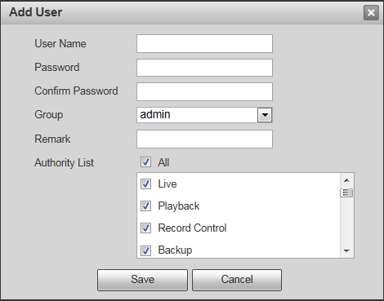
Figure 4-86
Modify user
It is to modify the user property, belonging group, password and rights. See Figure 4-87.
Modify password
It is to modify the user password. You need to input the old password and then input the new password twice to confirm the new setup. Please click the OK button to save.
Please note, the password ranges from 0-digit to 32-digit. It shall include the number and letter only. For the user who has the account rights, he can modify the password of other users.
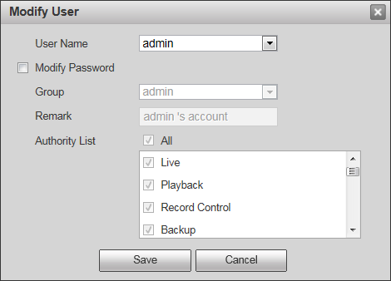
Figure 4-87

Group
The group management interface can add/remove group, modify group password and etc.
The interface is shown as in Figure 4-88.
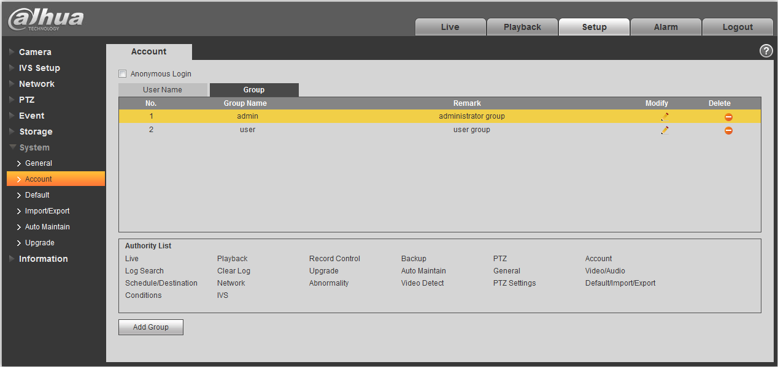
Figure 4-88
Add group: It is to add group and set its corresponding rights. See Figure 4-89.
Please input the group name and then check the box to select the corresponding rights. It includes: preview, playback, record control, PTZ control and etc.
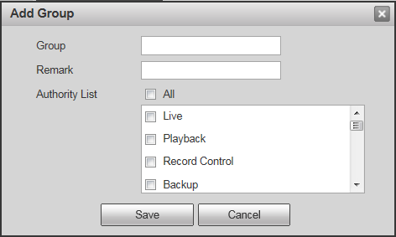
Figure 4-89
Modify group
Click the modify group button, you can see an interface is shown as in Figure 4-90.
Here you can modify group information such as remarks and rights.
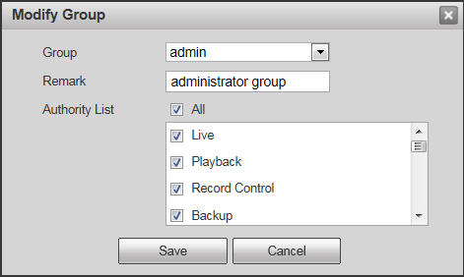
Figure 4-90

Default
The default setup interface is shown as in Figure 4-91.
Please note system cannot restore some information such as network IP address.
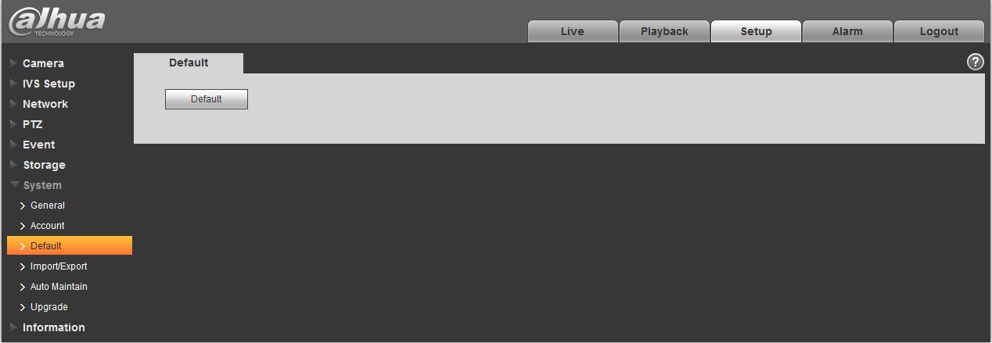
Figure 4-91

Import/Export
The interface is shown as in Figure 4-92.
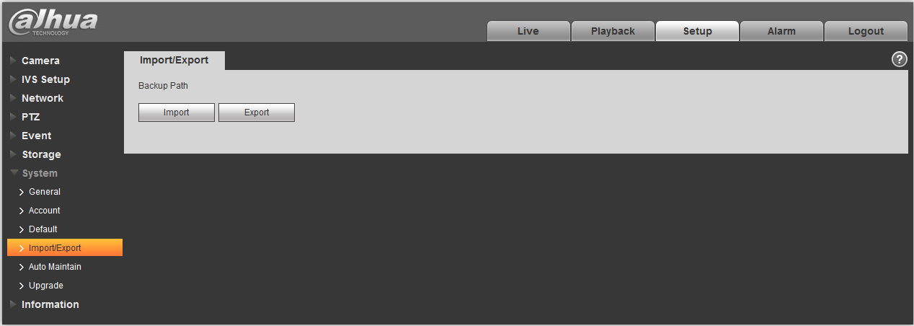
Figure 4-92
Please refer to the following sheet for detailed information.
Parameter | Function
Import | It is to import the local setup files to the system.
Export | It is to export the corresponding system setup to your local PC.

Auto Maintenance
The auto maintenance interface is shown as in Figure 4-93.
Here you can select auto reboot and auto delete old files interval from the dropdown list.
If you want to use the auto delete old files function, you need to set the file period.
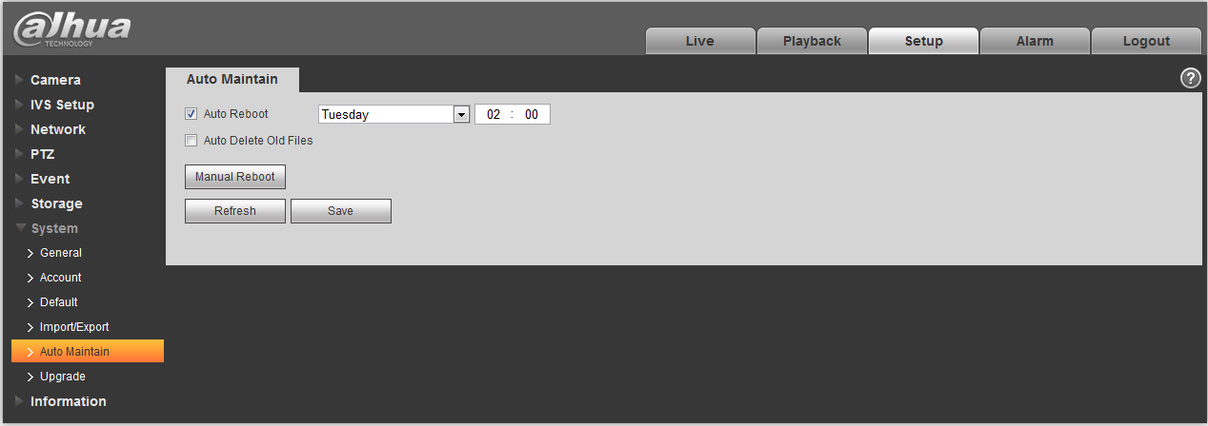
Figure 4-93
Parameter | Function
Auto Reboot | Check it and set auto reboot time.
Auto Delete Old  Files | Check it and set period within 1~31 days.

Upgrade
The upgrade interface is shown as in Figure 4-94.
Please select the upgrade file (file extension is “.bin”) and then click the update button to begin firmware update.
Important
Improper upgrade program may result in device malfunction!
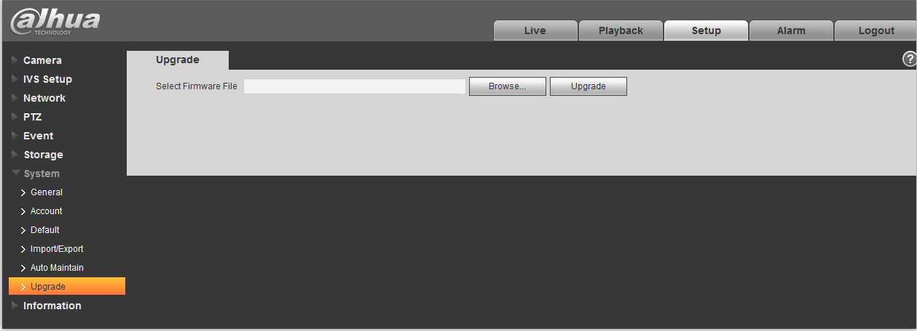
Figure 4-94

Information

Version
The version interface is shown as in Figure 4-95.
Here you can view system hardware features, software version, release date and etc. Please note the following information is for reference only.
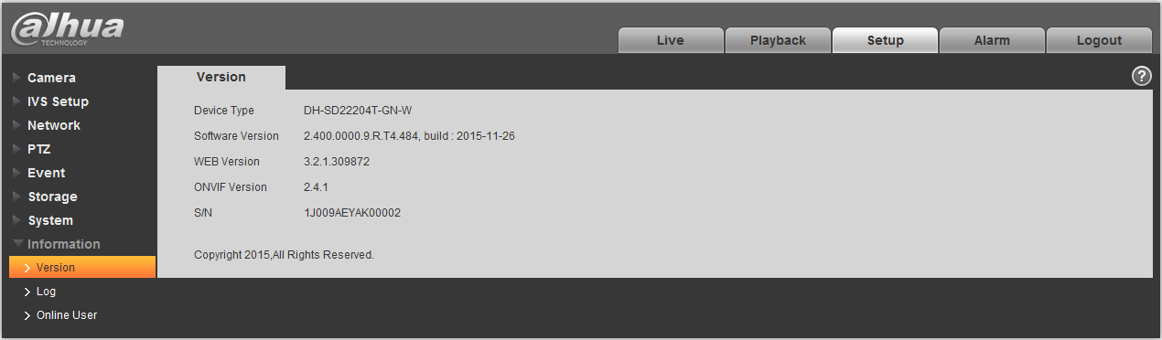
Figure 4-95

Log
Here you can view system log. See Figure 4-96.
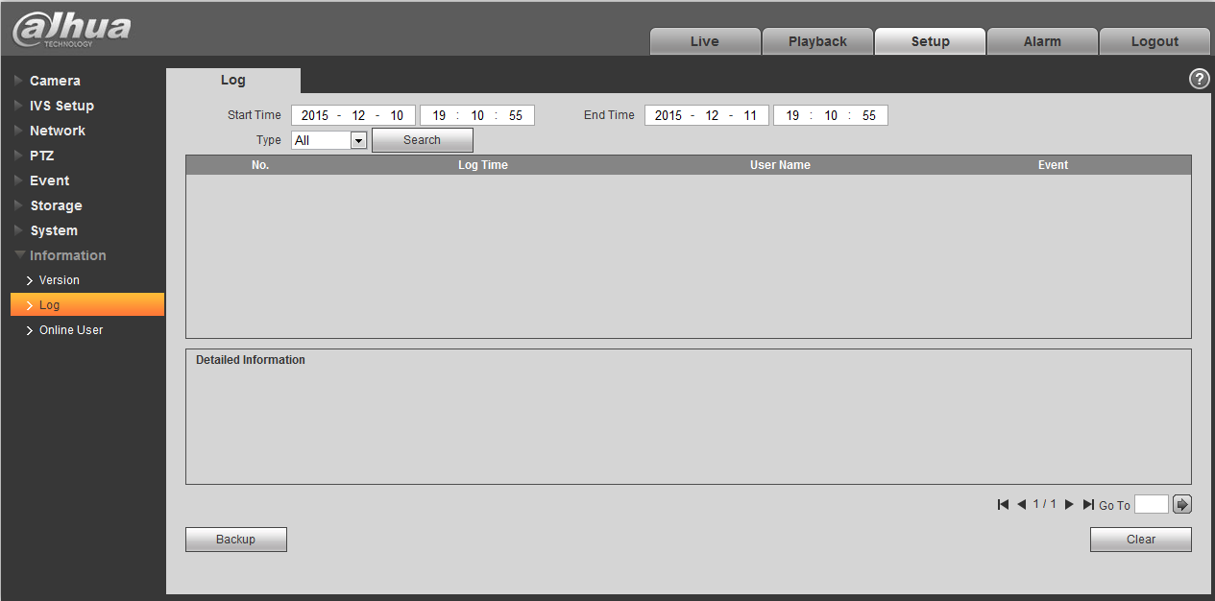
Figure 4-96
Please refer to the following sheet for log parameter information.
Parameter | Function
Start time | Set the start time of the requested log. (The earliest time is 2000/1/1)
End time | Set the end time of the requested log. (The latest time is 2037/12/31)
Type | Log type.
Search | You can select log type from the drop down list and then click search button to view the list.  You can click the stop button to terminate current search operation.
Log information | You can select one item to view the detailed information.
Clear | You can click this button to delete all displayed log files. Please note system does not support clear by type.
Backup | You can click this button to backup log files to current PC.

Online User
The online user interface is shown as in Figure 4-97.
Here you can view current online user, group name, IP address and login time.
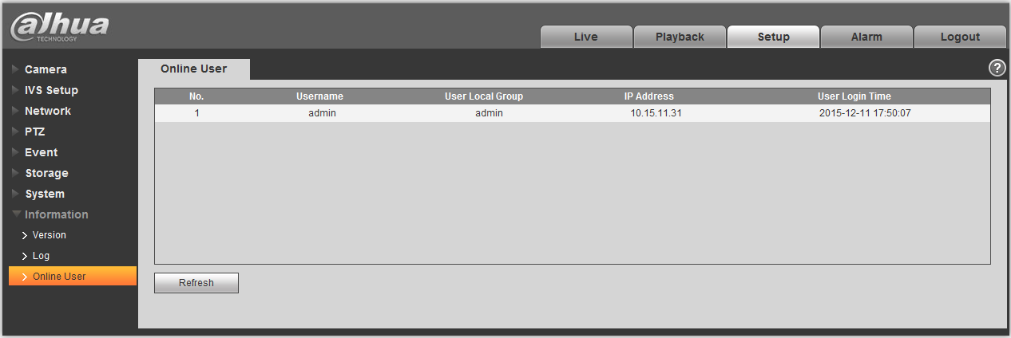
Figure 4-97

Alarm
Please note some series product does not support this function.
Click alarm function, you can see an interface is shown as in Figure 5-38.
Here you can set device alarm type and alarm sound setup.
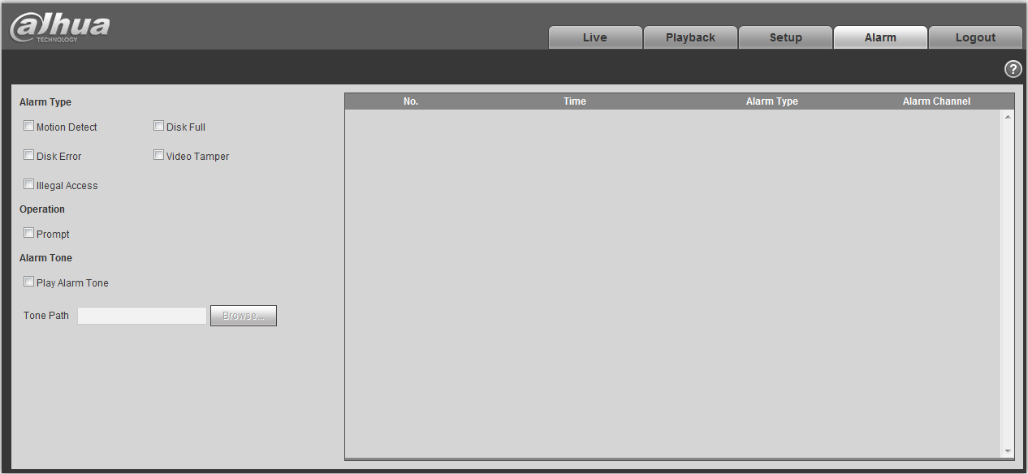
Figure 5-38
Please refer to the following sheet for detailed information.
Type | Parameter | Function
Alarm type | Motion detection | System alarms when motion detection alarm occurs,
Alarm type | Disk full | System alarms when disk is full.
Alarm type | Disk error | System generates an alarm when HDD is malfunction.
Alarm type | Video tampering | System alarms when camera is viciously masking.
Alarm type | Illegal access | System alarms when there is unauthorized access.
Operation | Prompt | When alarm is triggered, there will be s inmain menu of alarm interface and system automatically records alarm info. The icon disappears when user click alarm menu bar.  Note:  If alarm interface is displayed, when alarm is triggered, there will be no image prompt, but alarm record will be in list on the right.
Alarm audio | Audio | When alarm occurs, system auto generates alarm audio. The audio supports customized setup.
Alarm audio | Path | Here you can specify alarm sound file.

Log out
Click log out button, system goes back to log in interface. See Figure 6-39.
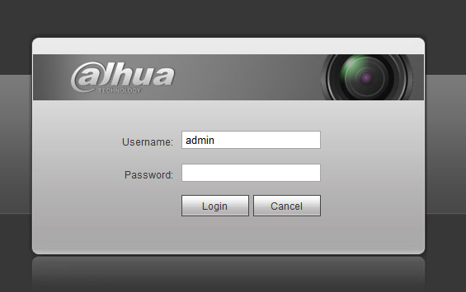
Figure 6-39
Note:
- This manual is for reference only. Slight difference may be found in user interface.
- All the designs and software here are subject to change without prior written notice.
- All trademarks and registered trademarks mentioned are the properties of their respective
owners.
- If there is any uncertainty or controversy, please refer to the final explanation of us.
- Please visit our website for more information.


Dahua Technology Co., Ltd
Address：No.1199 Bin’an Road, Binjiang District, Hangzhou, China.
Postcode: 310053
Tel: +86-571-87688883
Fax: +86-571-87688815
Email:overseas@dahuatech.com
Website: www.dahuasecurity.com

